# Section 1: Let's Dive In!

## How to Get Help

## Join Our Community!

## Course Resources

## Let's Build an App!

## Critical Questions

## Quiz 1: Core Concepts

## A Few More Critical Questions

## Node Setup

npx create-react-app <project name>

npx create-react-app jsx

cd jsx

npm start

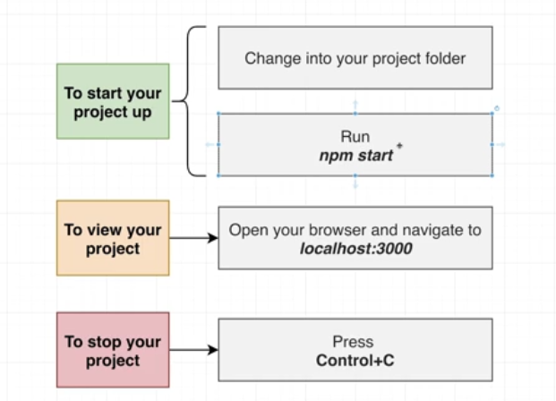

## What is Create React App?

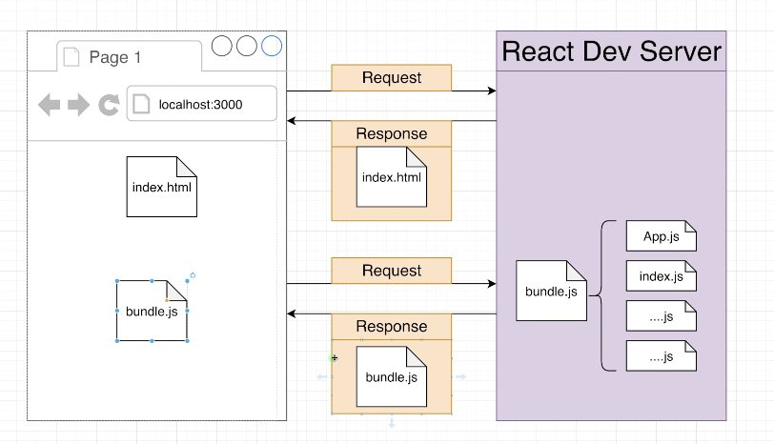 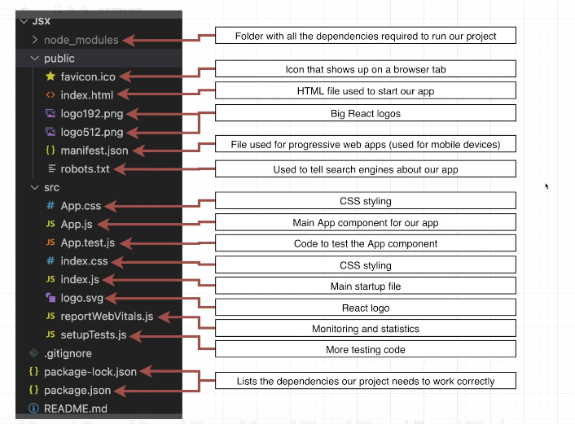 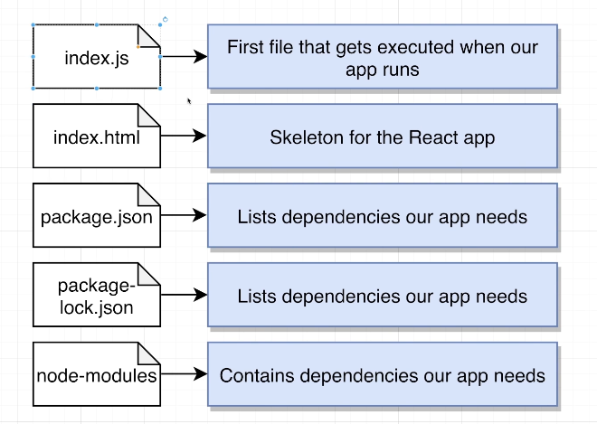

# Section 2: Creating Content with JSX

## Showing Basic Content

// 1) Import the React and ReactDOM libraries

import React from 'react';

import ReactDOM from 'react-dom/client';

// 2) Get a reference to the div with ID root

const el = document.getElementById('root');

// 3) Tell React to take control of that element

const root = ReactDOM.createRoot(el);

// 4) Create a component

function App() {

  return <h1>Hi there!</h1>;

}

// 5) Show the component on the screen

root.render(<App />);

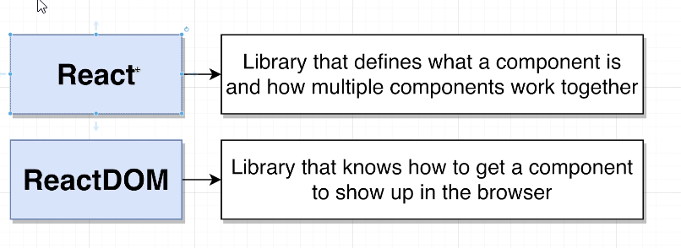

## What is JSX?

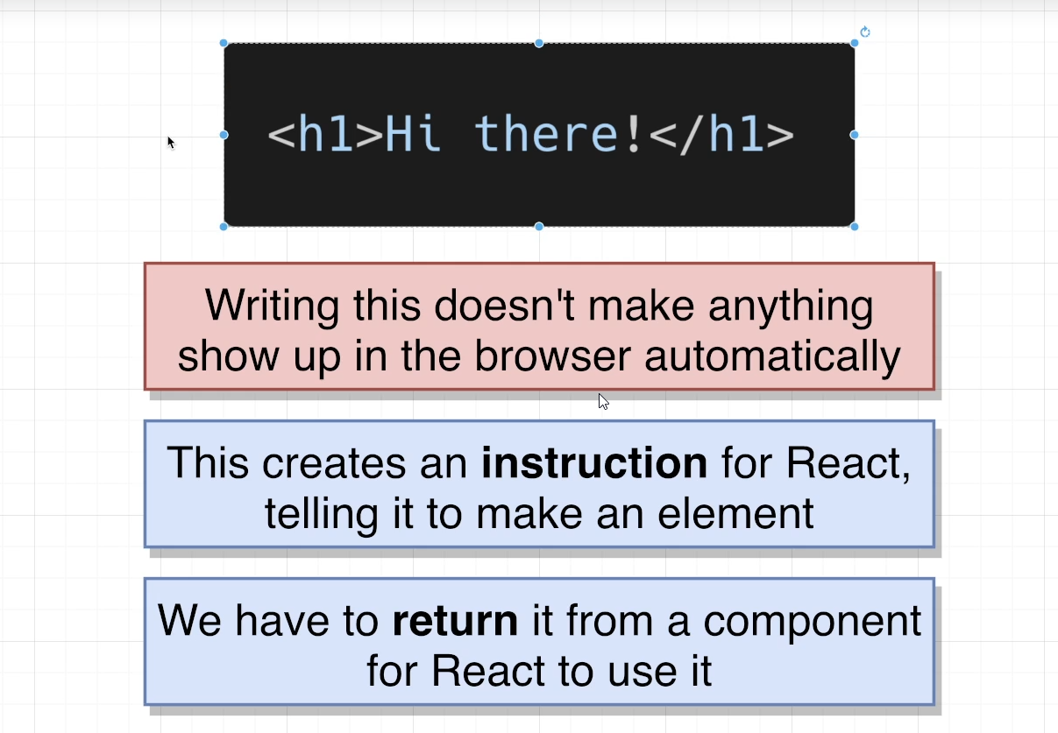

## Printing JavaScript Variables in JSX

1. function App() {
2. let message = 'Bye there';
3. if(Math.random() > 0.5) {
4. message = 'Hello there!';
5. }
6. return <h1>{message}</h1>;
7. }

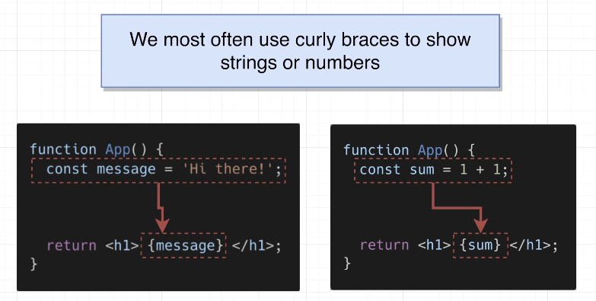 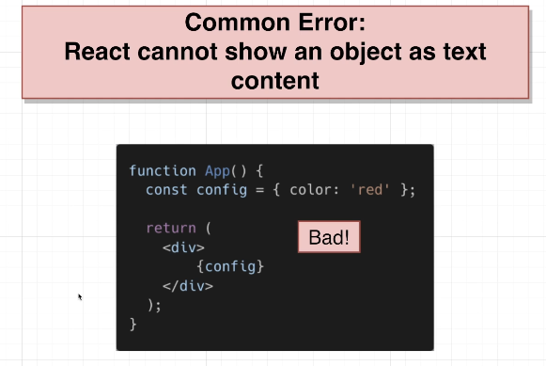

## Shorthand JS Expressions

1. function App() {
2. const date = new Date();
3. const time = date.toLocaleTimeString();
4. return <h1>{time}</h1>;
5. }

function App() {

  return <h1>{new Date().toLocaleTimeString()}</h1>;

}

## Quiz 2: Showing Javascript Values in JSX

## 14. Exercise Overview

## Coding Exercise 1: Quick Practice with JSX

import React from 'react';

function App() {

const name = 'Mehmet';

return (

<div>

My name is:

<h1>{name}</h1>

</div>

);

}

export default App;

## 15. Exercise Solution

## 16. Typical Component Layouts

function App() {

  const name = 'Samantha';

  const age = 23;

  return (

    <h1>

      Hi, my name is {name} and my age is {age}

    </h1>

  );

}

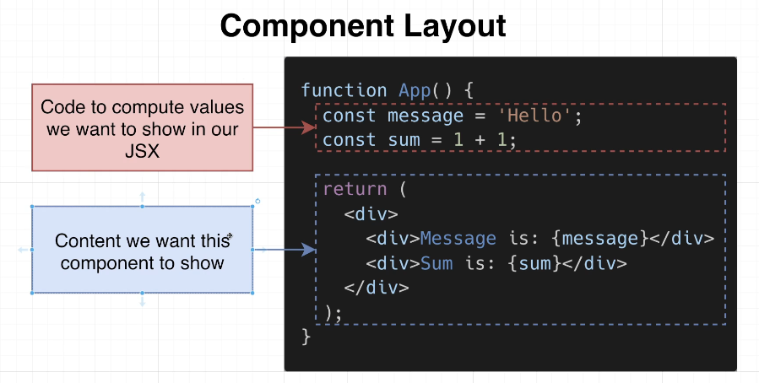

## 17. Customizing Elements with Props

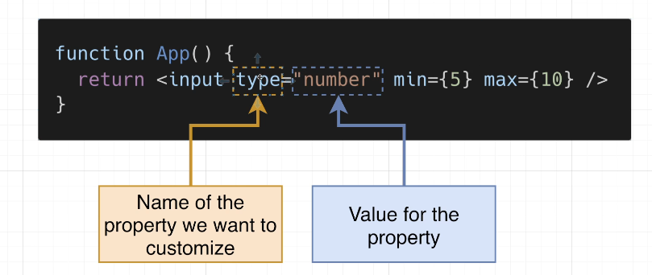

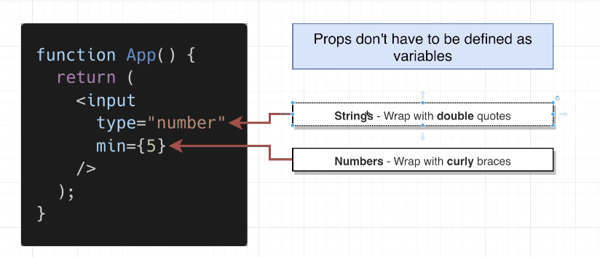

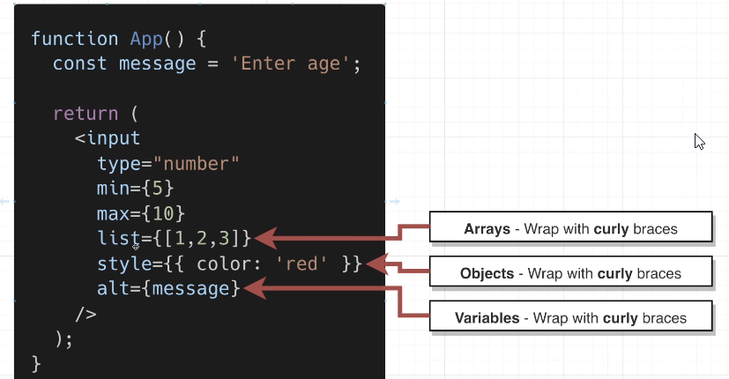

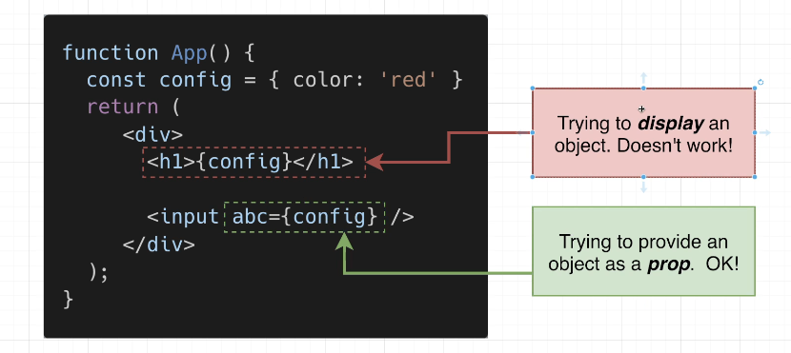

function App() {

  return <input style={{ border: '3px solid red' }} type="number" min={5} />;

}

## 18. Converting HTML to JSX

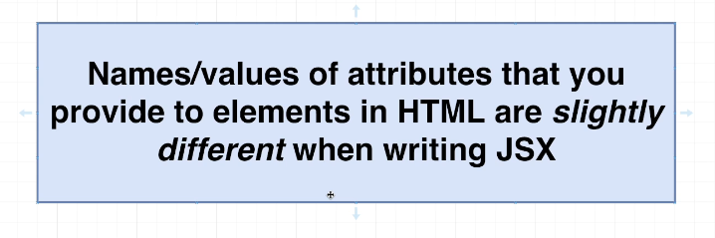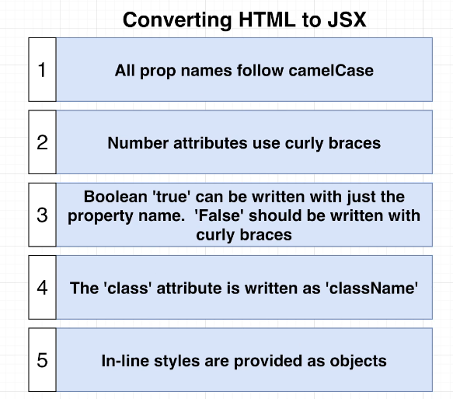

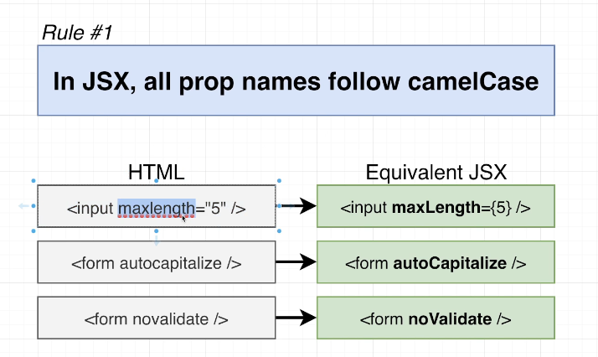

function App() {

  return <textarea autoFocus={true} />;

}

## 19. Applying Styling in JSX

function App() {

  return <input maxLength={5}  />;

}

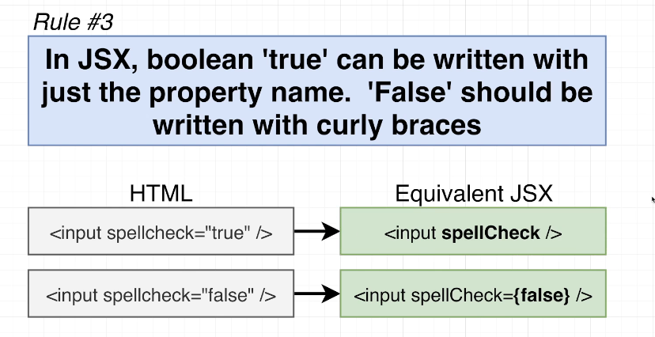

function App() {

  return <input spellCheck={false} />;

}

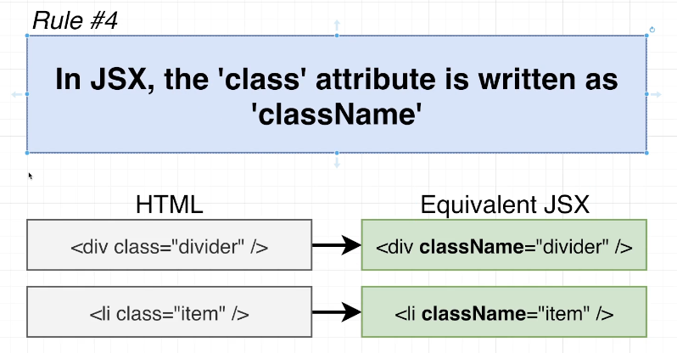

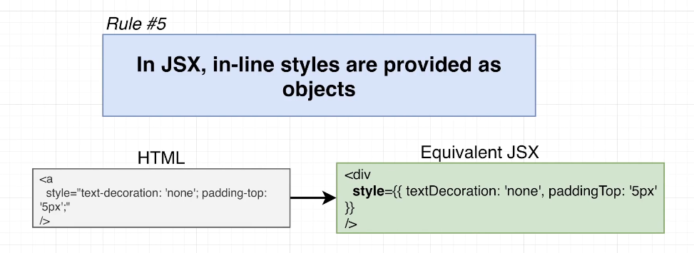

function App() {

  return (

    <div

      style={{

        textDecoration: "none",

        paddingTop: "10px",

        border: "1px solid black",

      }}

    >

      <p>

        test 1 2 3 4 5 6 7 8 9 10 11 12 13 14 15 16 17 18 19 20 21 22 23 24 25

        26 27 28 29 30 31 32 33 34 35 36 37 38 39 40 41 4

      </p>

    </div>

  );

}

## Quiz 3: More on JSX

## Coding Exercise 2: Practice JSX Conversion

## 20. Exercise Solution

function App() {

  return (

    <div className="wrapper">

      <textarea

        readOnly={true}

        maxLength ={3}

        spellCheck ={true}

        style={{ backgroundColor: 'gray'}}

      />

    </div>

  );

}

## 21. Extracting Components

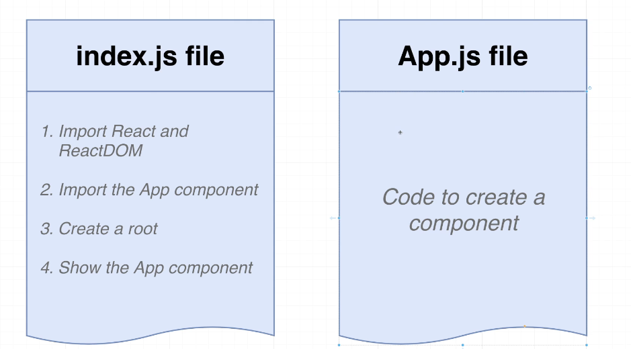 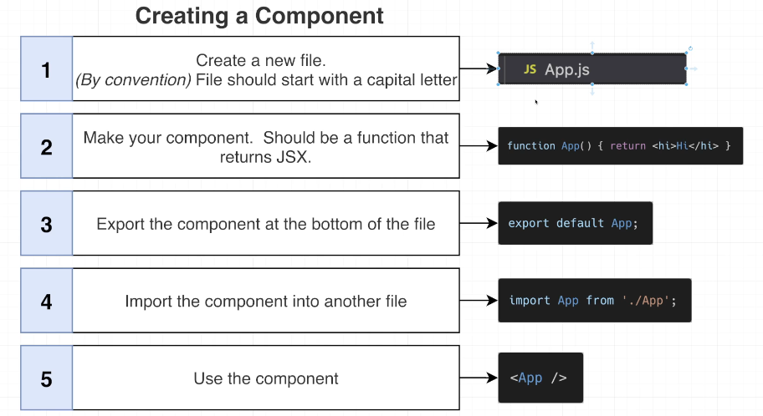

function App() {

  const name = 'Samantha';

  const age = 23;

  return (

    <h1>

      Hi, my name is {name} and my age is {age}

    </h1>

  );

}

## 22. Module Systems Overview

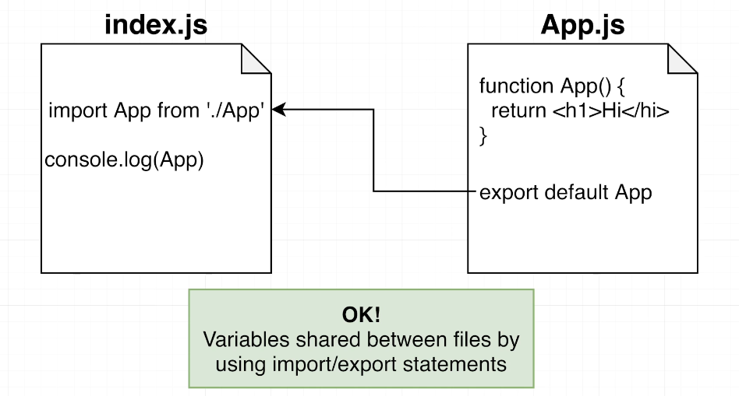

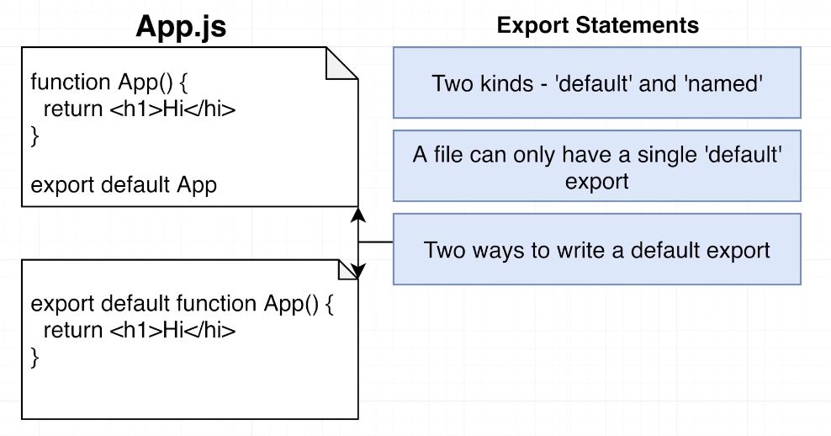 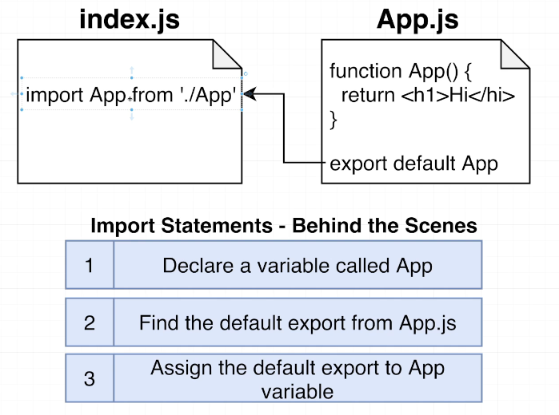

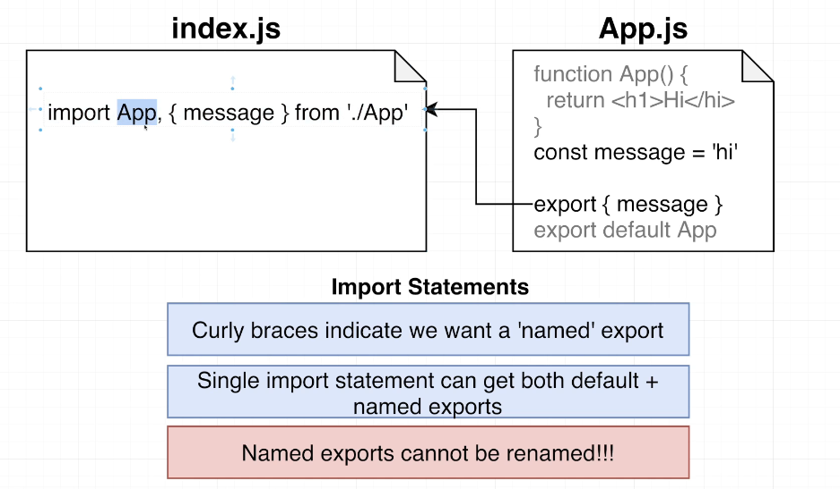

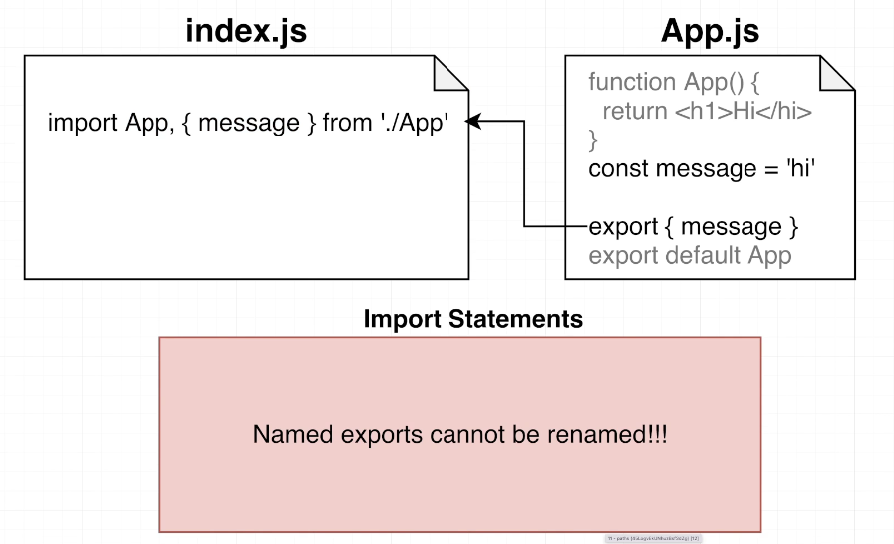

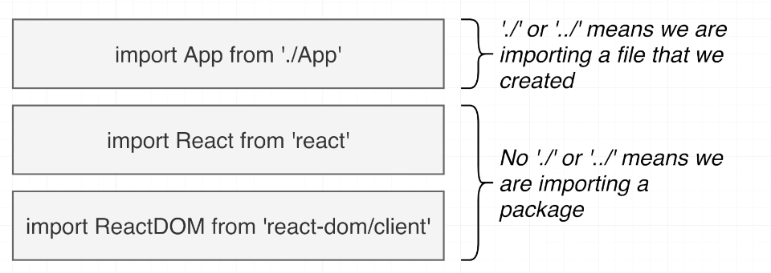

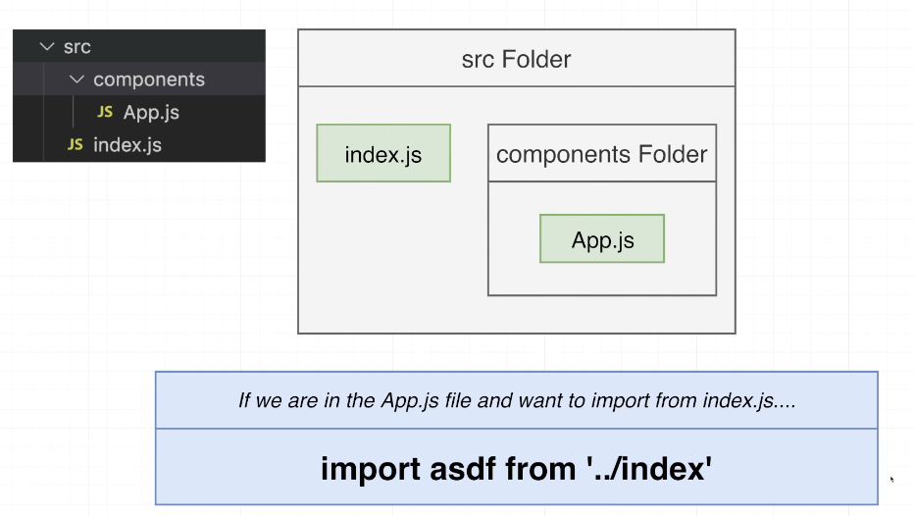

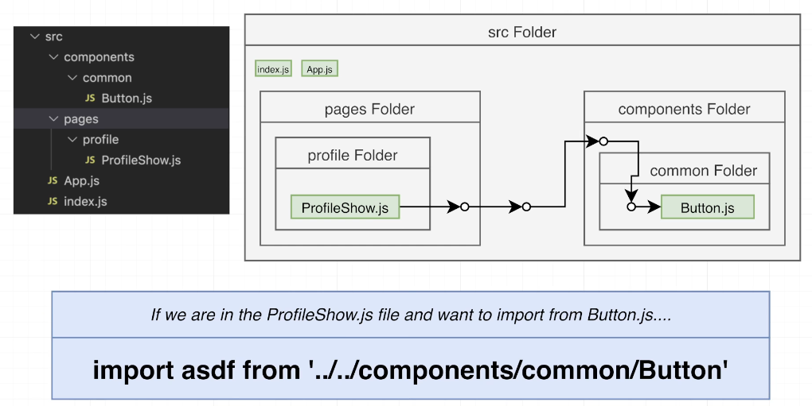

## Quiz 4: Imports and Exports

## 23. Cheatsheet for JSX

<https://jsx-notes.vercel.app/>

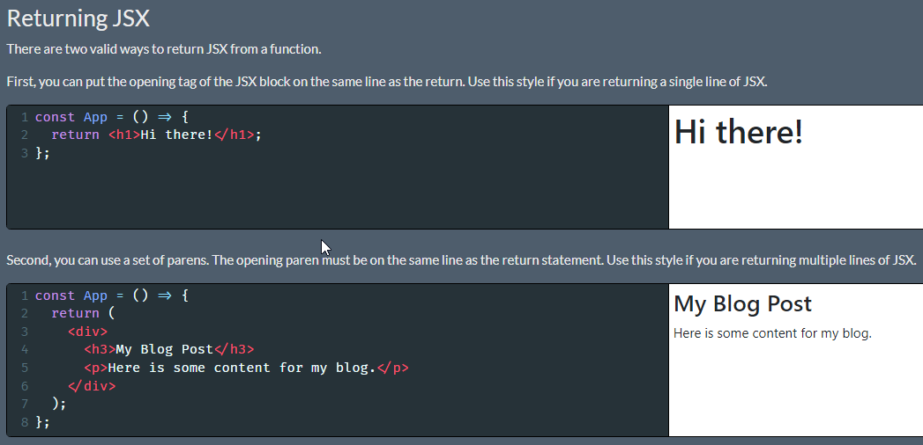

Make sure you always put the opening JSX element or paren on the same line as the return statement. If you don't, Javascript will assume you want to return nothing at all!

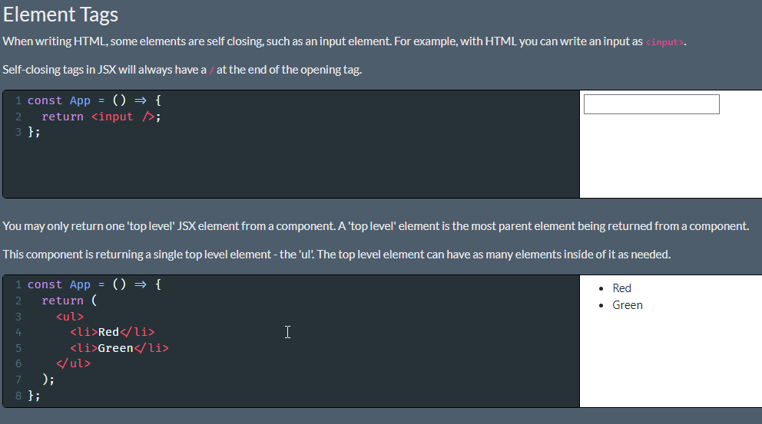

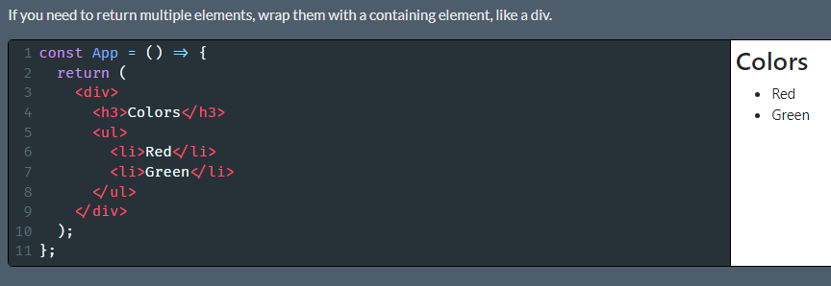

Sometimes, you don't want to insert an extra wrapping element, since it can conflict with some CSS styles. If you don't want to add an extra element, you can return wrap the content in a 'fragment', which looks like an empty JSX element.

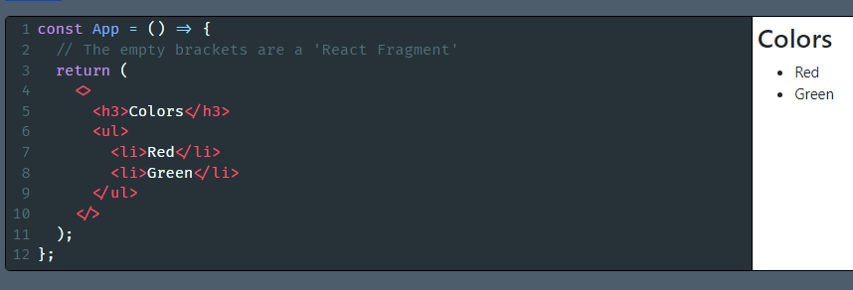

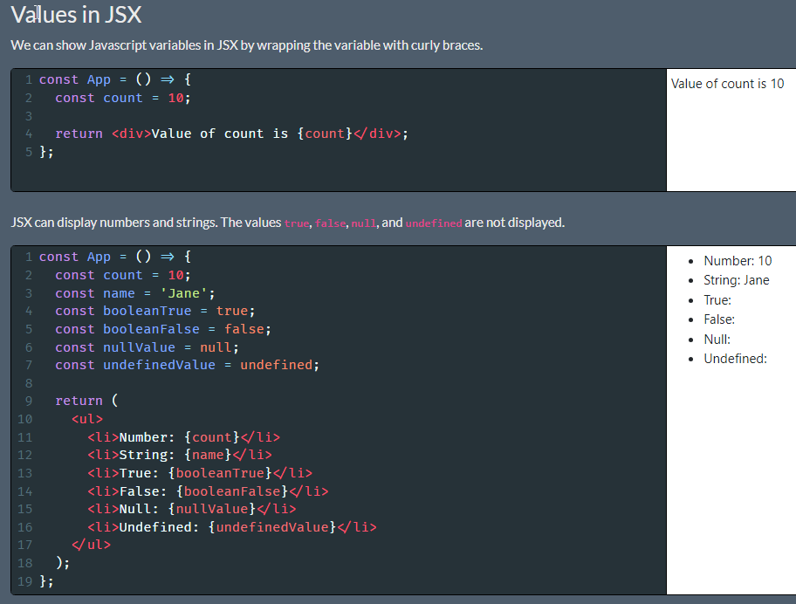

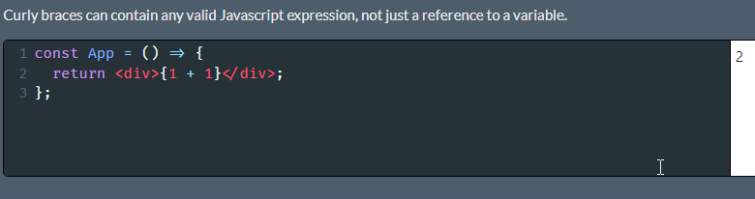

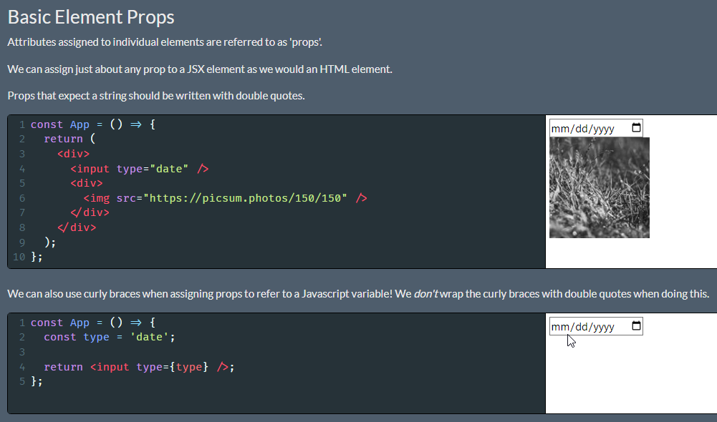

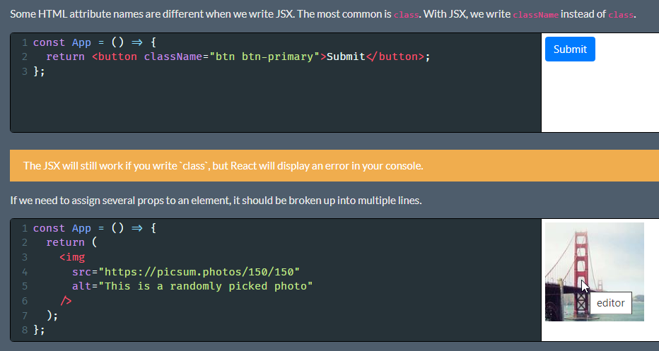

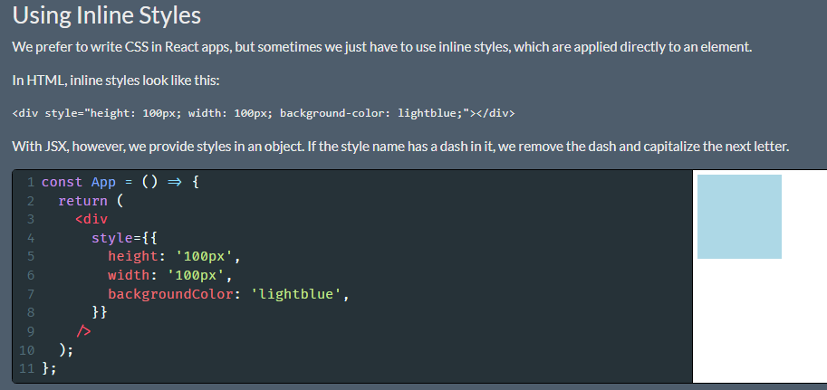

Notice the two sets of curly braces. The outer set means that we are about to write some Javascript in JSX. The inner set creates the object.

Earlier, we saw that objects can't be displayed in JSX. The key word there is 'displayed'. We can't show an object on the screen, but we can provide an object as a prop to an element.

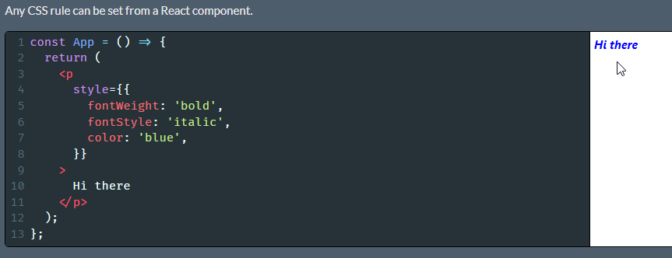

# Section 3: Building with Reusable Components

## 24. Project Overview

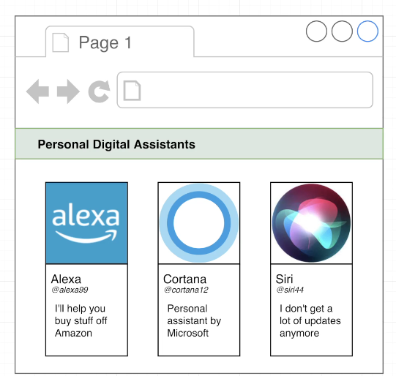

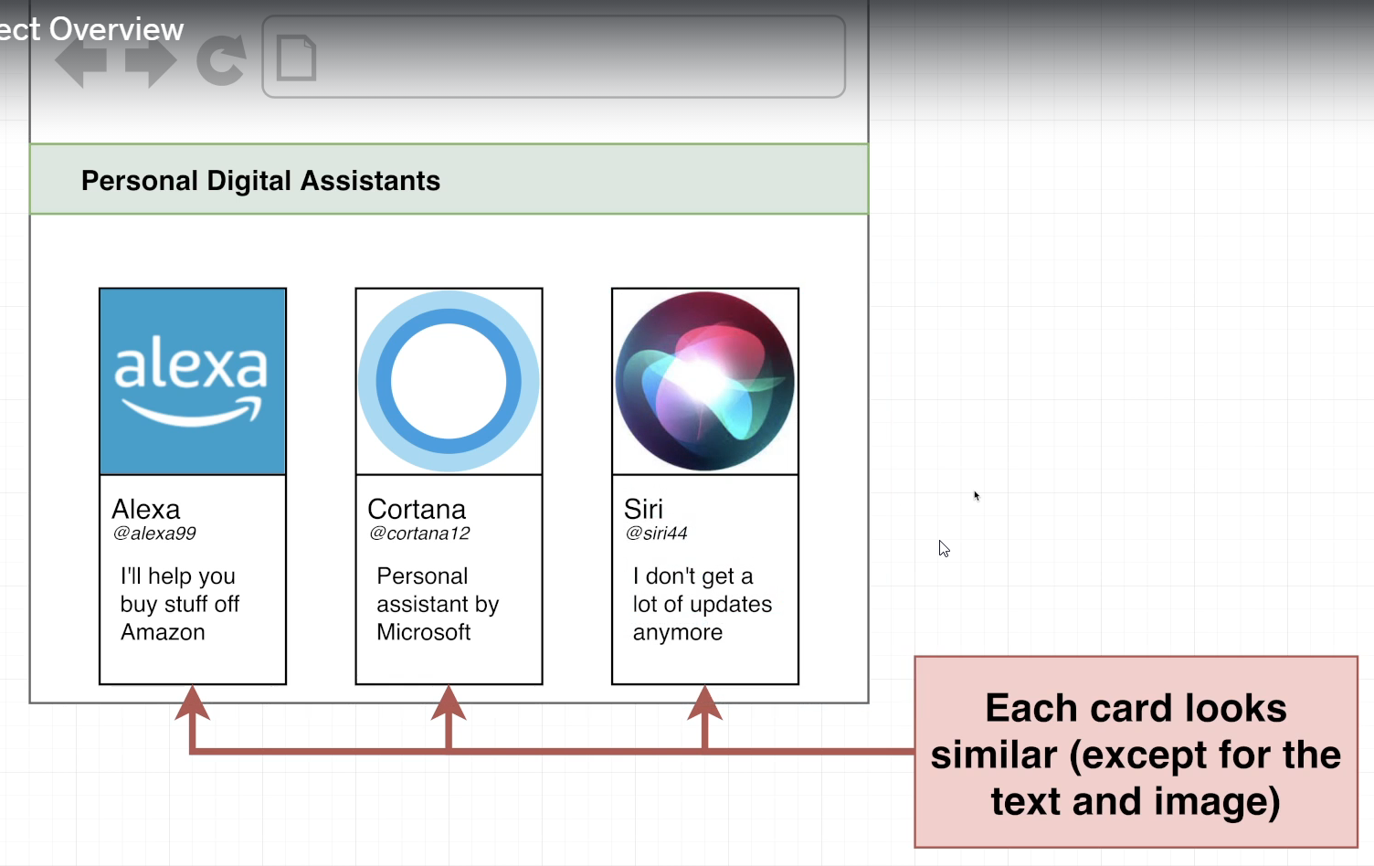

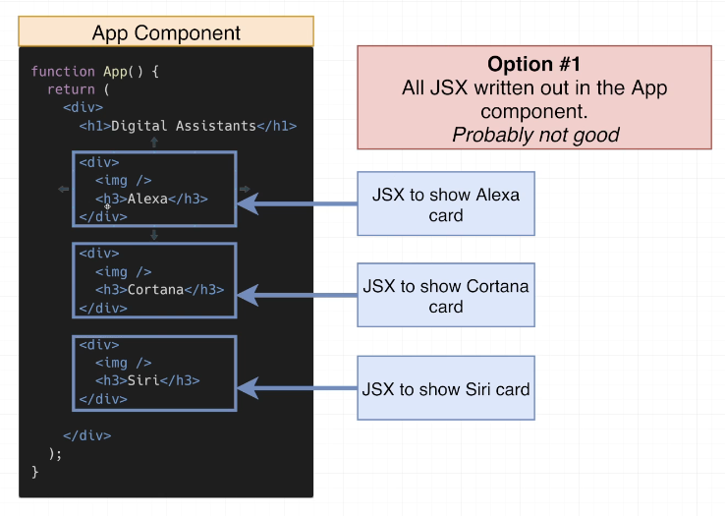

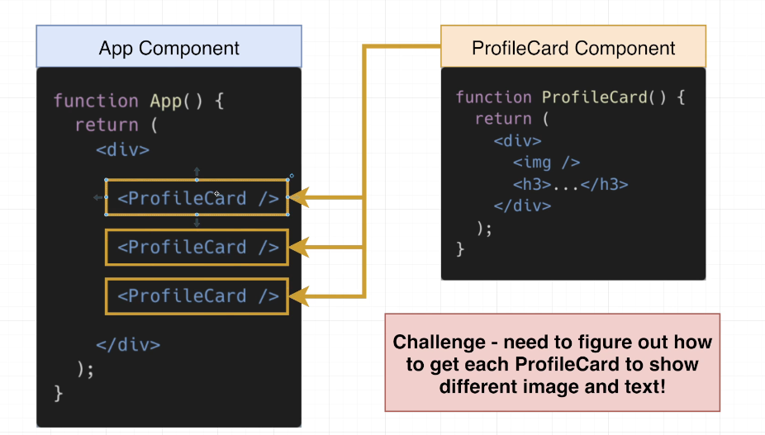

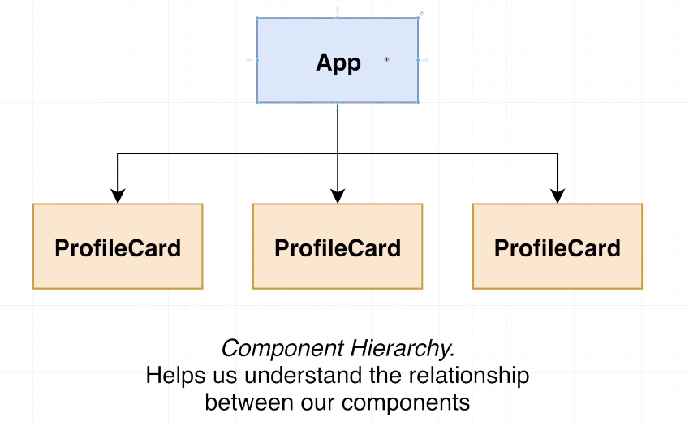

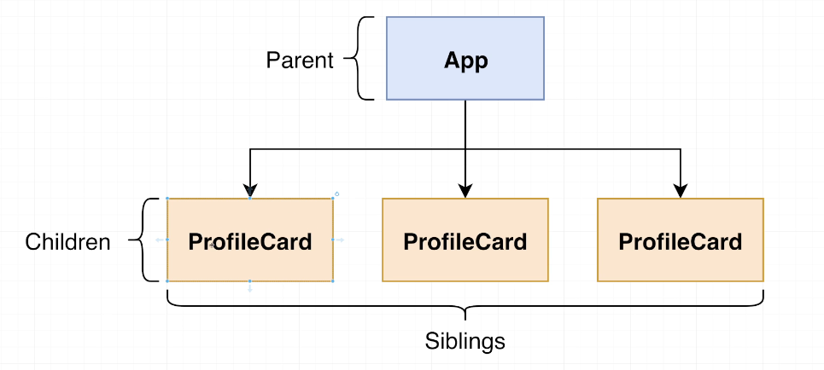

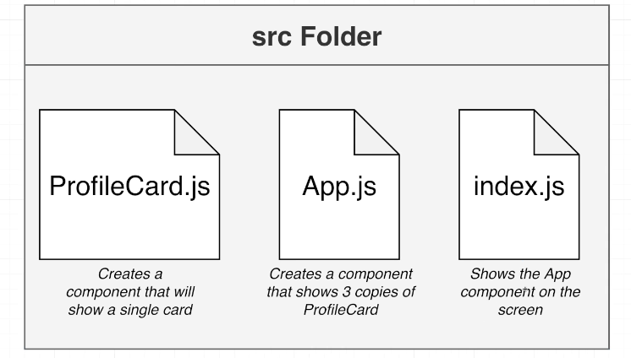

npx create-react-app pdas

cd pdas

npm start

## 25. Creating Core Components

ProfileCard.js

function ProfileCard(){

    return <div>Profile Card</div>

}

export default ProfileCard;

App.js

import ProfileCard from "./ProfileCard";

function App() {

  return (

    <div>

      <div>Personal Digital Assistans</div>

      <ProfileCard />

      <ProfileCard />

      <ProfileCard />

    </div>

  )

}

export default App;

index.js

import React from 'react';

import ReactDOM from 'react-dom/client';

import App from './App';

const el = document.getElementById('root');

const root = ReactDOM.createRoot(el);

root.render(<App />);

## 26. Introducing the Props System

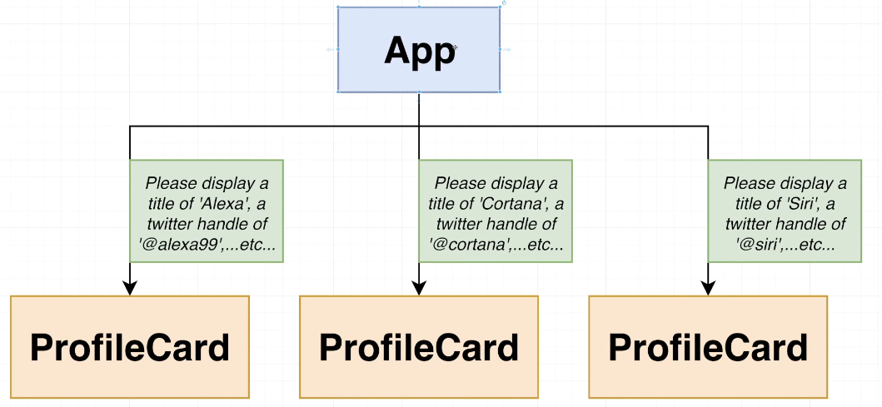

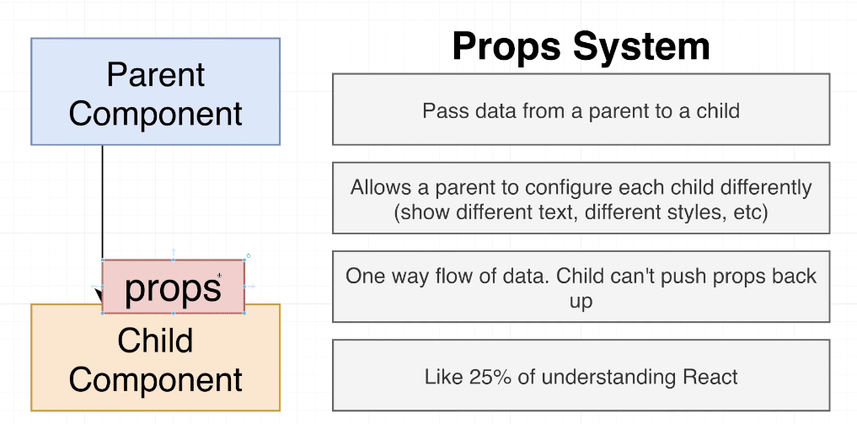

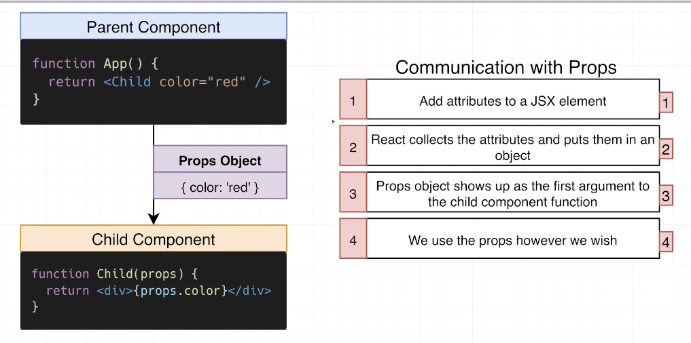

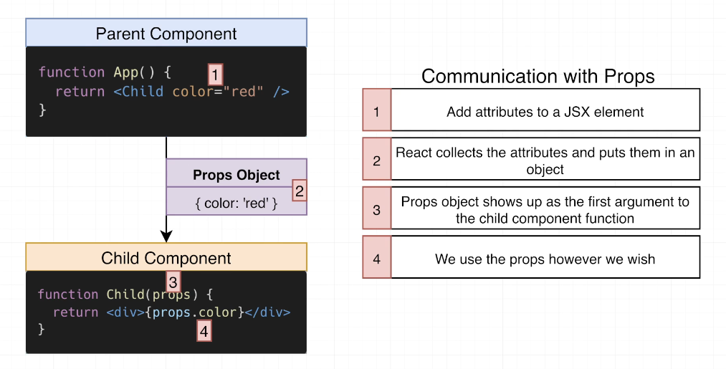

## 27. Picturing the Movement of Data

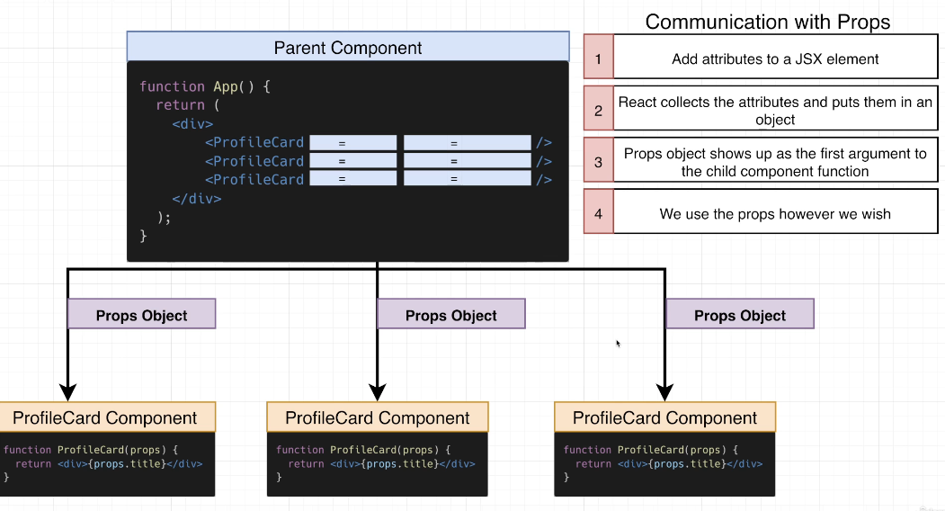

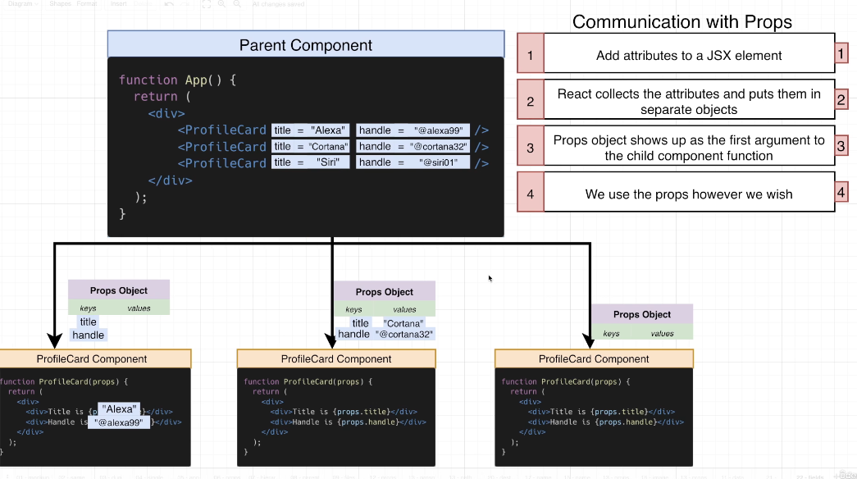

## 28. Adding Props

Index.js

import React from 'react';

import ReactDOM from 'react-dom/client';

import App from './App';

const el = document.getElementById('root');

const root = ReactDOM.createRoot(el);

root.render(<App />);

App.js

import ProfileCard from "./ProfileCard";

function App() {

  return (

    <div>

      <div>Personal Digital Assistans</div>

      <ProfileCard title="Alexa" handle="@alexa99" />

      <ProfileCard title="Cortana" handle="@cortana32" />

      <ProfileCard title="Siri" handle="@siri01" />

    </div>

  )

}

export default App;

ProfileCard.js

function ProfileCard(props){

    console.log('props', props);

    return (

    <div>

        <div>Title is {props.title}</div>

        <div>Handle is {props.handle}</div>

    </div>

    )

}

export default ProfileCard;

## 29. Using Argument Destructuring

function ProfileCard({title , handle}) {

return (

    <div>

        <div>Title is {title}</div>

        <div>Handle is {handle}</div>

    </div>

    )

}

export default ProfileCard;

## Coding Exercise 3: Practice with Props

BrightText.js

import React from 'react';

// This is all done!  No changes needed!

export default function BrightText({ color }) {

  const style = { color: color };

  // You might see an error on this line from the code editor

  // There is no error, no changes are needed

  return <h1 style={style}>Hi!</h1>

}

App.js

import React from 'react';

import BrightText from './BrightText'

function App() {

    return (

        <div>

          <BrightText color = "red" />

          <BrightText color = "green" />

          <BrightText color = "blue" />

        </div>

    );

}

export default App;

## 31. The React Developer Tools

Install react-developer-tools from the <https://react.dev/learn/react-developer-tools> to your default internet browser for debugging react app.

## 32. The Most Common Props Mistake

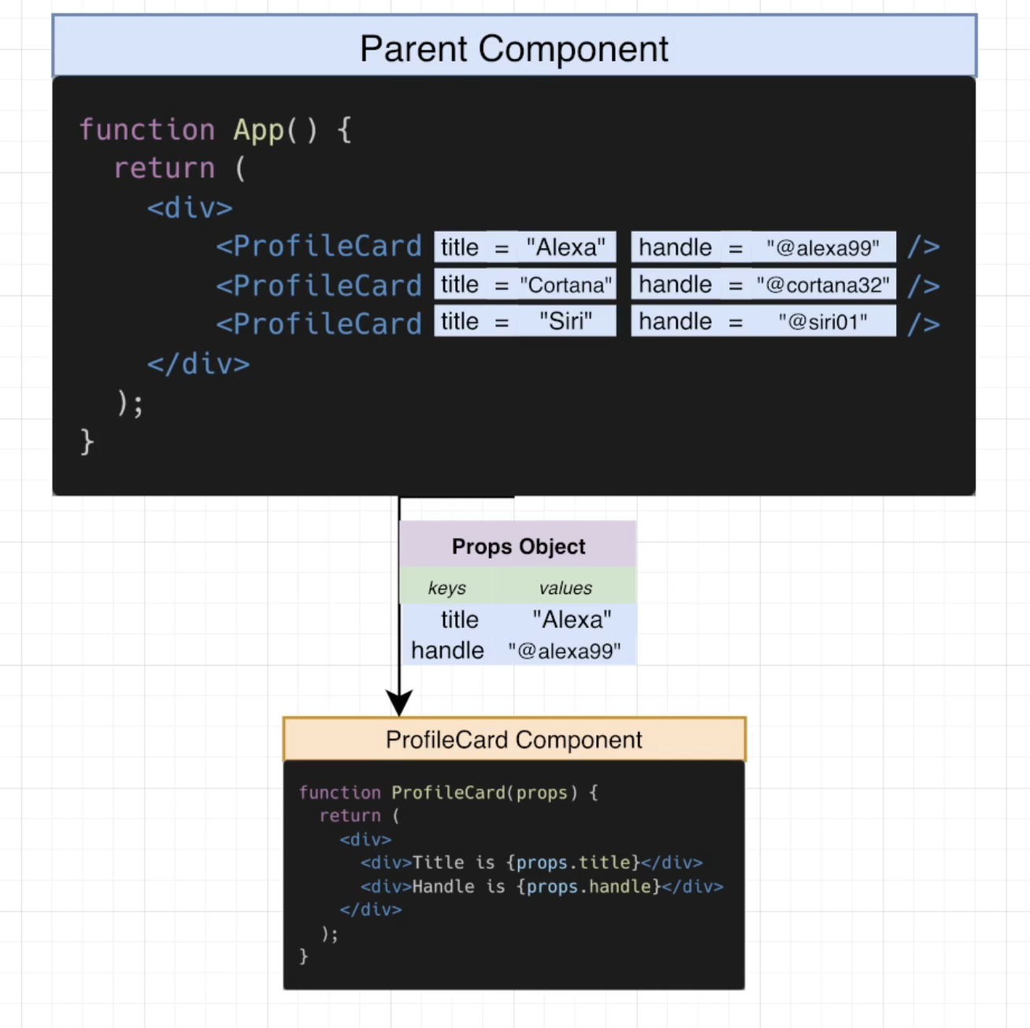

## Quiz 5: Communicating With Props

## 33. Images for the App

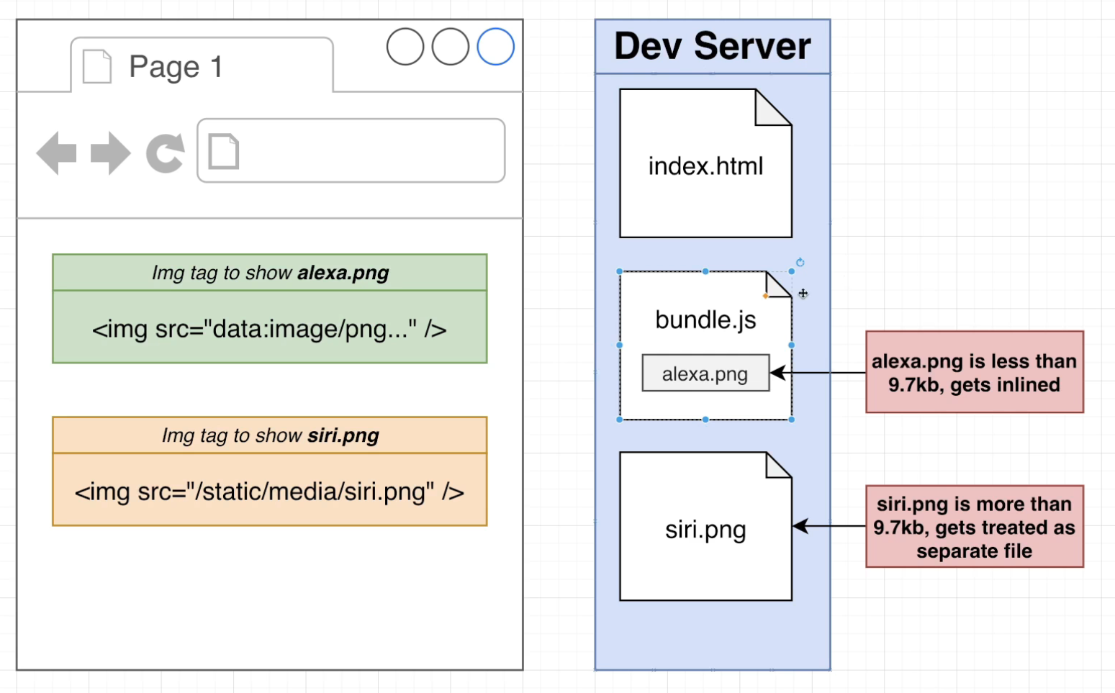

## 34. Including Images

import ProfileCard from "./ProfileCard";

import AlexaImage from './images/alexa.png';

import CortanaImage from './images/cortana.png';

import SiriImage from './images/siri.png';

console.log(AlexaImage)

console.log(CortanaImage)

console.log(SiriImage)

function App() {

  return (

    <div>

      <div>Personal Digital Assistans</div>

      <ProfileCard title="Alexa" handle="@alexa99" image={AlexaImage} />

      <ProfileCard title="Cortana" handle="@cortana32" image={CortanaImage} />

      <ProfileCard title="Siri" handle="@siri01" image={SiriImage} />

    </div>

  )

}

export default App;

## 35. Handling Image Accessibility

function ProfileCard({title , handle, image}) {

return (

    <div>

        <img src={image} alt="pda logo" />

        <div>Title is {title}</div>

        <div>Handle is {handle}</div>4

    </div>

    )

}

export default ProfileCard;

## 36. Review on how CSS Works

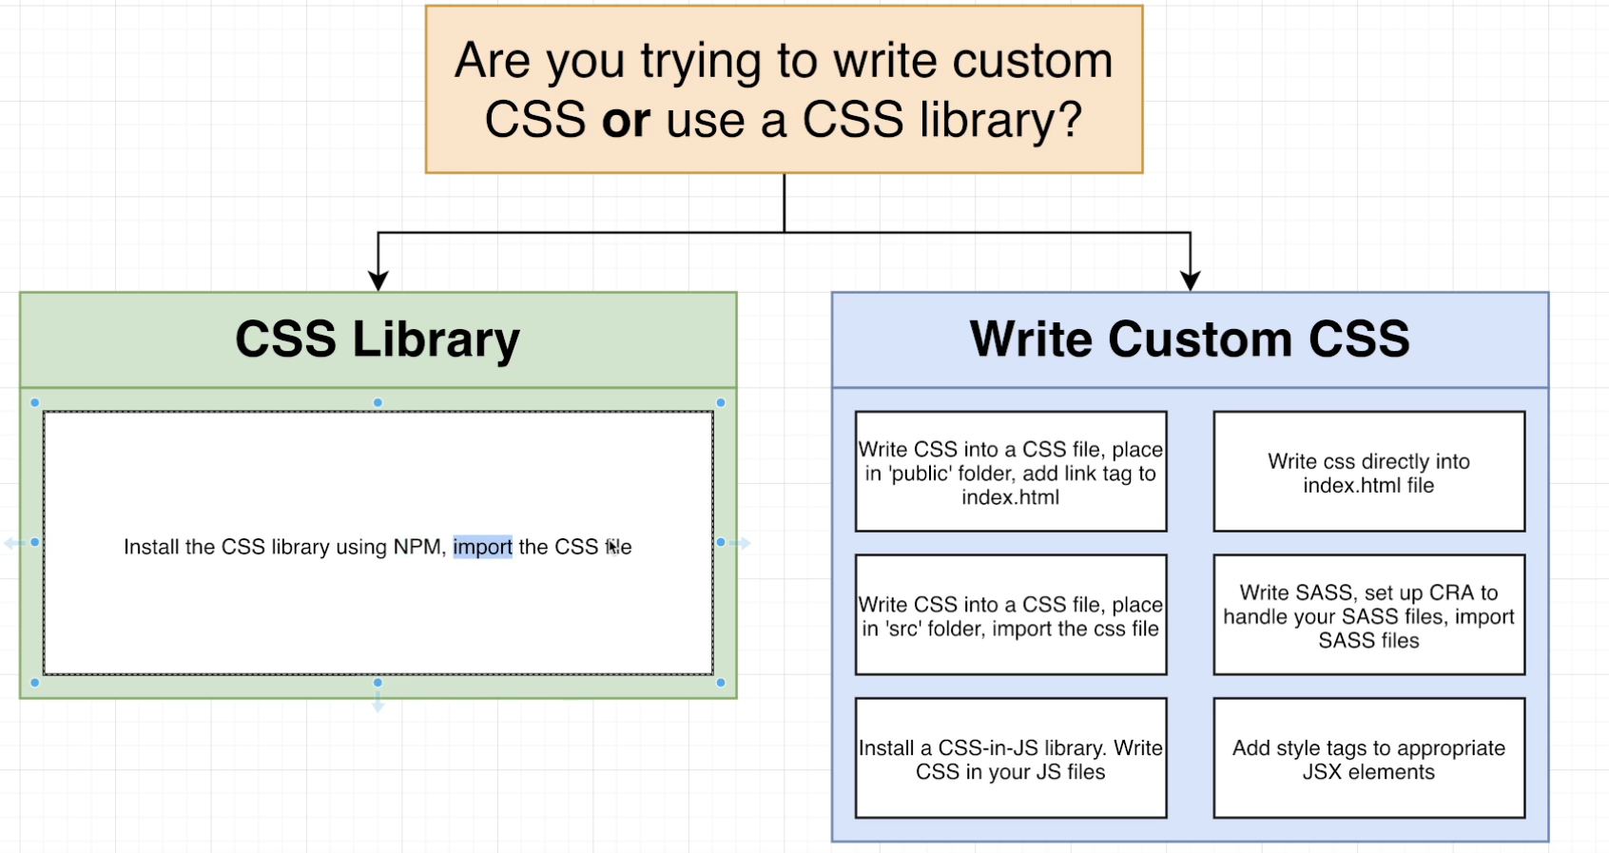

## 37. Adding CSS Libraries with NPM

<https://bulma.io/documentation/>

npm install bulma

## 38. A Big Pile of HTML!

Index.js

import React from 'react';

import ReactDOM from 'react-dom/client';

import App from './App';

const el = document.getElementById('root');

const root = ReactDOM.createRoot(el);

root.render(<App />);

App.js

import "bulma/css/bulma.css";

import ProfileCard from "./ProfileCard";

import AlexaImage from "./images/alexa.png";

import CortanaImage from "./images/cortana.png";

import SiriImage from "./images/siri.png";

// console.log(AlexaImage)

// console.log(CortanaImage)

// console.log(SiriImage)

function App() {

  return (

    <div>

      <div>Personal Digital Assistans</div>

      <div className="container">

        <section className="section">

          <div className="column is-4">

            <ProfileCard title="Alexa" handle="@alexa99" image={AlexaImage} />

          </div>

          <div className="column is-4">

            <ProfileCard

              title="Cortana"

              handle="@cortana32"

              image={CortanaImage}

            />

          </div>

          <div className="column is-4">

            <ProfileCard title="Siri" handle="@siri01" image={SiriImage} />

          </div>

        </section>

      </div>

    </div>

  );

}

export default App;

ProfileCard.js

function ProfileCard({ title, handle, image }) {

  return (

    <div className="card">

      <div className="card-image">

        <figure className="image is-1by1">

          <img src={image} alt="pda logo" />

        </figure>

      </div>

      <div className="card-content">

        <div className="media-content">

          <p className="title is-4">{title}</p>

          <p className="subtitle is-6">{handle}</p>

        </div>

      </div>

    </div>

  );

}

export default ProfileCard;

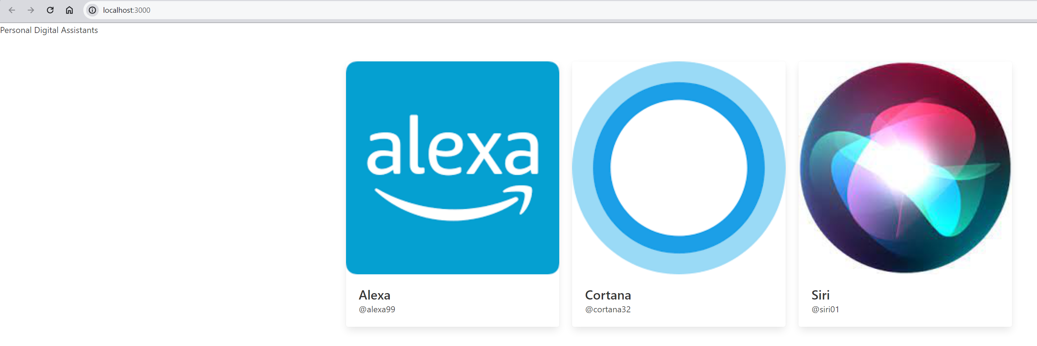

## 39. Last Bit of Styling

Index.js

import React from 'react';

import ReactDOM from 'react-dom/client';

import App from './App';

const el = document.getElementById('root');

const root = ReactDOM.createRoot(el);

root.render(<App />);

App.js

import 'bulma/css/bulma.css';

import ProfileCard from './ProfileCard';

import AlexaImage from './images/alexa.png';

import CortanaImage from './images/cortana.png';

import SiriImage from './images/siri.png';

function App() {

  return (

    <div>

      <section className="hero is-primary">

        <div className="hero-body">

          <p className="title">Personal Digital Assistants</p>

        </div>

      </section>

      <div className="container">

        <section className="section">

          <div className="columns">

            <div className="column is-4">

              <ProfileCard

                title="Alexa"

                handle="@alexa99"

                image={AlexaImage}

                description="Alexa was created by Amazon and helps you buy things."

              />

            </div>

            <div className="column is-4">

              <ProfileCard

                title="Cortana"

                handle="@cortana32"

                image={CortanaImage}

                description="Cortana was made by Microsoft. Who knows what it does?"

              />

            </div>

            <div className="column is-4">

              <ProfileCard

                title="Siri"

                handle="@siri01"

                image={SiriImage}

                description="Siri was made by Apple and is being phased out"

              />

            </div>

          </div>

        </section>

      </div>

    </div>

  );

}

export default App;

ProfileCard.js

function ProfileCard({ title, handle, image, description }) {

  return (

    <div className="card">

      <div className="card-image">

        <figure className="image is-1by1">

          <img src={image} alt="pda logo" />

        </figure>

      </div>

      <div className="card-content">

        <div className="media-content">

          <p className="title is-4">{title}</p>

          <p className="subtitle is-6">{handle}</p>

        </div>

        <div className="content">{description}</div>

      </div>

    </div>

  );

}

export default ProfileCard;

The Output:

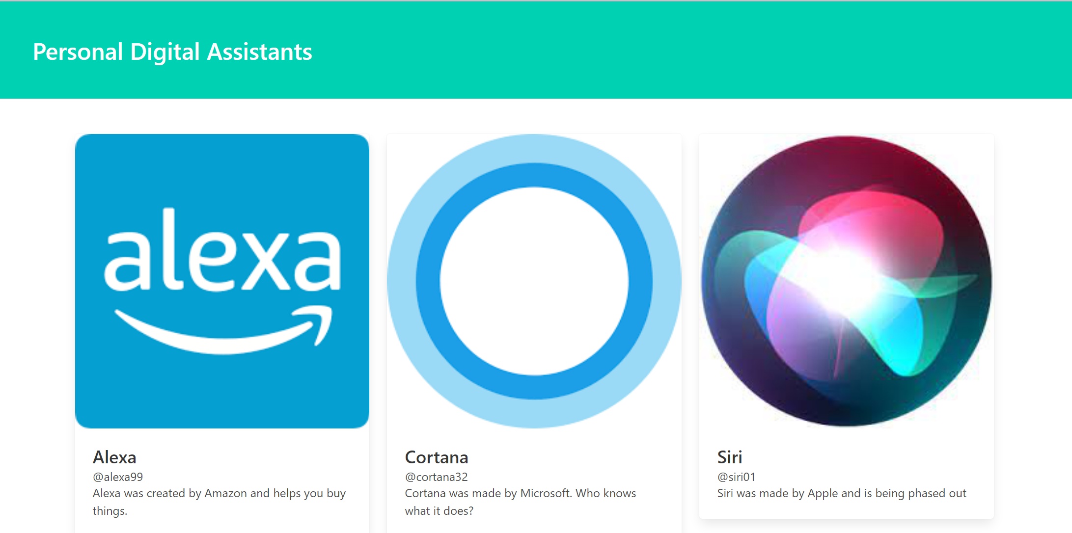

# Section 4: State: How to Change Your App

## 40. App Overview

npx create-react-app animals

## 41. Initial App Setup

npm start

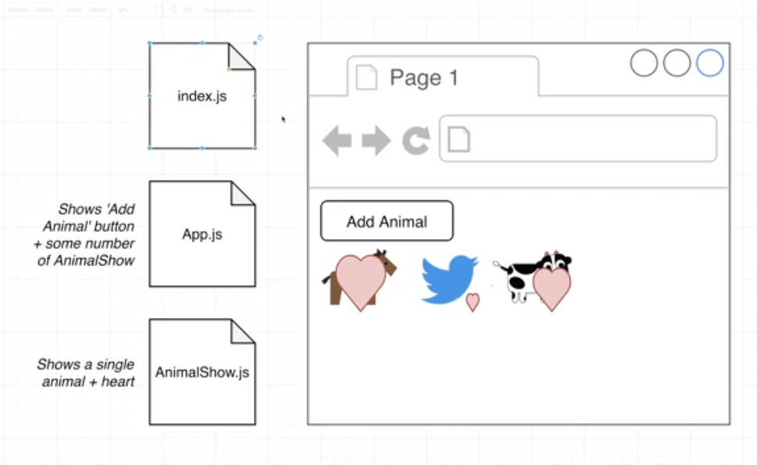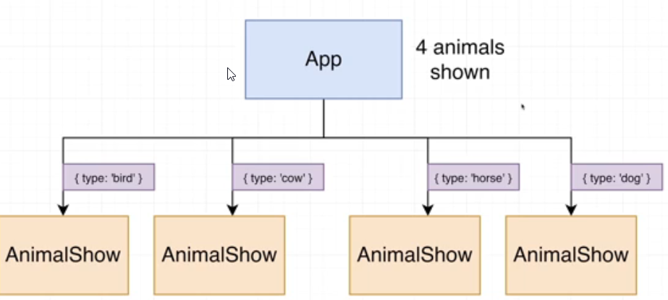

## 42. Introducing the Event System

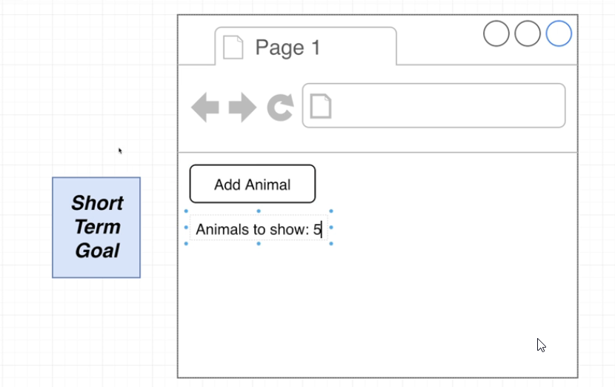

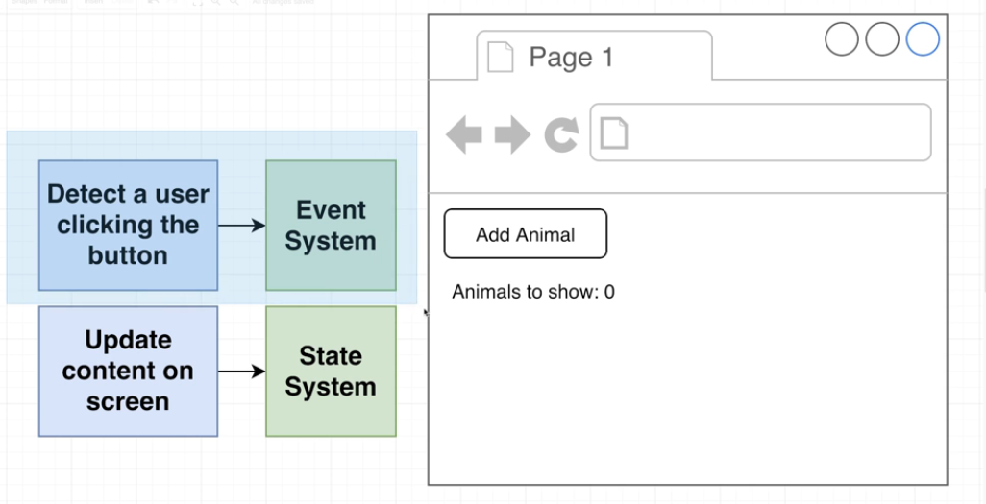

App.js

function App() {

    const handleClick = () => {

        console.log('Button was clicked')

    };

    return (

    <div>

        <button onClick={handleClick}>Add Animal</button>

        </div>

    )

}

export default App;

## 43. Events in Detail

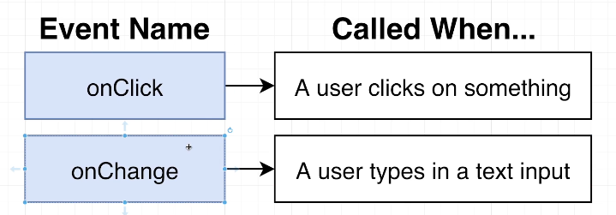

App.js

function App() {

    const handleClick = () => {

        console.log('Button was clicked')

    };

    const handleMouseMove = () => {

        console.log('Mouse moved inside of the button')

    };

    return (

    <div>

        <button onClick={handleClick} onMouseMove={handleMouseMove}>Add Animal</button>

        </div>

    )

}

export default App;

## 44. Variations on Event Handlers

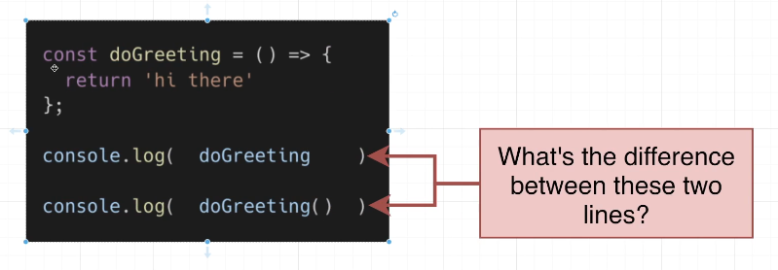

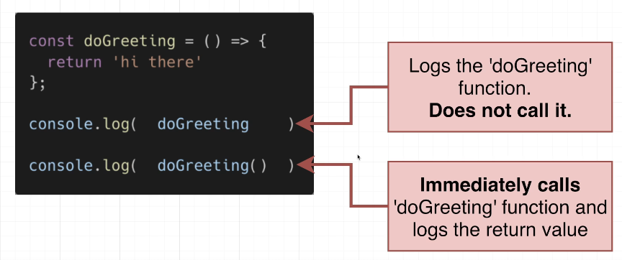

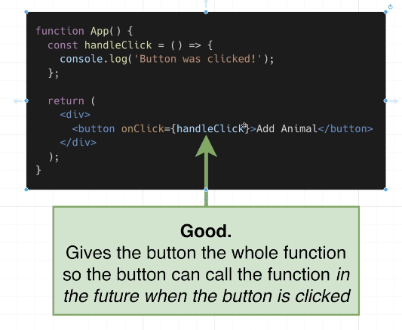

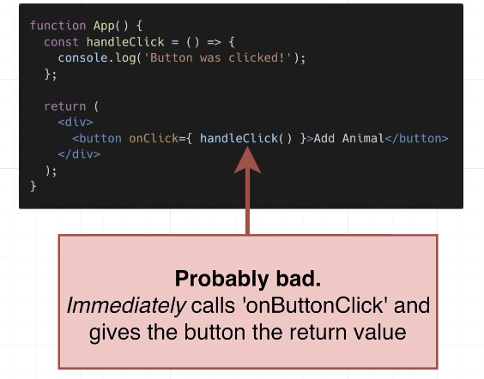

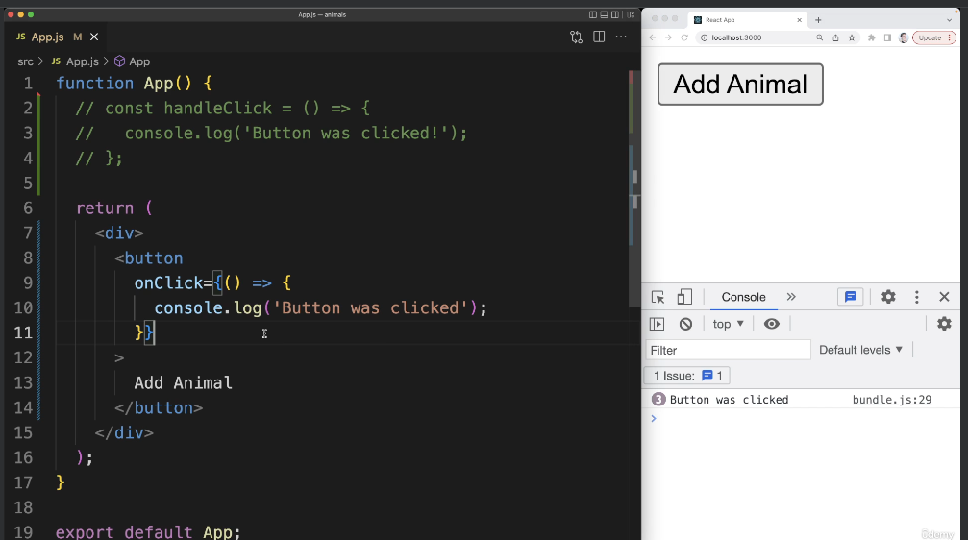

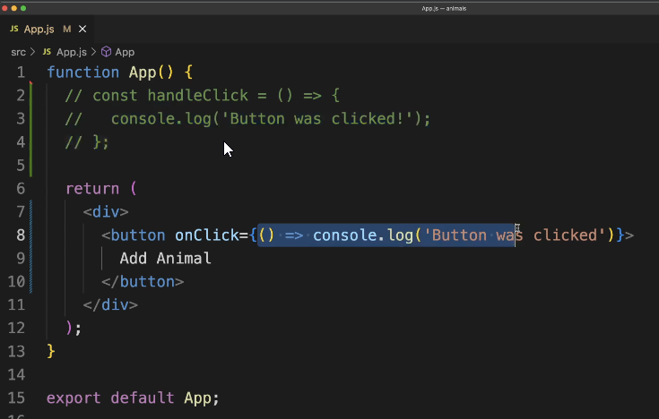

## Coding Exercise 4: Exercise with Events

import React from 'react';

function App() {

    return (

        <div>

            <button onClick={() => console.log('Hello there!')}>Click Me!</button>

        </div>

    );

}

export default App;

## 45. Exercise Solution

## 46. Introducing the State System

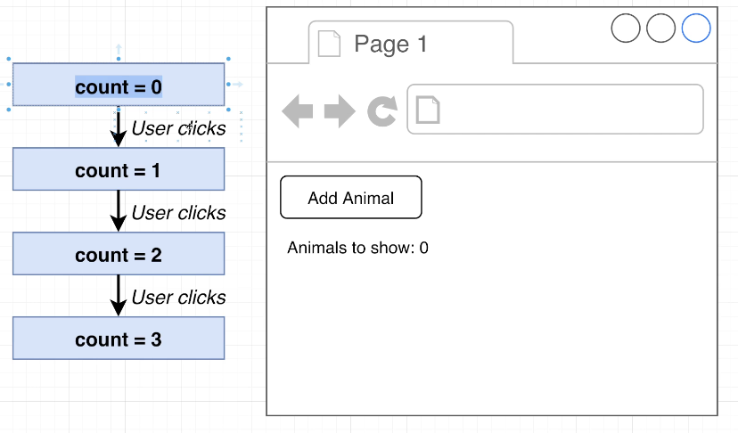

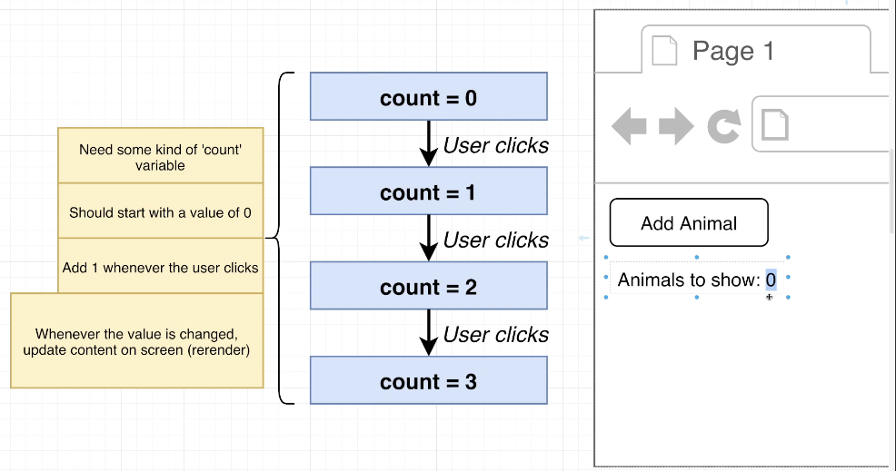

import { useState } from "react";

function App() {

  const [count, setCount] = useState(0);

  const handleClick = () => {

    setCount(count + 1);

  };

  return (

    <div>

      <button onClick={handleClick}>Add Animal</button>

      <div>Number of animals: {count}</div>

    </div>

  );

}

export default App;

## 47. More on State

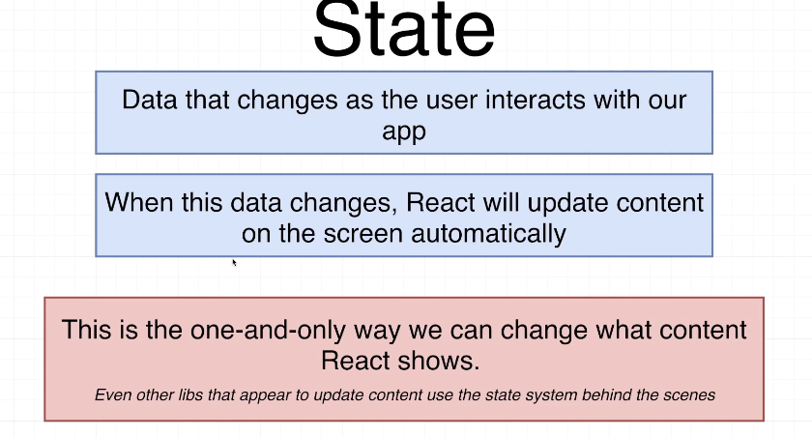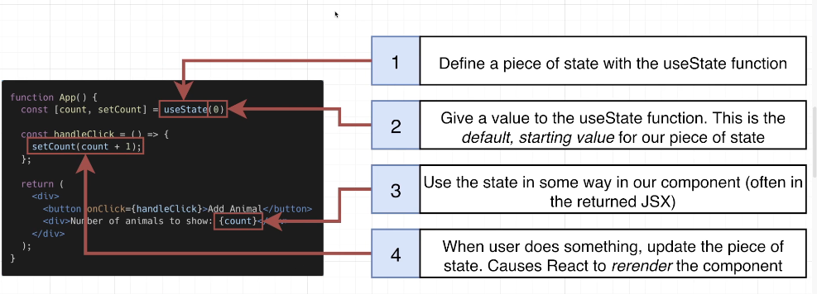

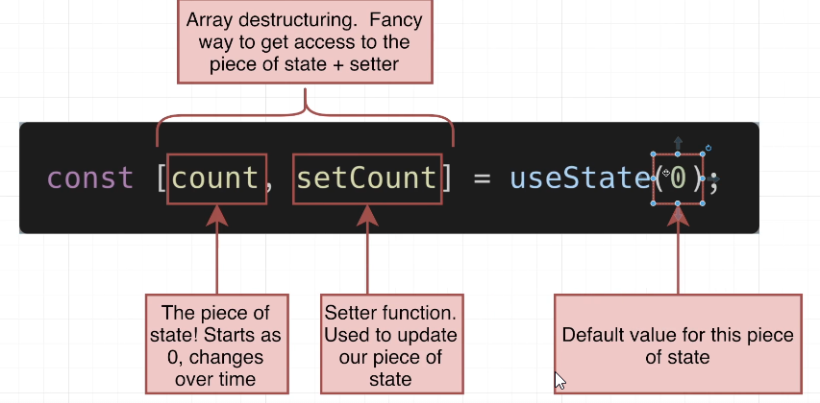

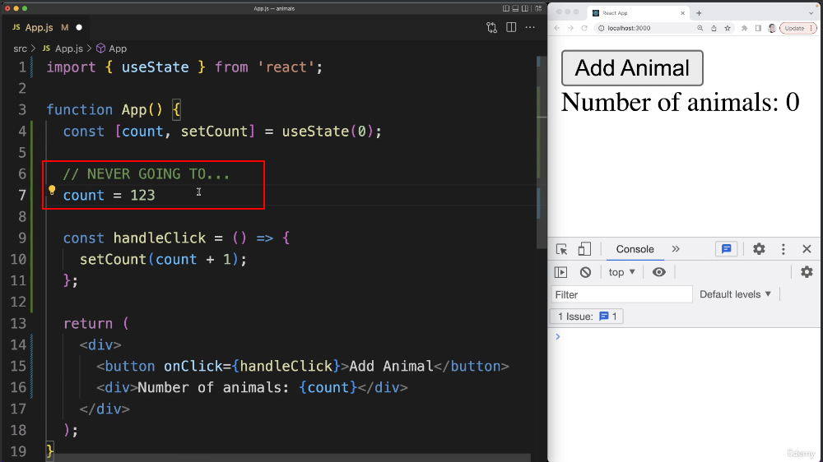

## 48. Understanding the Re-Rendering Process

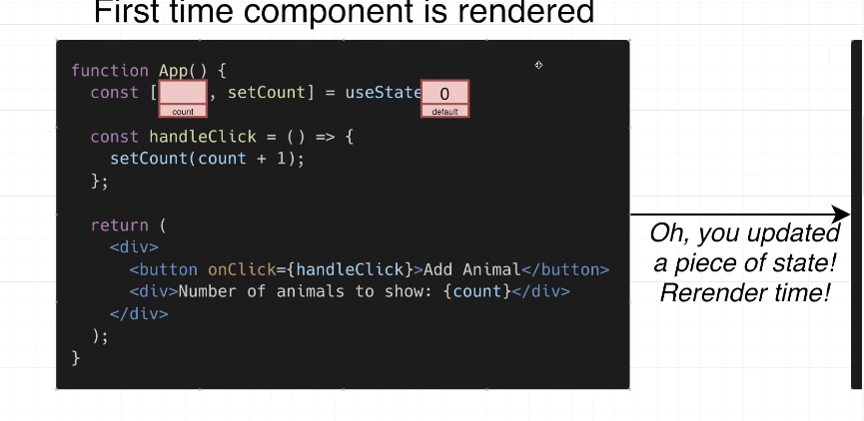

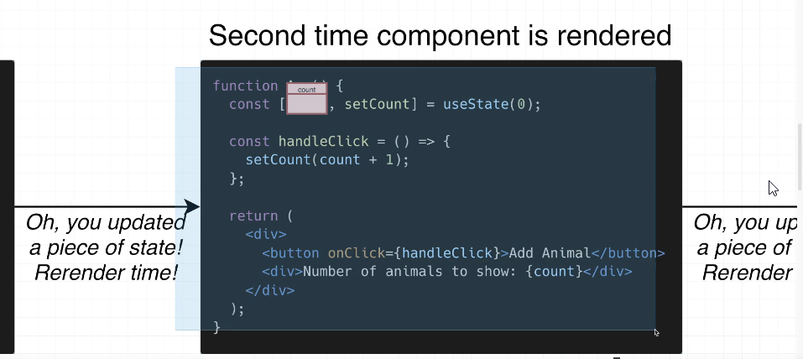

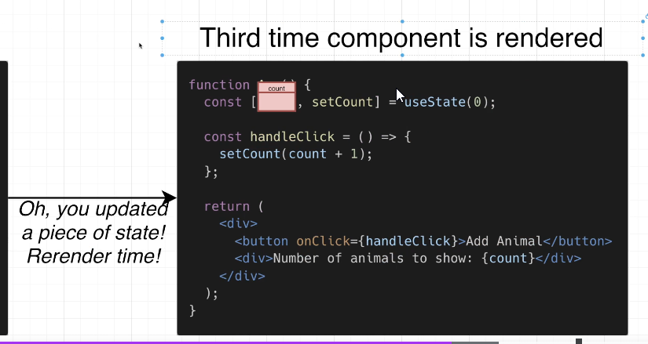

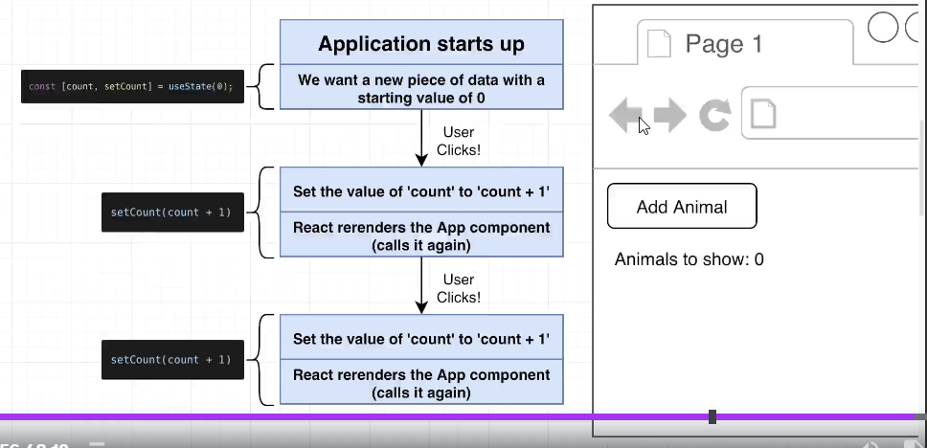

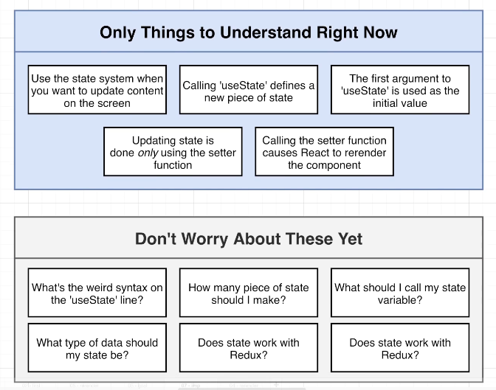

## 49. Why Array Destructuring?

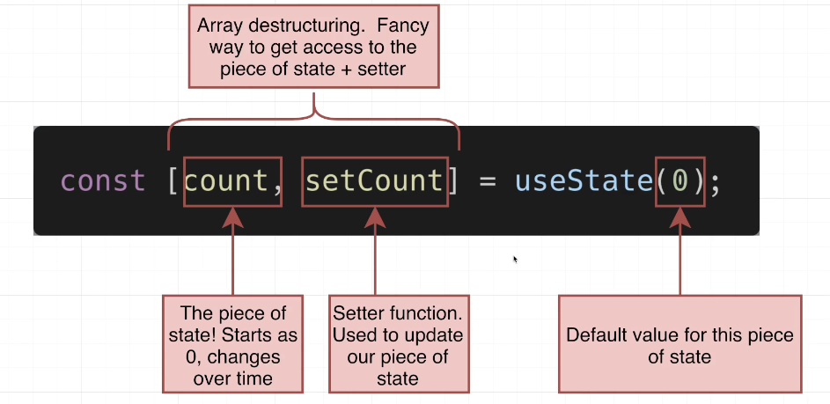

function App() {

  function makeArray(){

    return [1, 10, 32,40];

  }

  const myArray = makeArray();

  const firstElement1 = myArray[0];

  const secondElement1 = myArray[1];

  console.log(firstElement1, secondElement1);

  // Array Desctructing

  const [firstElement2, secondElement2] = makeArray();

  console.log(firstElement2, secondElement2);

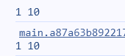

 console.log(useState(50));

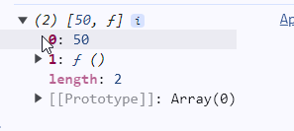

useState implementation is as follows:

function useState(defaultValue) {

  return {

    yourState: defaultValue,

    yourSetter: () => {}

  };

}

Variable declaration and usage of useState function is as follows:

function App() {

  const stageConfig = useState(0);

  const count = stageConfig.yourState;

  const setCount = stageConfig.yourSetter;

object destruction style is same with previous style, but it is style longer

const {yourState: count, yourSetter: setCount} = useState(0);

array destruction style is the shortest way to using state

import { useState } from "react";

function App() {

  const [count, setCount] = useState(0);

## 50. Back to the App

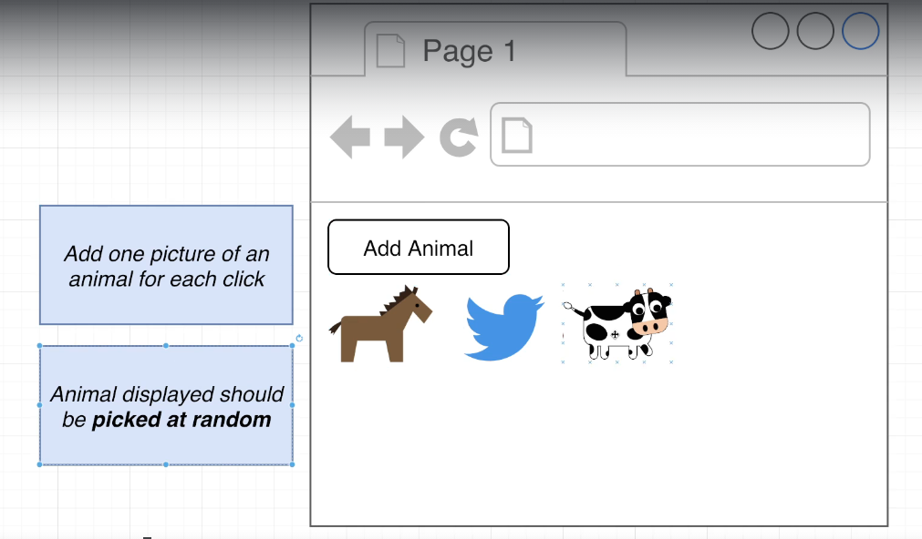

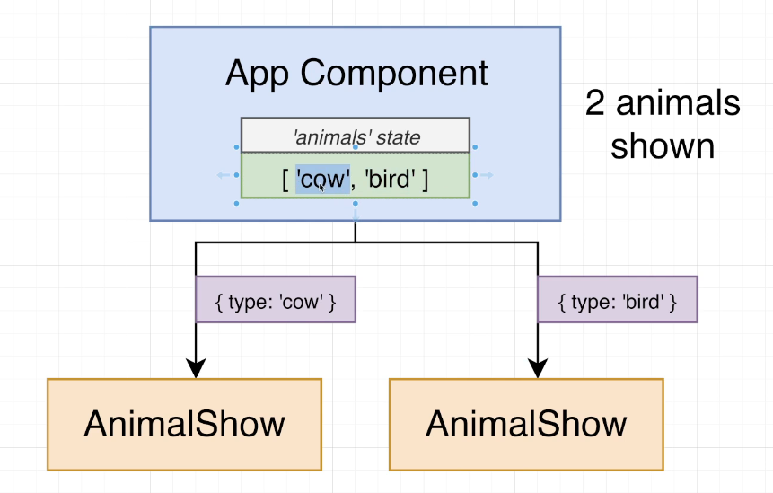

## 51. Picking a Random Element

App.js

function getRandomAnimal() {

  const animals = ["bird", "cat", "cow", "dog", "gator", "horse"];

  return animals[Math.floor(Math.random() * animals.length)];

}

function App() {

  const [animals, setAnimals] = useState([]);

  const handleClick = () => {

     setAnimals([...animals, getRandomAnimal()]);

  };

## 52. List Building in React

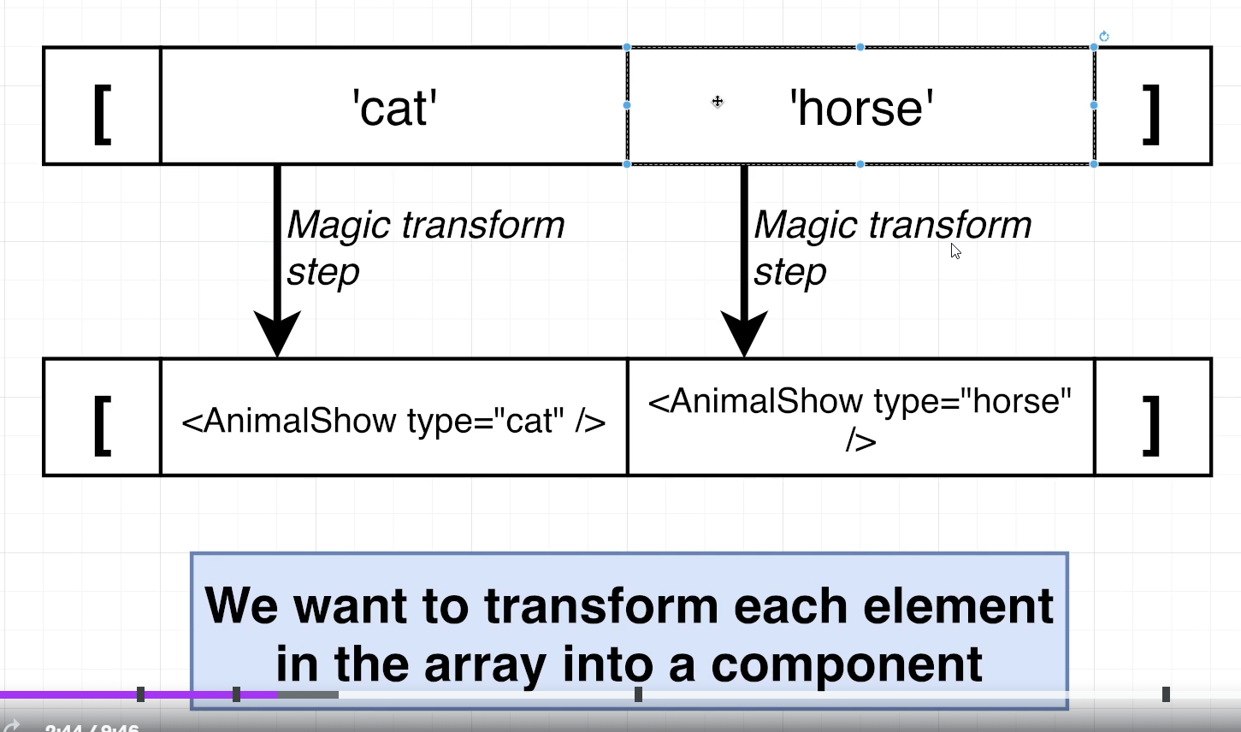

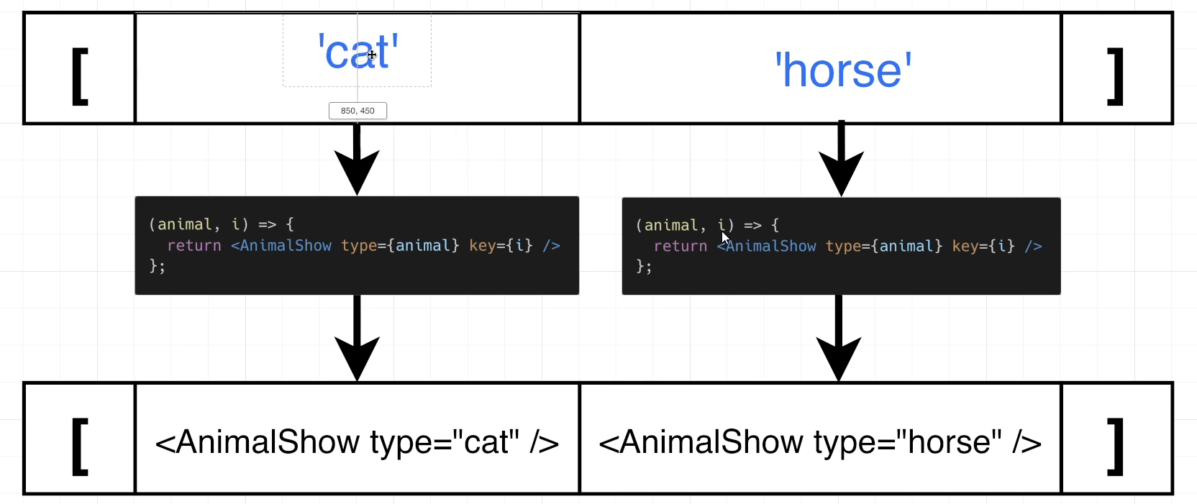

## 53. Images for the App

## 54. Loading and Showing SVGs

AnimalShow.js

import bird from "./svg/bird.svg";

import cat from "./svg/cat.svg";

import cow from "./svg/cow.svg";

import dog from "./svg/dog.svg";

import gator from "./svg/gator.svg";

import heart from "./svg/heart.svg";

import horse from "./svg/horse.svg";

const svgMap = {

  bird,

  cat,

  cow,

  dog,

  gator,

  horse,

};

function AnimalShow({ type }) {

  return (

    <div>

      <img alt="animal" src={svgMap[type]} />

    </div>

  );

}

export default AnimalShow;

## 55. Increasing Image Size

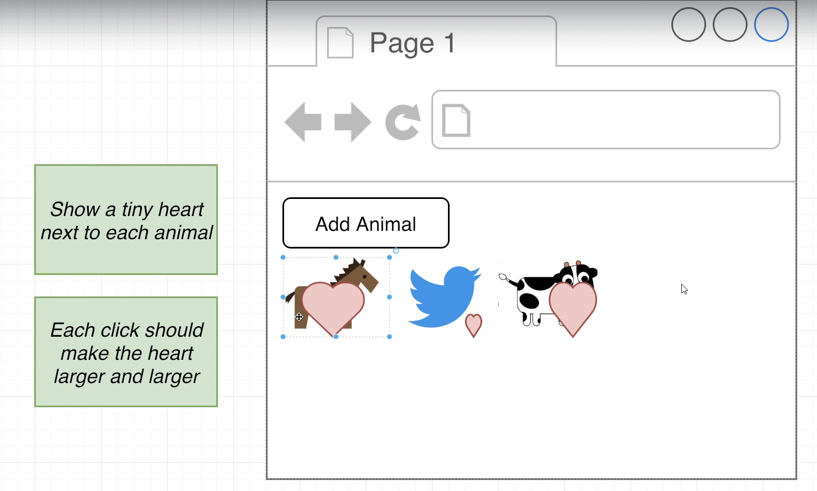

AnimalShow.js

import { useState } from "react";

import bird from "./svg/bird.svg";

import cat from "./svg/cat.svg";

import cow from "./svg/cow.svg";

import dog from "./svg/dog.svg";

import gator from "./svg/gator.svg";

import heart from "./svg/heart.svg";

import horse from "./svg/horse.svg";

const svgMap = {

  bird,

  cat,

  cow,

  dog,

  gator,

  horse,

};

function AnimalShow({ type }) {

    const [clicks, setClicks] = useState(0);

  function handleClick() {

     setClicks(clicks + 1);

  }

  return (

    <div onClick={handleClick}>

      <img alt="animal" src={svgMap[type]} />

      <img

        alt="heart"

        src={heart}

        style={{width: 10 + 10 * clicks + 'px'}}

      />

    </div>

  );

}

export default AnimalShow;

## 56. Adding Custom CSS

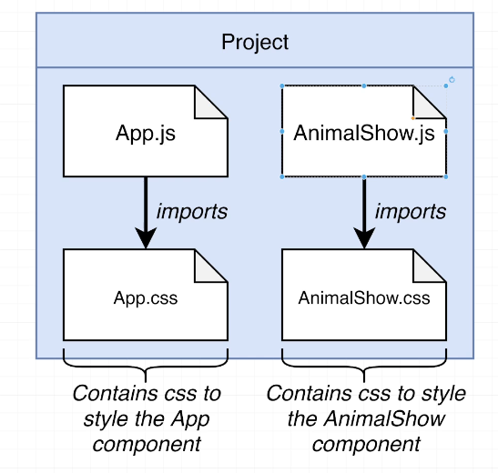

## 57. Finalizing Styling

AnimalShow.js

import './AnimalShow.css';

import { useState } from "react";

import bird from "./svg/bird.svg";

import cat from "./svg/cat.svg";

import cow from "./svg/cow.svg";

import dog from "./svg/dog.svg";

import gator from "./svg/gator.svg";

import heart from "./svg/heart.svg";

import horse from "./svg/horse.svg";

const svgMap = {

  bird,

  cat,

  cow,

  dog,

  gator,

  horse,

};

function AnimalShow({ type }) {

    const [clicks, setClicks] = useState(0);

  function handleClick() {

     setClicks(clicks + 1);

  }

  return (

    <div className="animal-show" onClick={handleClick}>

      <img className='animal' alt="animal" src={svgMap[type]} />

      <img className='heart'

        alt="heart"

        src={heart}

        style={{width: 10 + 10 * clicks + 'px'}}

      />

    </div>

  );

}

export default AnimalShow;

App.js

import "./App.css";

import { useState } from "react";

import AnimalShow from "./AnimalShow";

function getRandomAnimal() {

  const animals = ["bird", "cat", "cow", "dog", "gator", "horse"];

  return animals[Math.floor(Math.random() * animals.length)];

}

function App() {

  const [animals, setAnimals] = useState([]);

  const handleClick = () => {

     setAnimals([...animals, getRandomAnimal()]);

  };

  const renderedAnimals = animals.map((animal, index) => {

    return <AnimalShow key={index} type={animal} />

  })

  return (

    <div className="app">

      <button onClick={handleClick}>Add Animal</button>

      <div className="animal-list">{renderedAnimals}</div>

    </div>

  );

}

export default App;

## 58. App Wrapup and Review

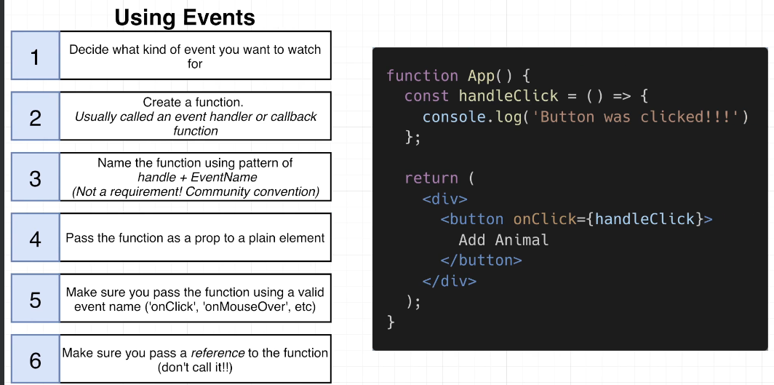

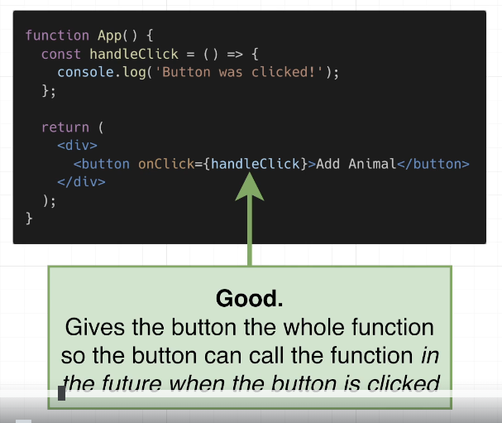

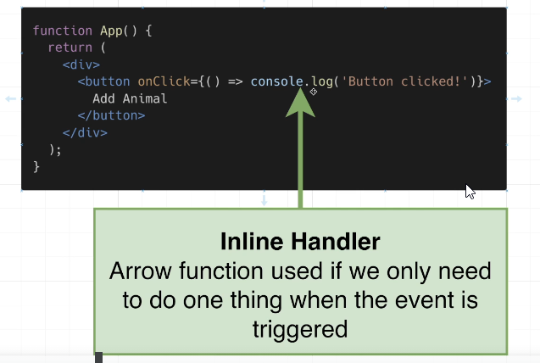

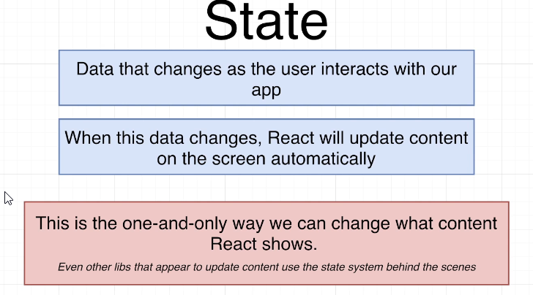

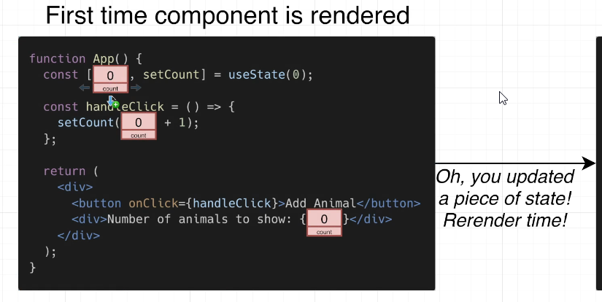

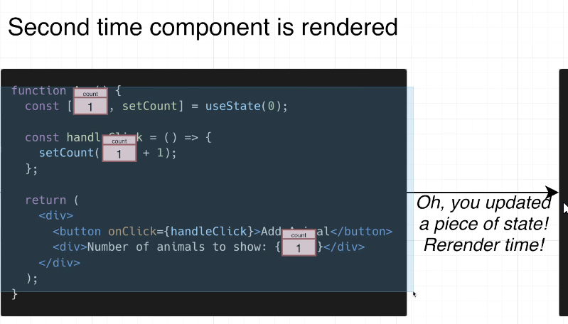

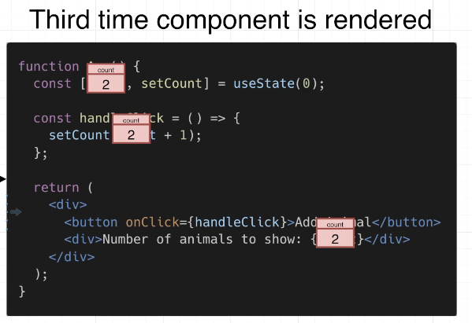

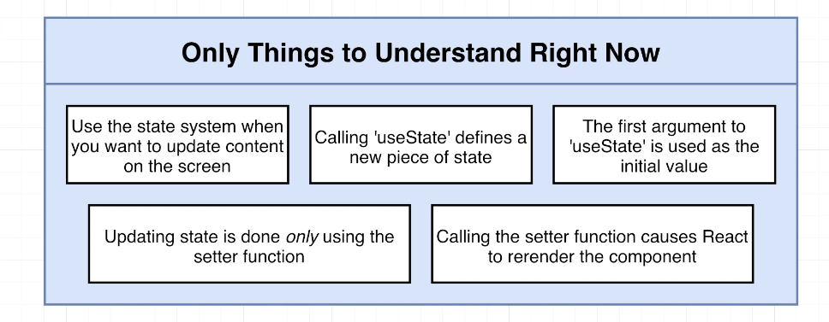

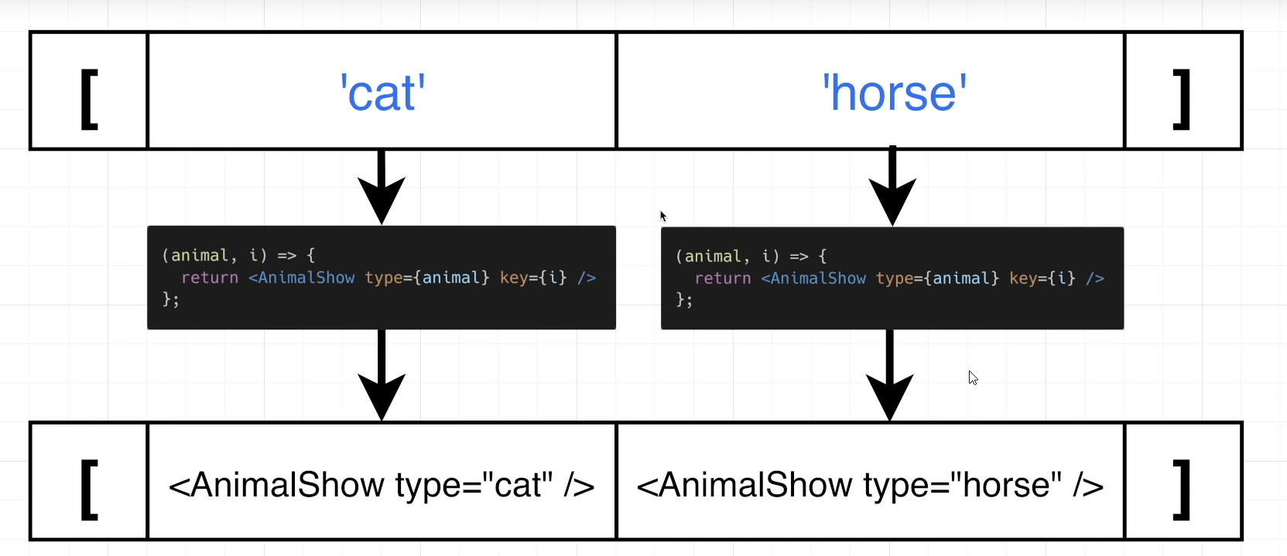

# Section 5: Using an API with React

## 59. App Overview

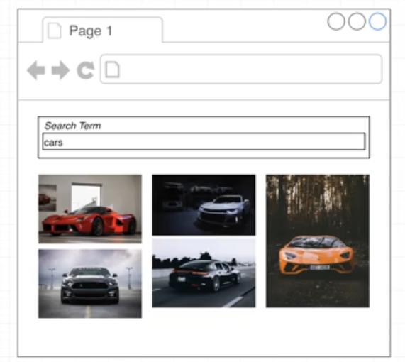

npx create-react-app 04pics

cd 04pics

npm start

## 60. Project Setup

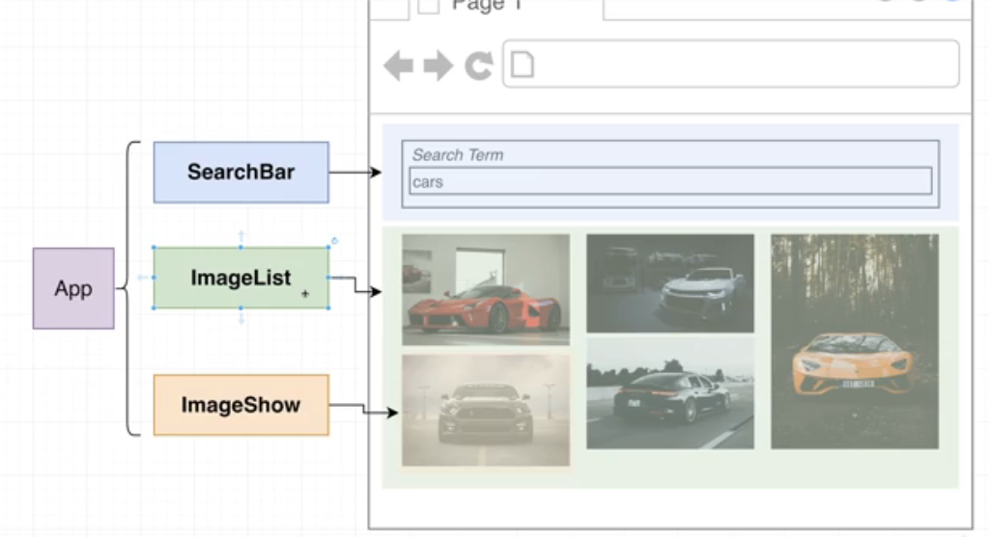

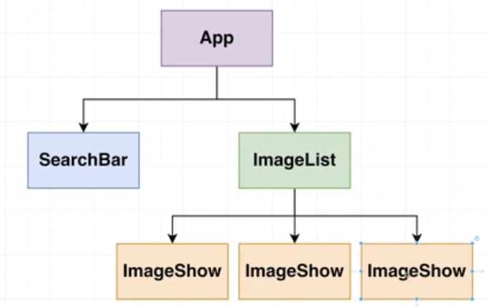

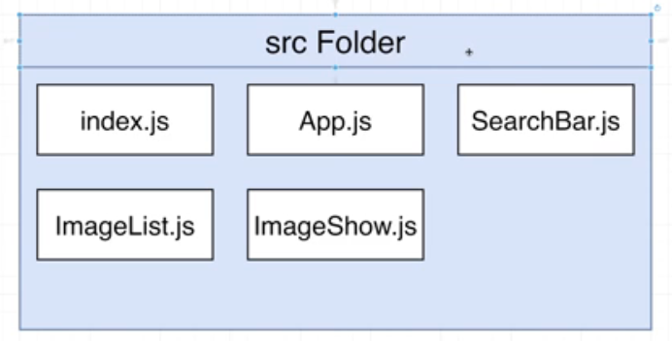

## 61. The Path Forward

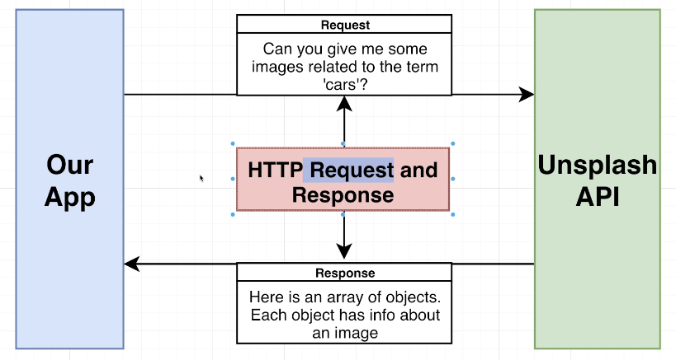

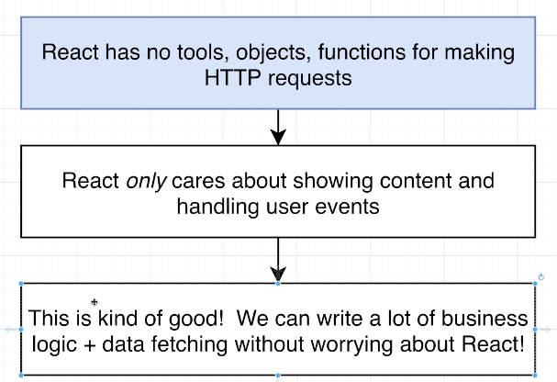

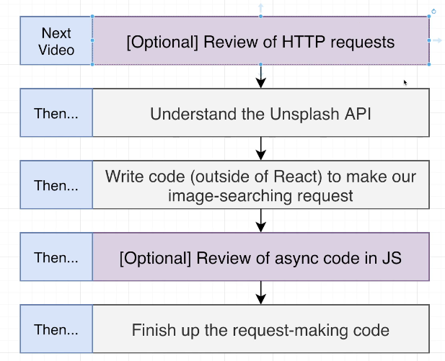

## 62. Overview of HTTP Requests

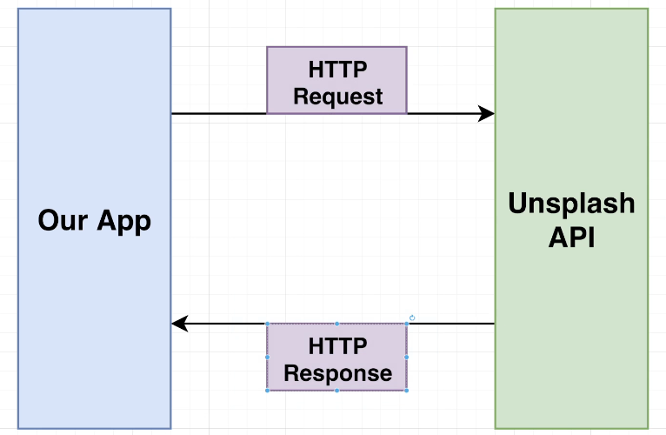

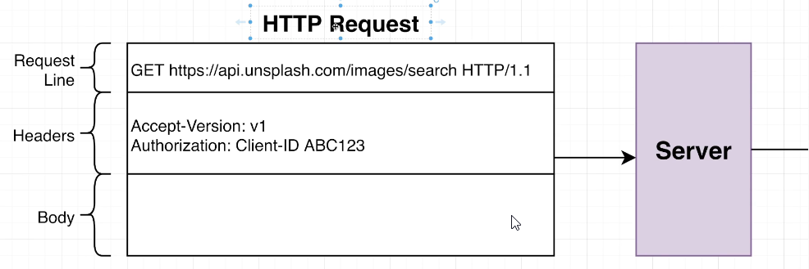

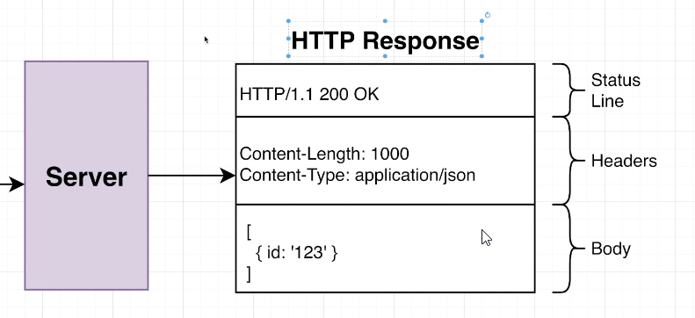

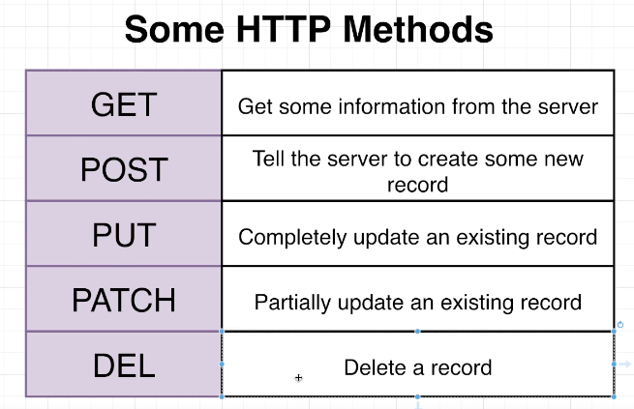

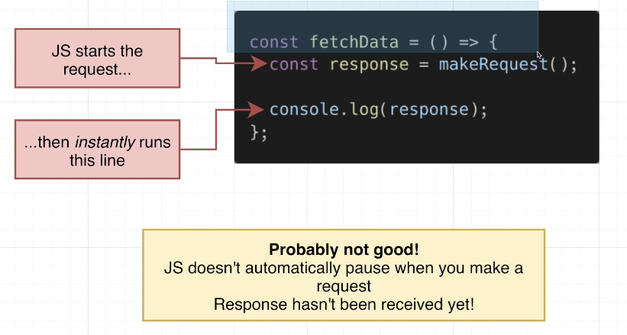

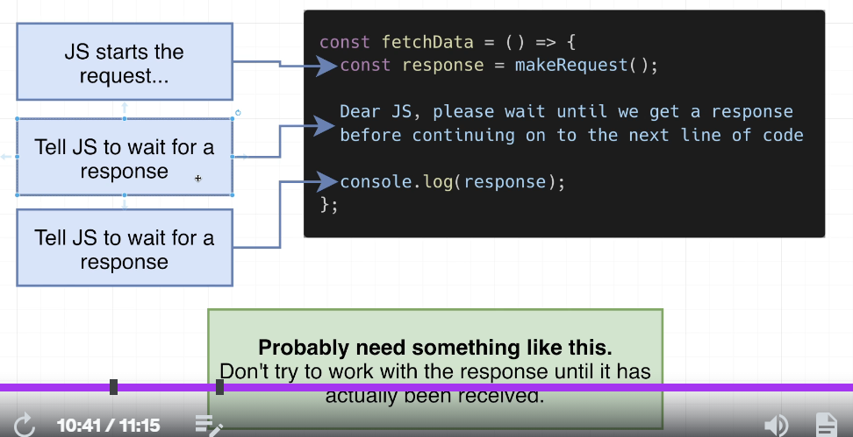

## 63. Note About the Unsplash API

## 64. Understanding the API

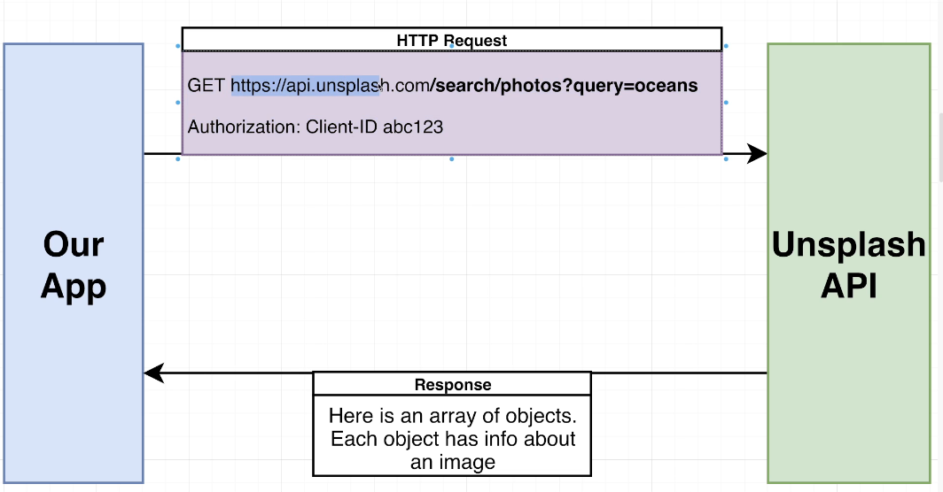

## 65. Making an HTTP Request

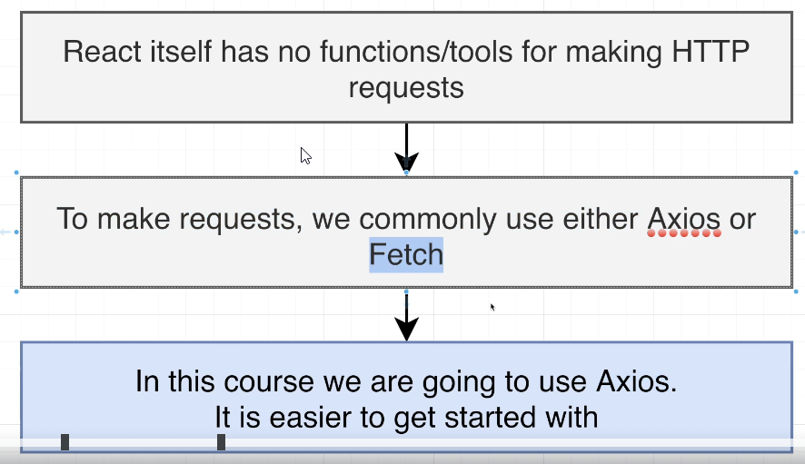

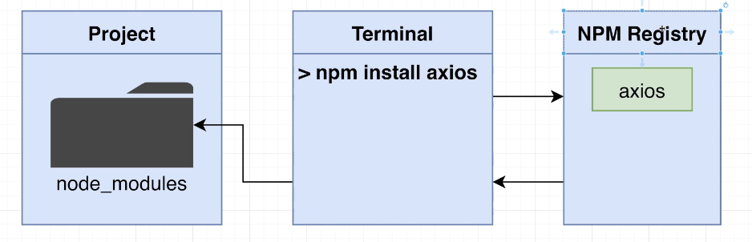

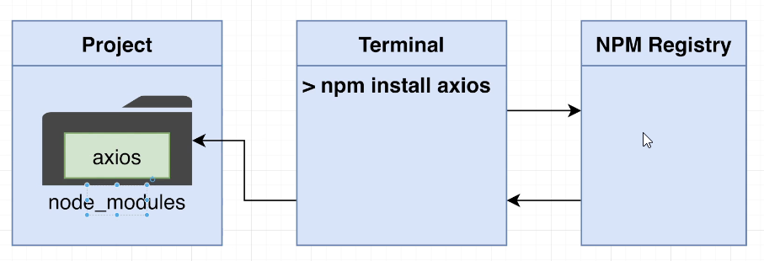

npm install axios

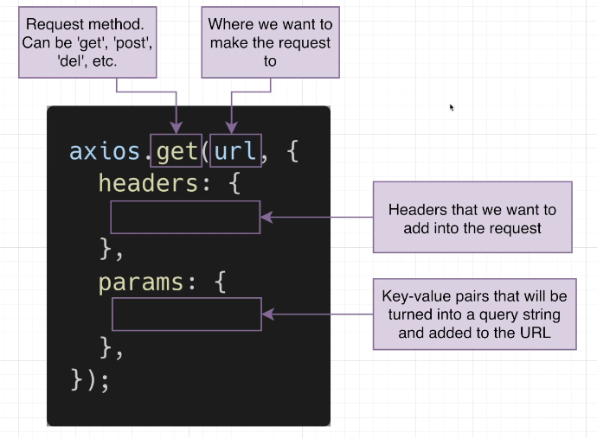

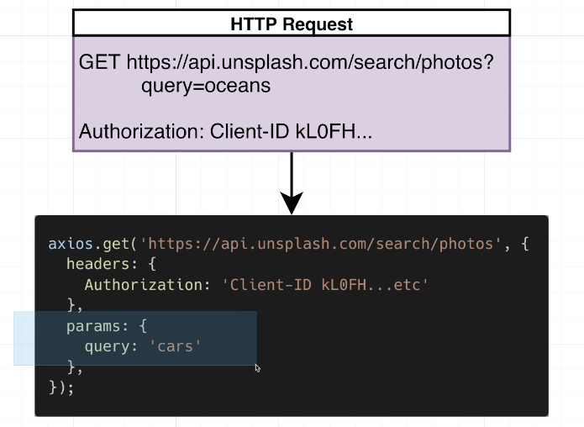

api.js

import axios from "axios";

const searchImages = async () => {

  const response = await axios.get("https://api.unsplash.com/search/photos", {

    headers: {

      Authorization:

        "Client-ID dba28937347d88249d994981b554ecc4d4b2b770ade79a0419adcb2823f744e4",

    },

    params: {

      query: "cars",

    },

  });

  console.log('response', response);

  return response

};

export default searchImages;

## 65. [Optional] Using Async:Await

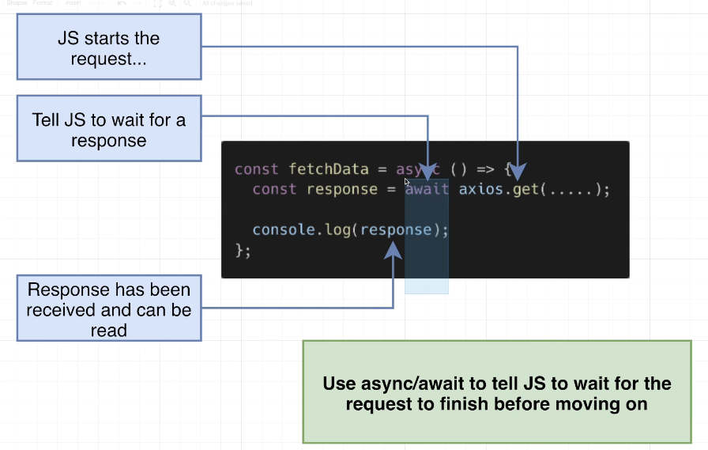

## 67. Data Fetching Cleanup

Api.js

import axios from "axios";

const searchImages = async (term) => {

  const response = await axios.get("https://api.unsplash.com/search/photos", {

    headers: {

      Authorization:

        "Client-ID dba28937347d88249d994981b554ecc4d4b2b770ade79a0419adcb2823f744e4",

    },

    params: {

      query: term,

    },

  });

  return response.data.results;

};

export default searchImages;

## 68. Thinking About Data Flow

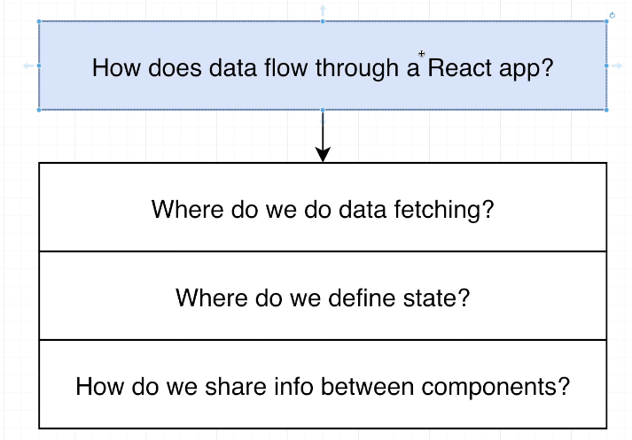

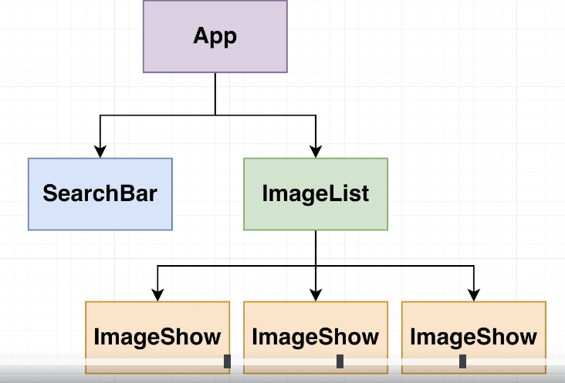 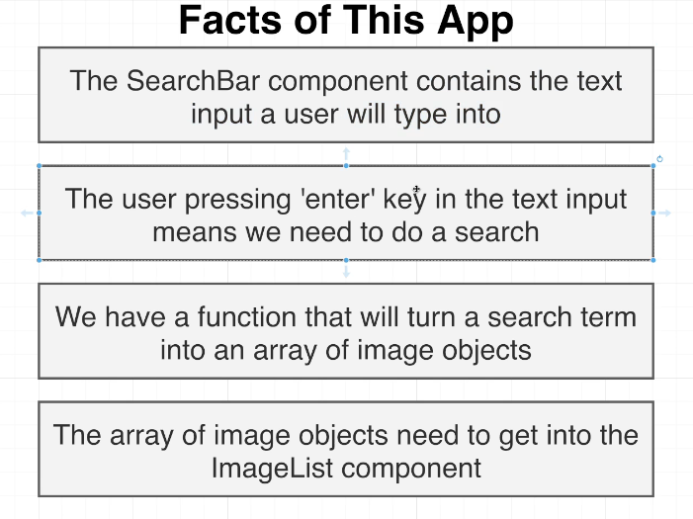

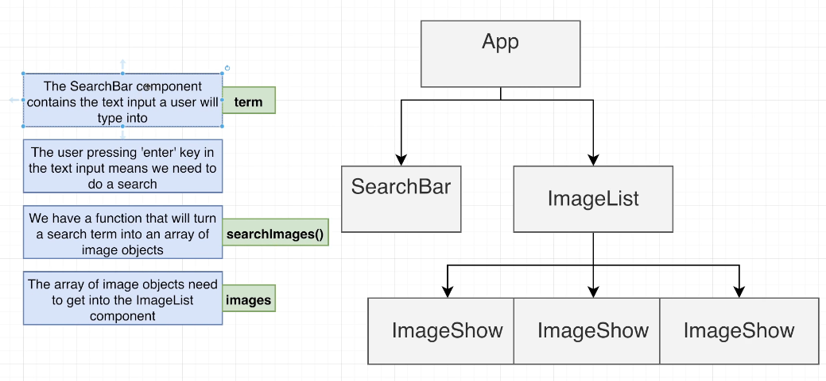

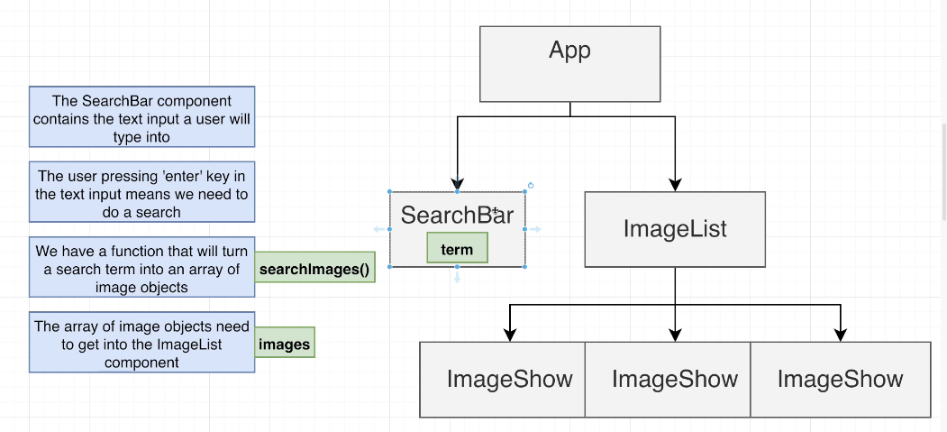

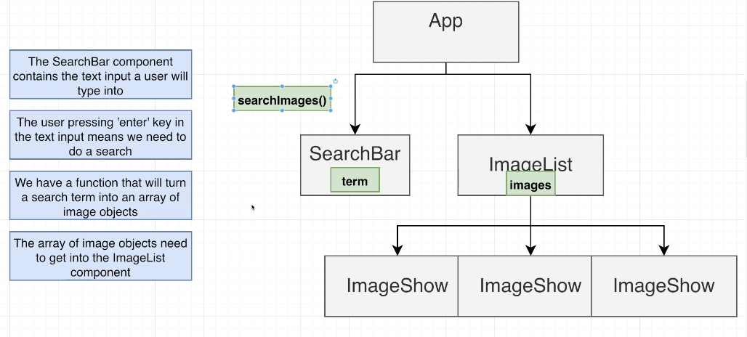

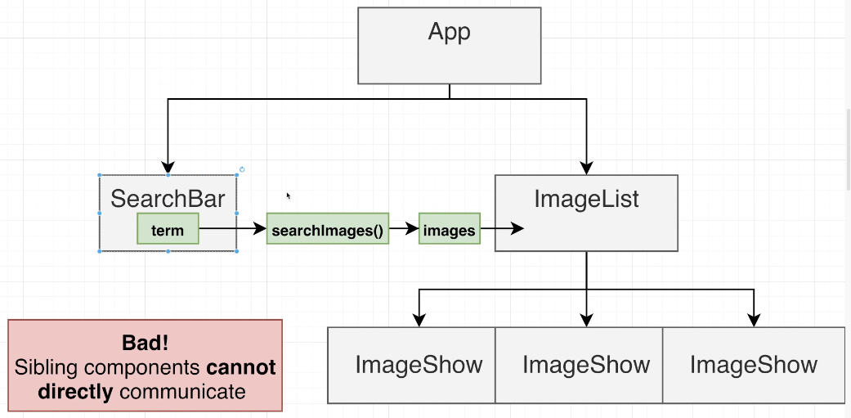

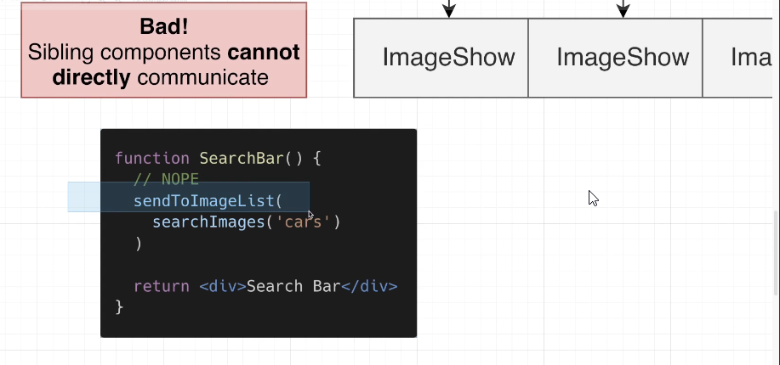

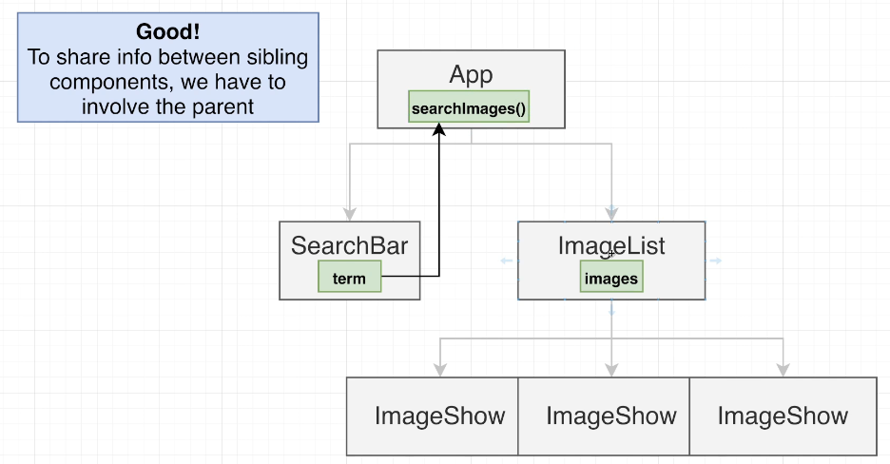

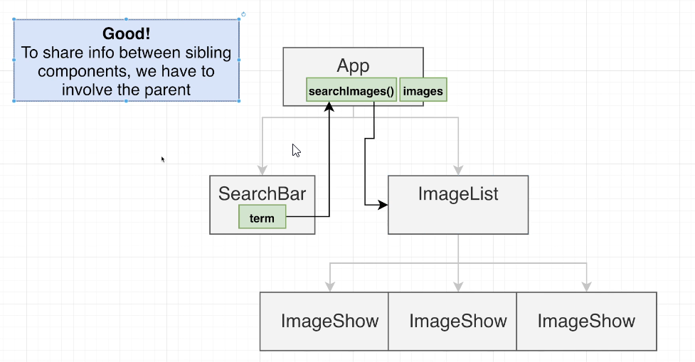

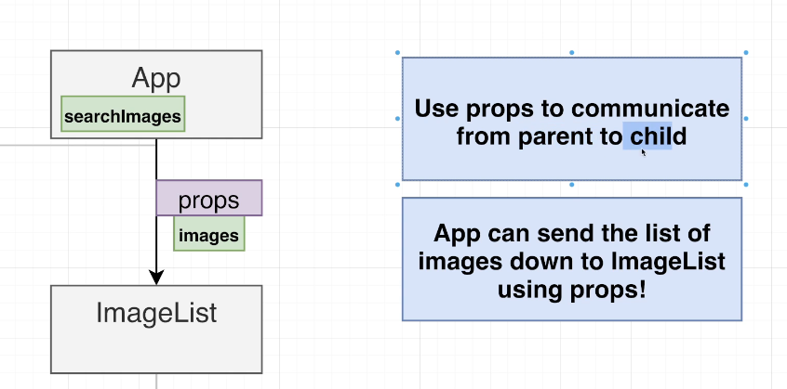

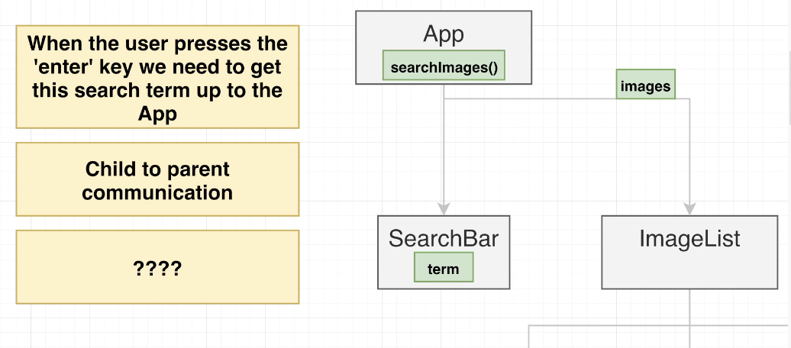

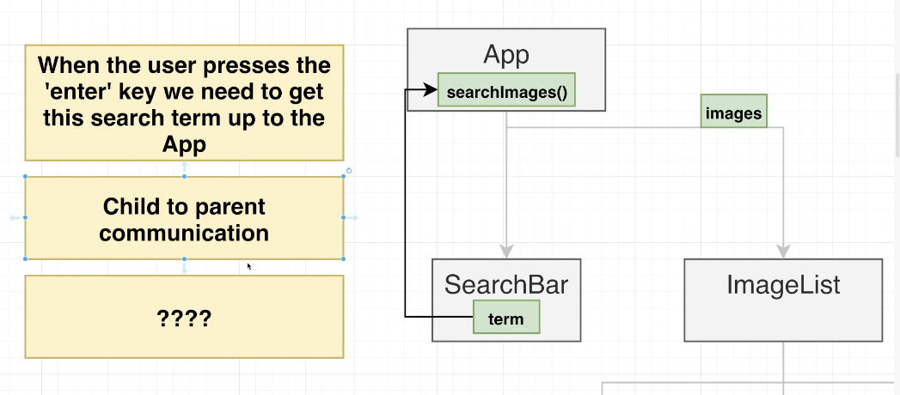

## 69. Child to Parent Communication

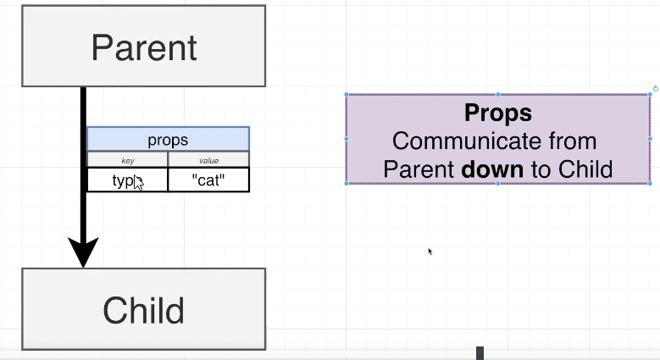

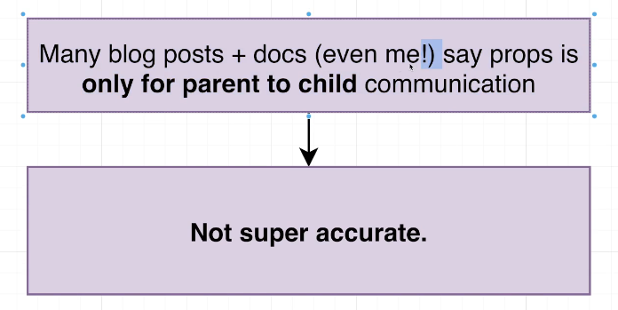

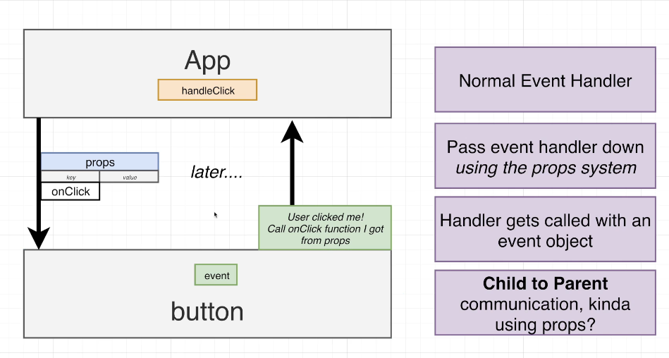

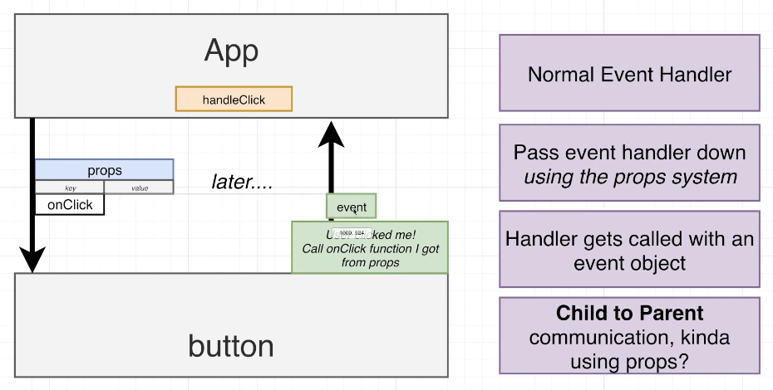

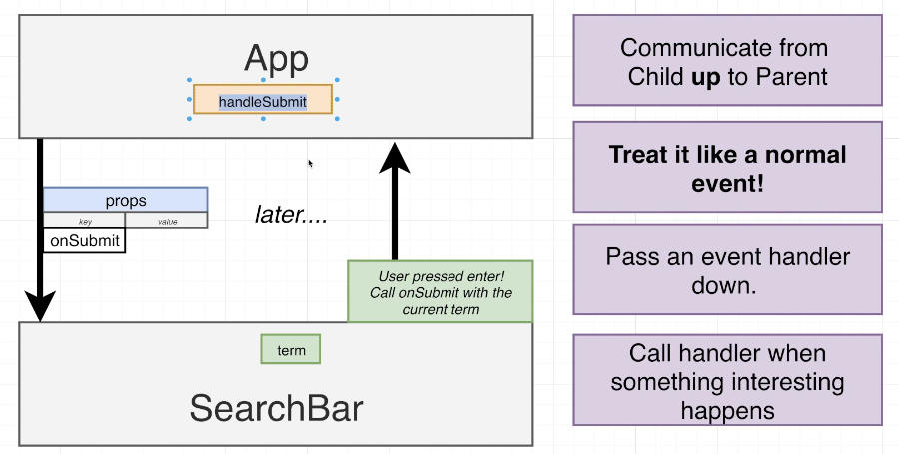

## 70. Implementing Child to Parent Communication

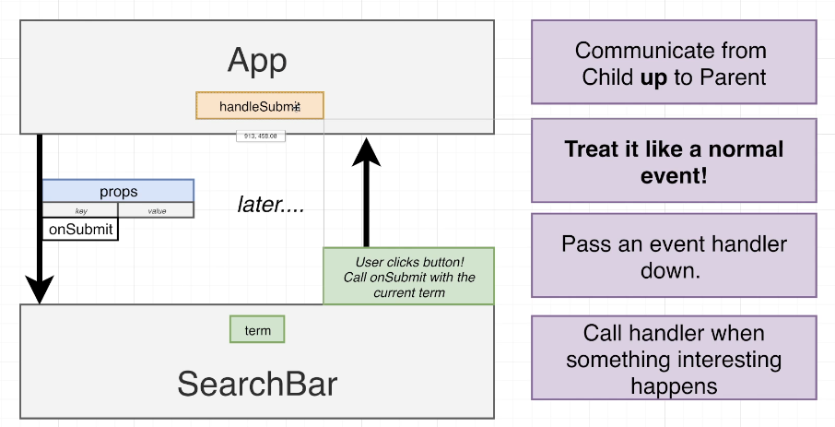

## 71. Handling Form Submission

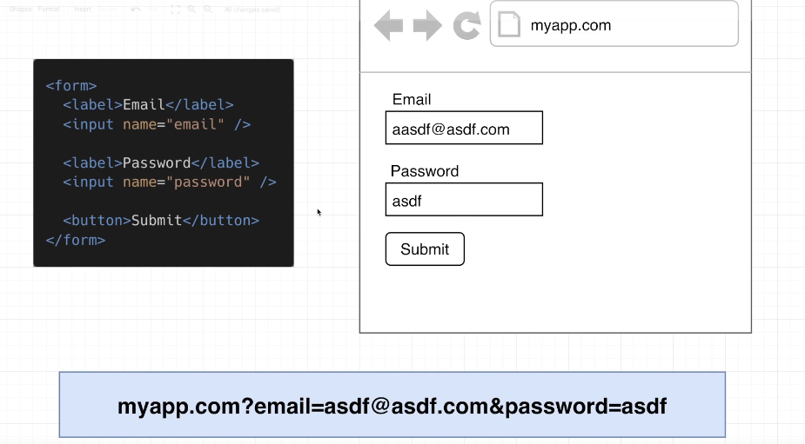

## 72. Handling Input Elements

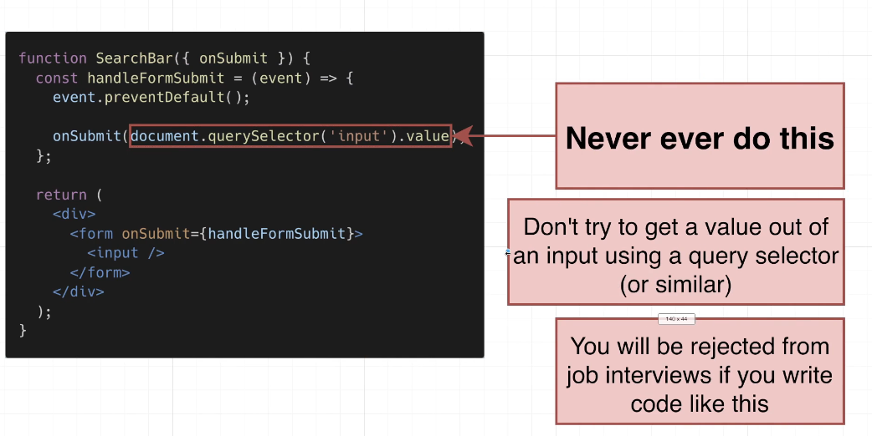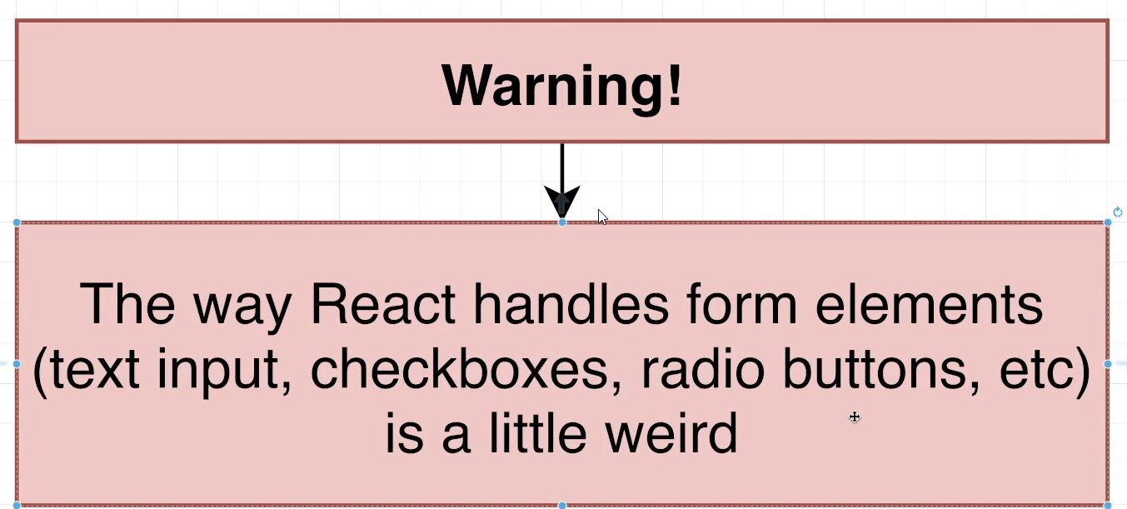

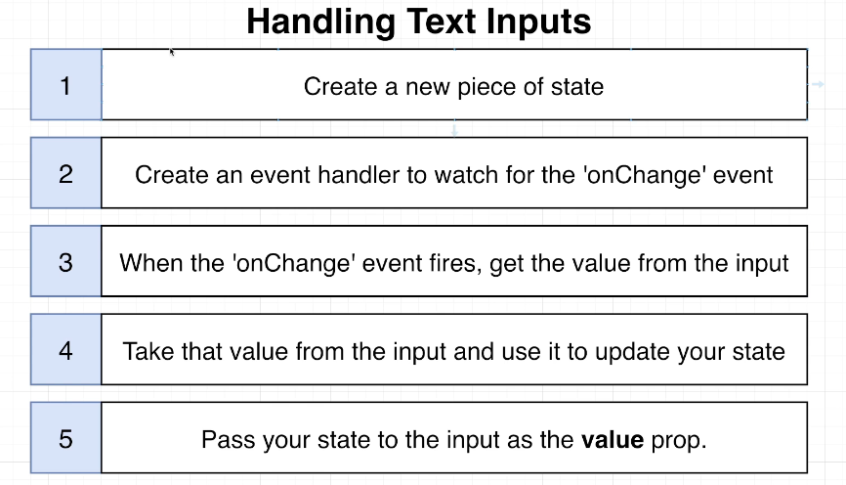

import { useState } from "react";

function SearchBar({ onSubmit }) {

  const [term, setTerm] = useState('');

  const handleFormSubmit = (event) => {

    event.preventDefault();

    onSubmit("cars");

  };

  const handleChange = (event) => {

    setTerm(event.target.value);

  };

  return (

    <div>

      <form onSubmit={handleFormSubmit}>

        <input value={term} onChange={handleChange} />

      </form>

    </div>

  );

}

export default SearchBar;

## 73. [Optional] OK But Why?

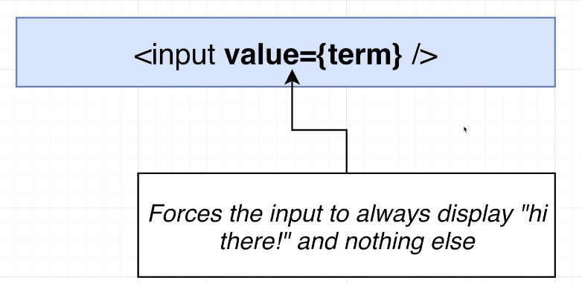

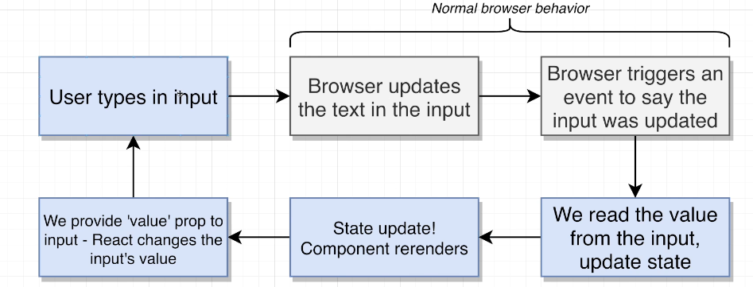

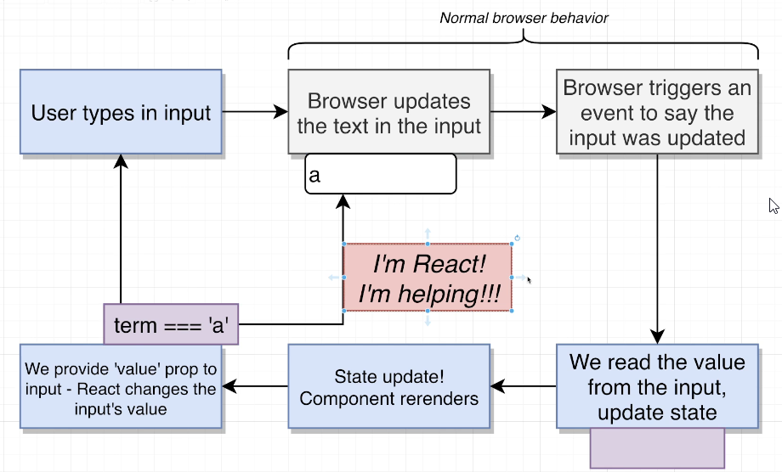

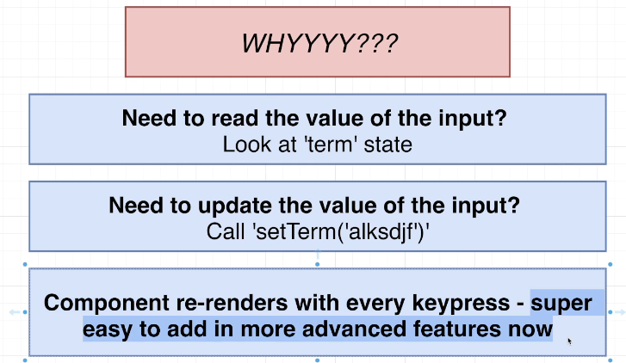

## Coding Exercise 5: Creating a Controlled Input

## 74. Exercise Solution

import React from 'react';

function App() {

    const [term, setTerm] = useState('');

    const handleChange = (event) => {

        setTerm(event.target.value);

    };

    return (

        <div>

          <div>

            Enter some text

          </div>

          <input value={term} onChange={handleChange} />

          <h3>Your Text</h3>

          <p>

            {term}

          </p>

        </div>

    );

}

const useState = React.useState;

export default App;

## 75. Running the Search

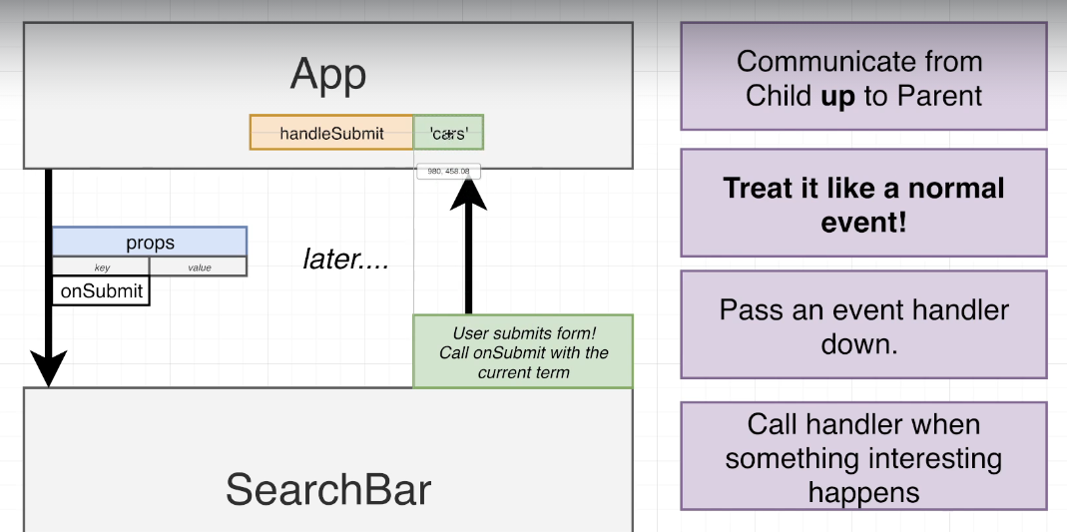

## 76. Reminder on Async:Await

## 77. Communicating the List of Images Down

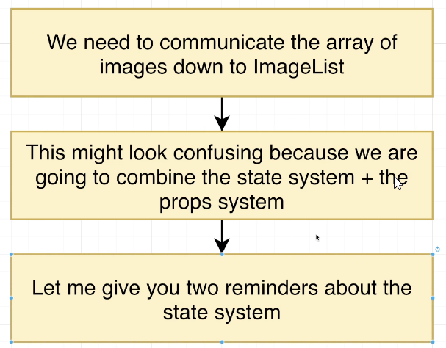

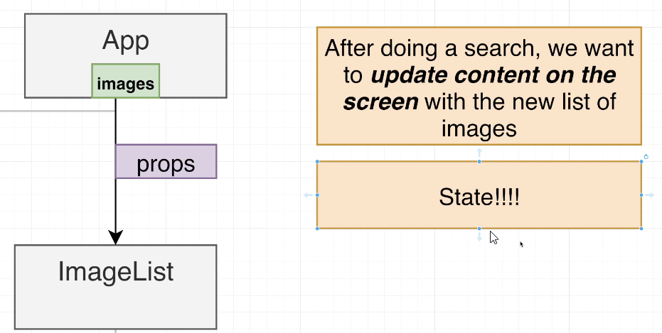

## 78. Building a List of Images

## 79. Handling List Updates

## 80. Notes on Keys

## 81. Displaying Images

## 82. A Touch of Styling

## 83. App Wrapup

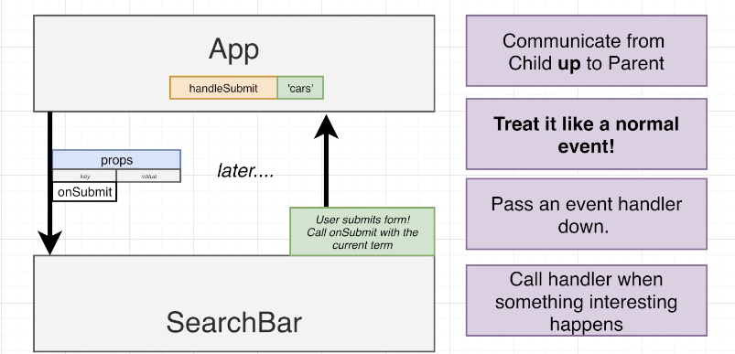

Index.js

import React from 'react';

import ReactDOM from 'react-dom/client';

import App from './App';

const el = document.getElementById('root');

const root = ReactDOM.createRoot(el);

root.render(<App />);

App.js

import { useState } from 'react';

import SearchBar from './components/SearchBar';

import ImageList from './components/ImageList';

import searchImages from './api';

function App() {

  const [images, setImages] = useState([]);

  const handleSubmit = async (term) => {

    console.log('Do a search with', term);

    const result = await searchImages(term);

    console.log(result);

    setImages(result);

  };

  return (

    <div>

      <SearchBar onSubmit={handleSubmit} />

      <ImageList images={images} />

    </div>

  );

}

export default App;

api.js

import axios from "axios";

const searchImages = async (term) => {

  const response = await axios.get("https://api.unsplash.com/search/photos", {

    headers: {

      Authorization:

        "Client-ID dba28937347d88249d994981b554ecc4d4b2b770ade79a0419adcb2823f744e4",

    },

    params: {

      query: term,

    },

  });

  return response.data.results;

};

export default searchImages;

SearchBar.js

import './SearchBar.css';

import { useState } from 'react';

function SearchBar({ onSubmit }) {

  const [term, setTerm] = useState('');

  const handleFormSubmit = (event) => {

    event.preventDefault();

    onSubmit(term);

  };

  const handleChange = (event) => {

    setTerm(event.target.value);

  };

  return (

    <div className="search-bar">

      <form onSubmit={handleFormSubmit}>

        <label>Enter Search Term</label>

        <input value={term} onChange={handleChange} />

      </form>

    </div>

  );

}

export default SearchBar;

ImageList.js

import './ImageList.css';

import ImageShow from './ImageShow';

function ImageList({ images }) {

  const renderedImages = images.map((image) => {

    return <ImageShow key={image.id} image={image} />;

  });

  return <div className="image-list">{renderedImages}</div>;

}

export default ImageList;

ImageShow.js

function ImageShow({ image }) {

    return (

      <div>

        <img src={image.urls.small} alt={image.alt_description} />

      </div>

    );

  }

  export default ImageShow;

# Section 6: How to Handle Forms

## 84. App Overview

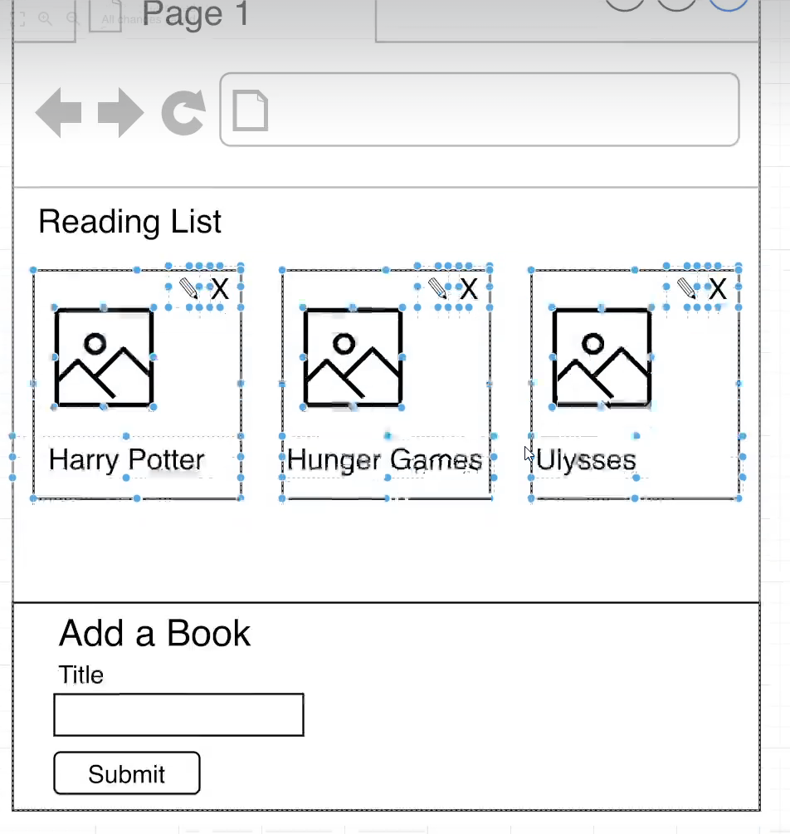

npx create-react-app books

npm start

## 85. Initial Setup

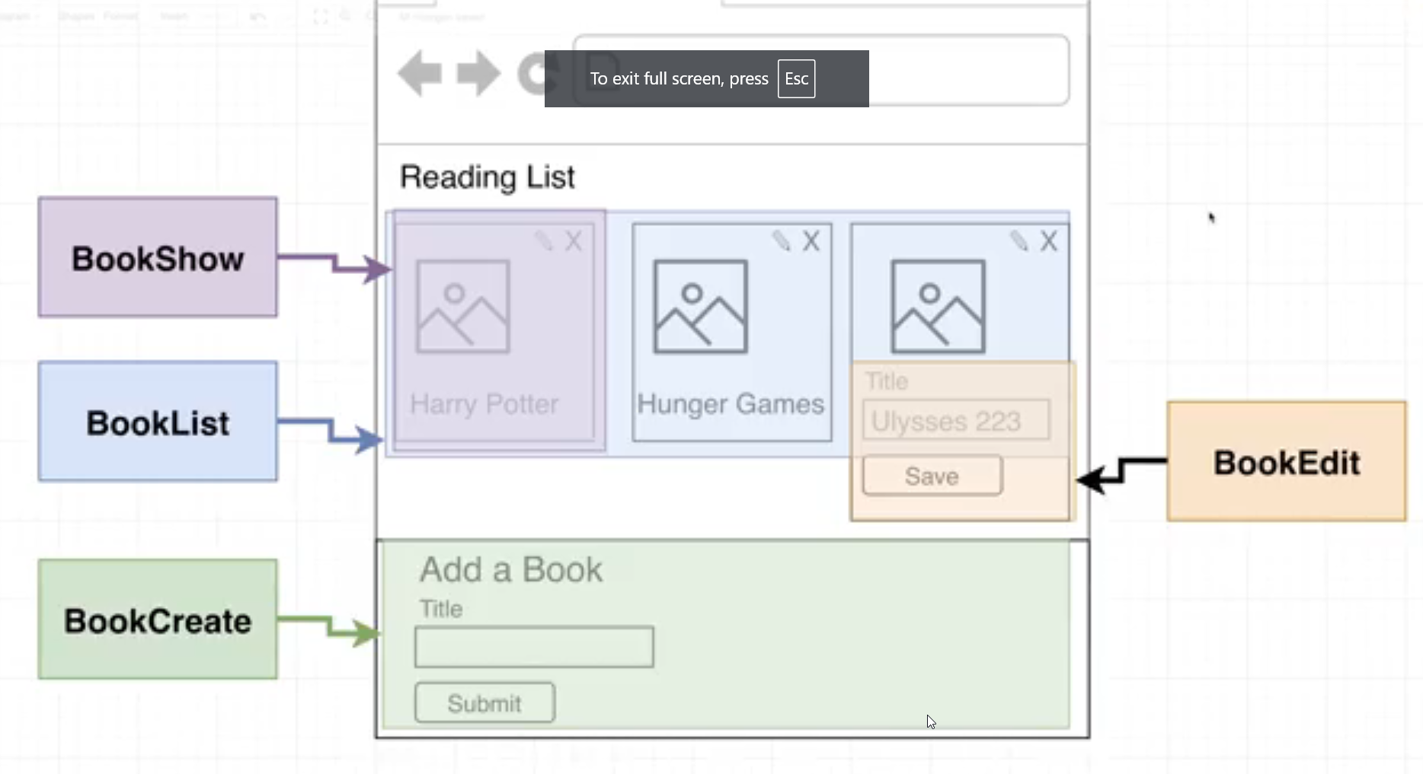

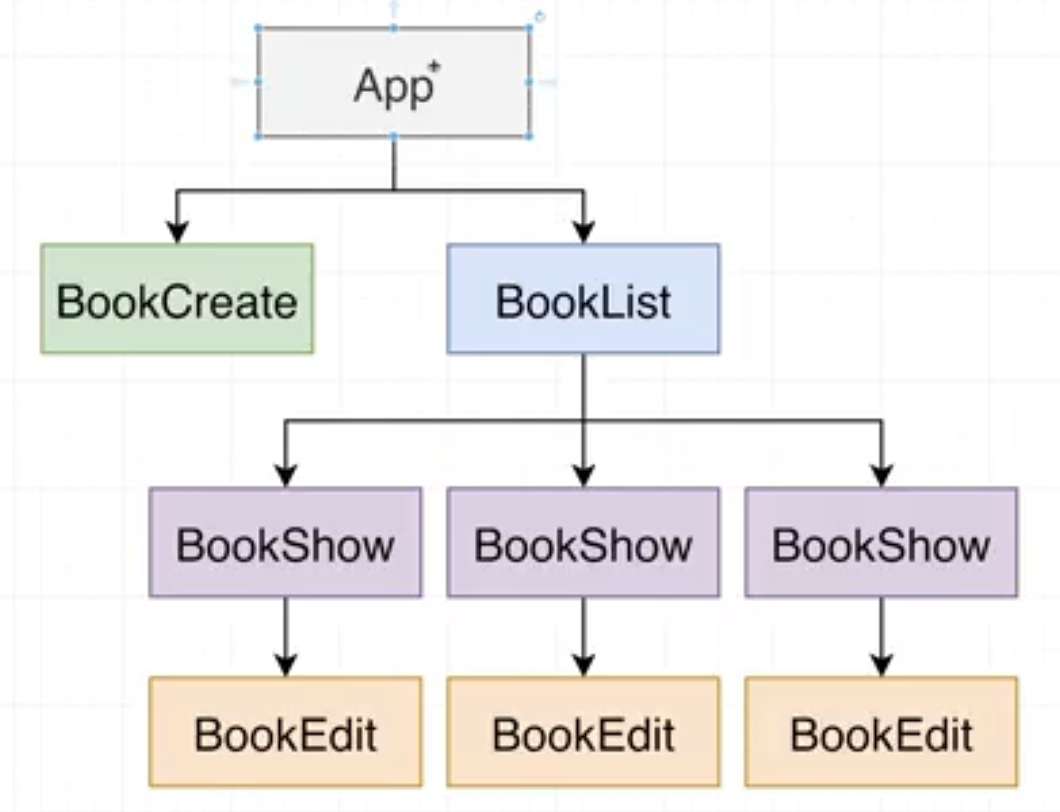

## 86. State Location

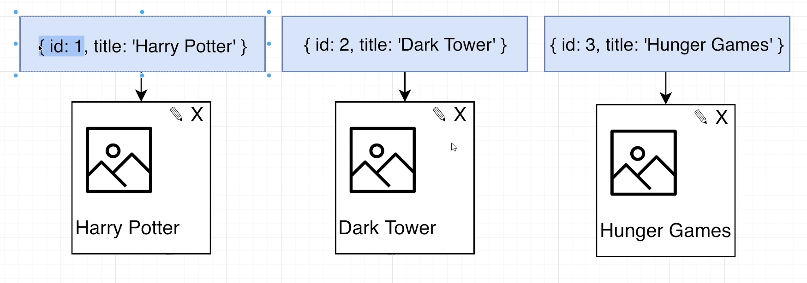

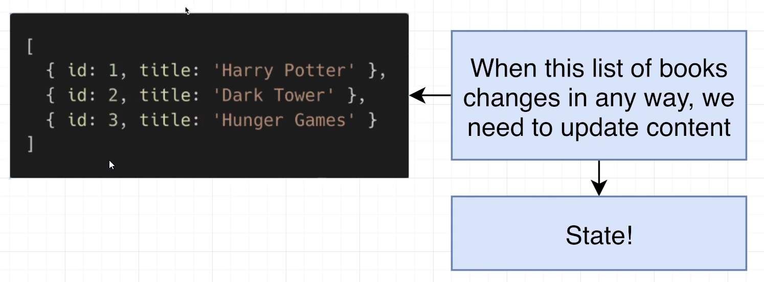

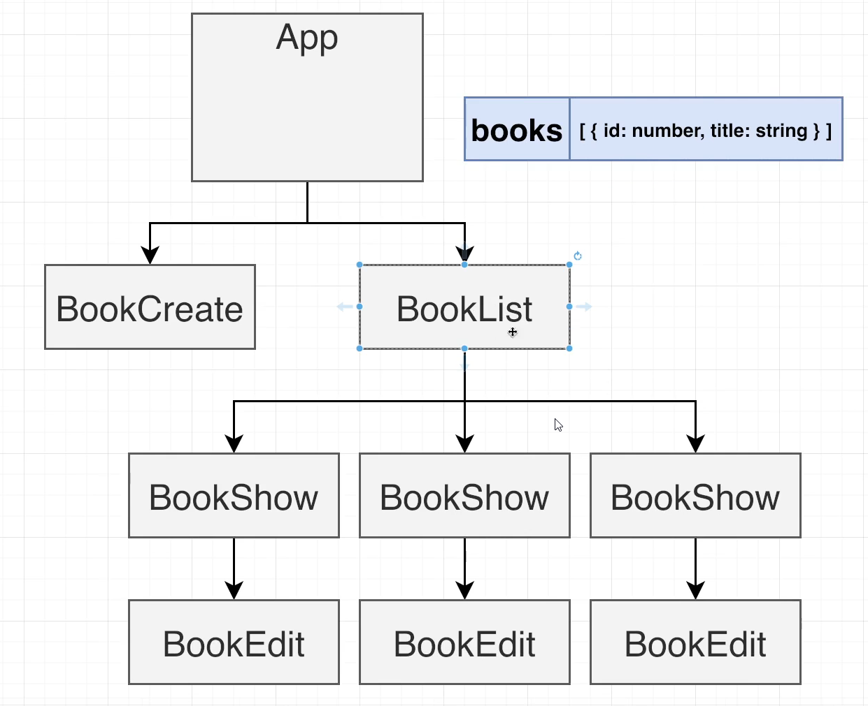

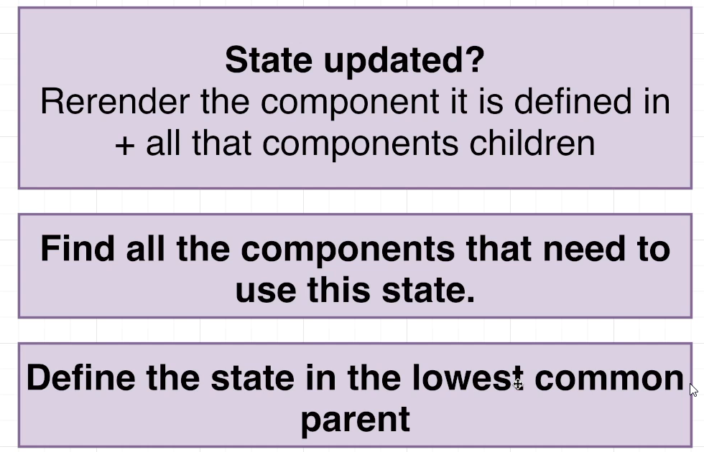

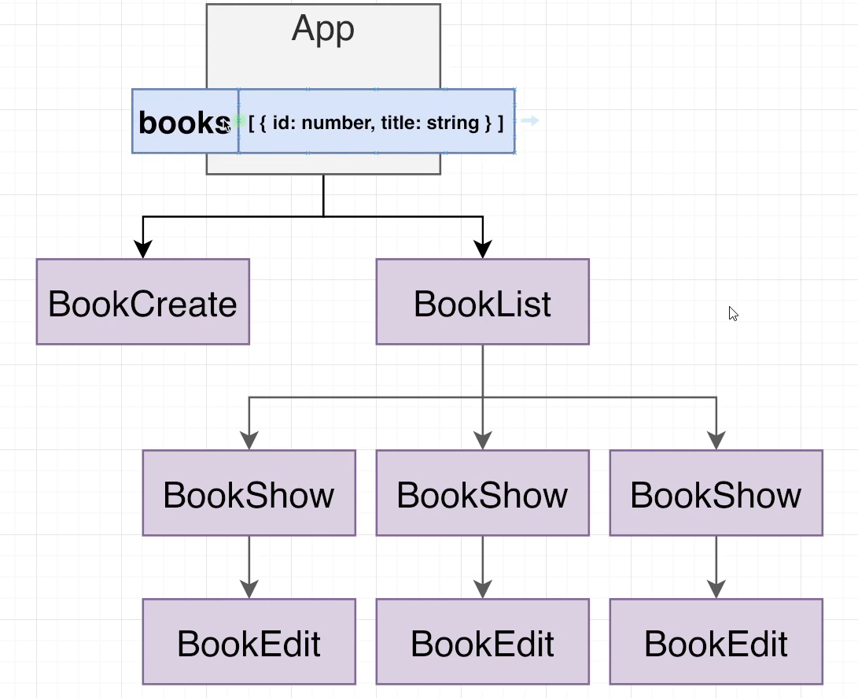

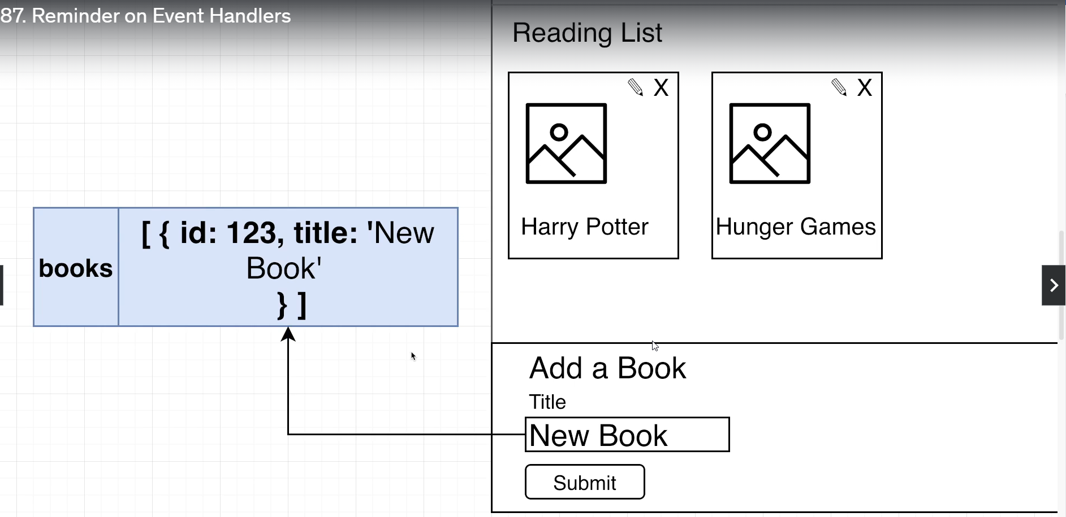

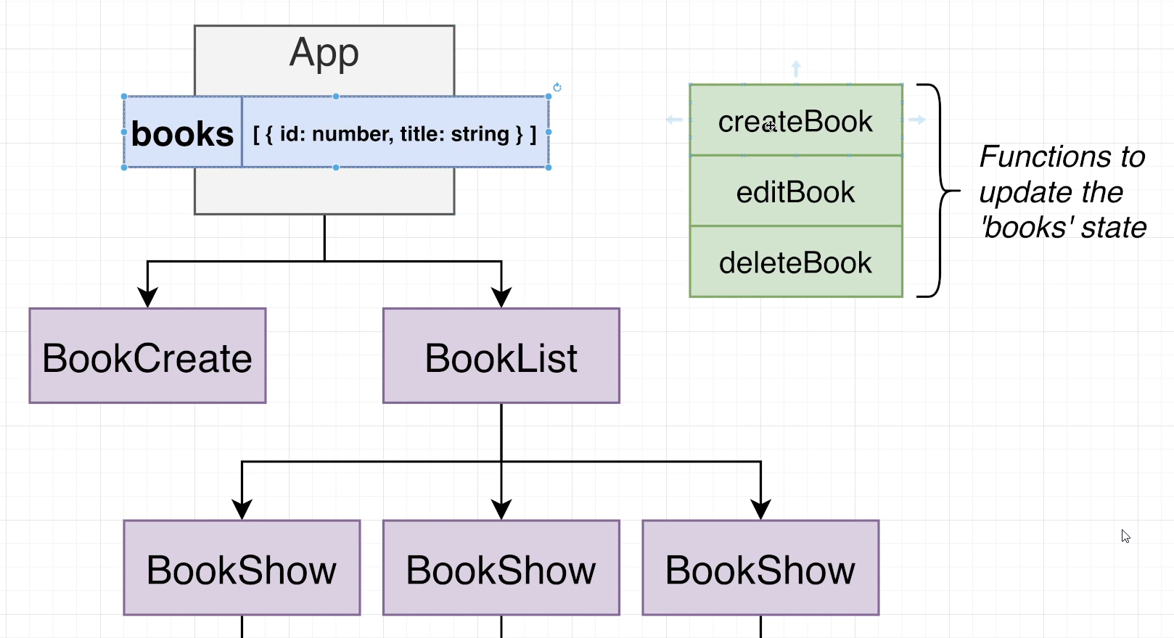

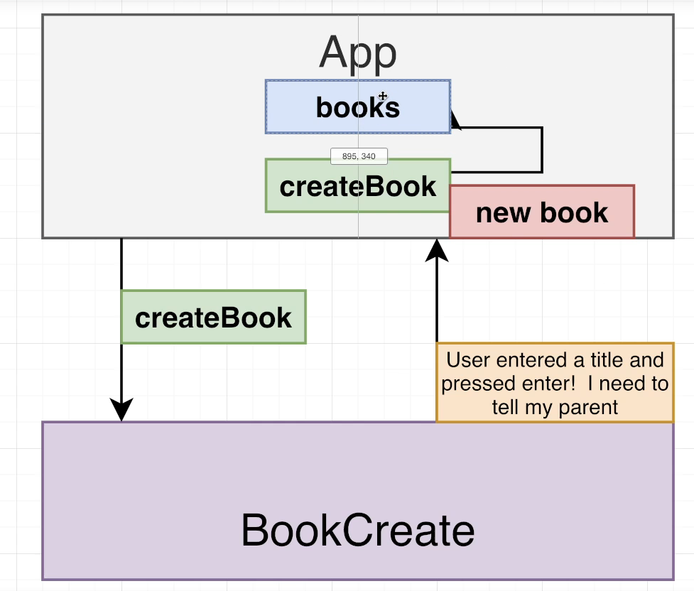

## 87. Reminder on Event Handlers

## 88. Extra CSS

## 89. Receiving New Titles

## 90. Adding Styling

## 91. Updating State

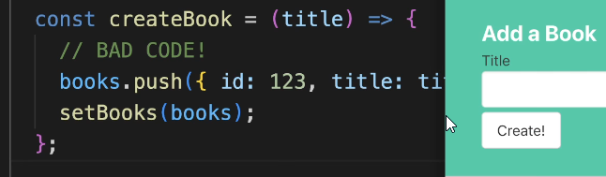

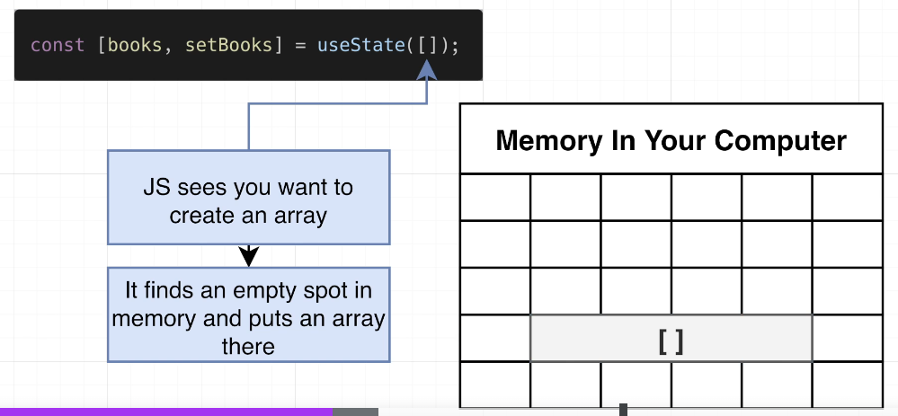

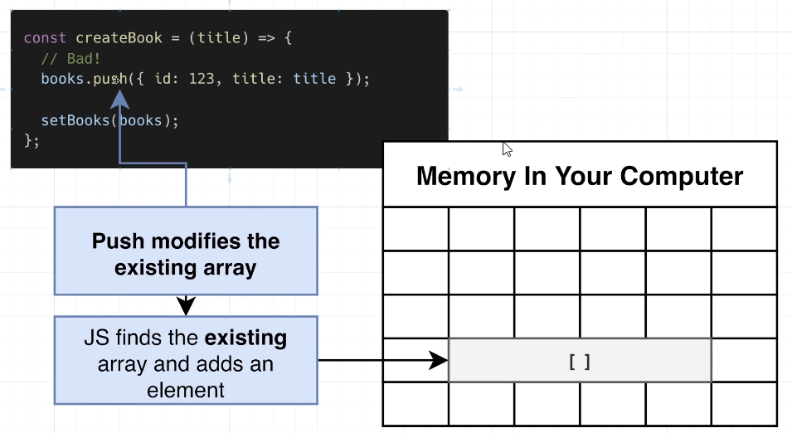

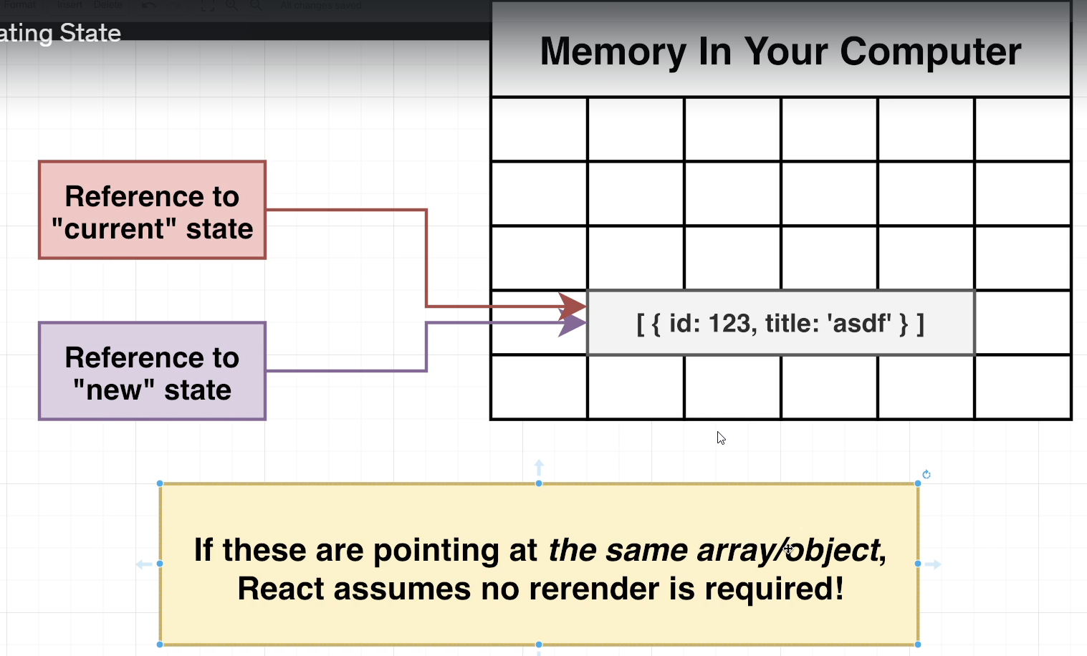

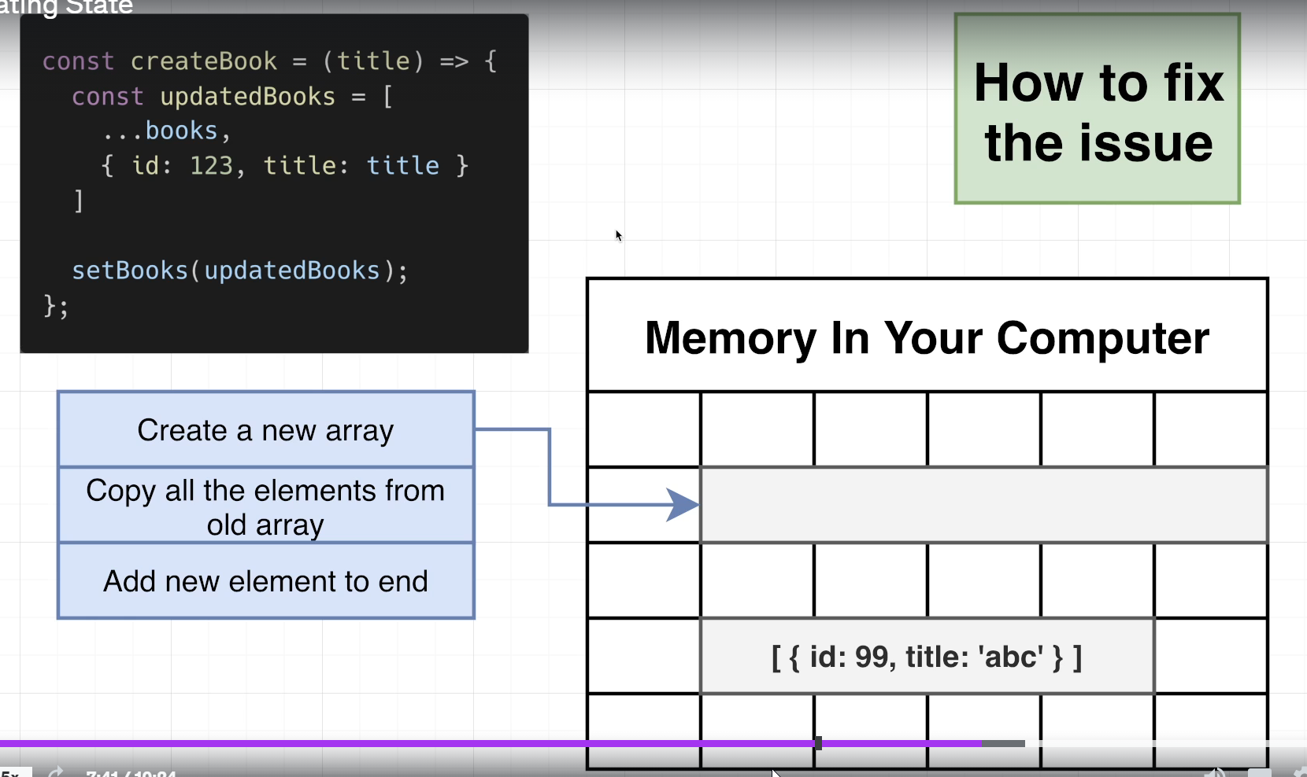

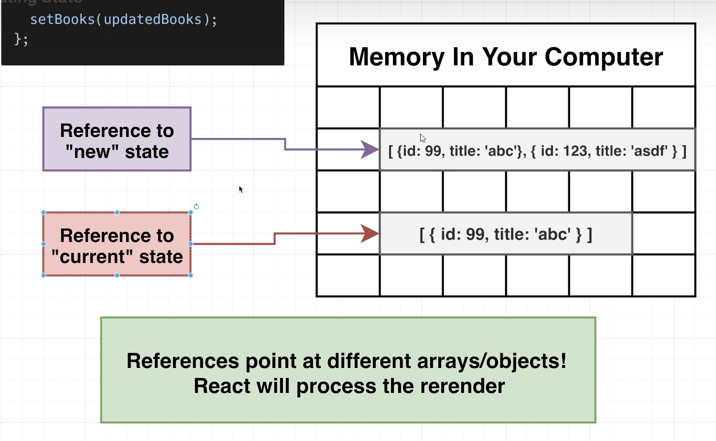

## 92. Don't Mutate That State!

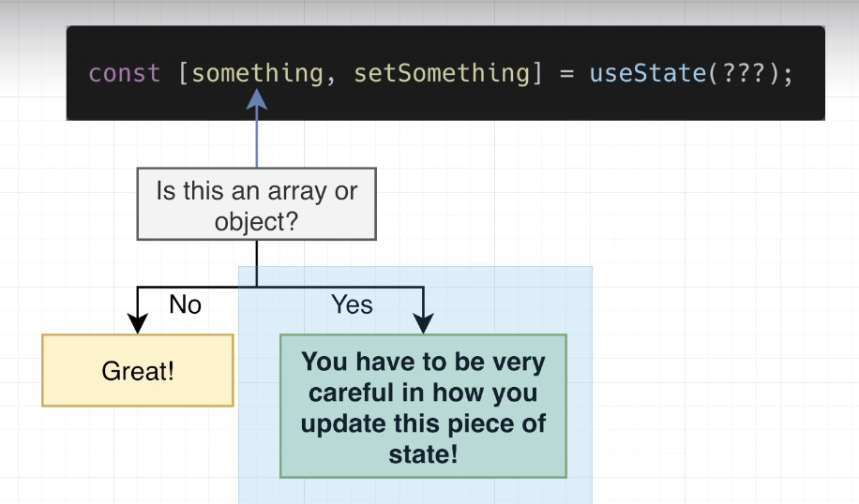

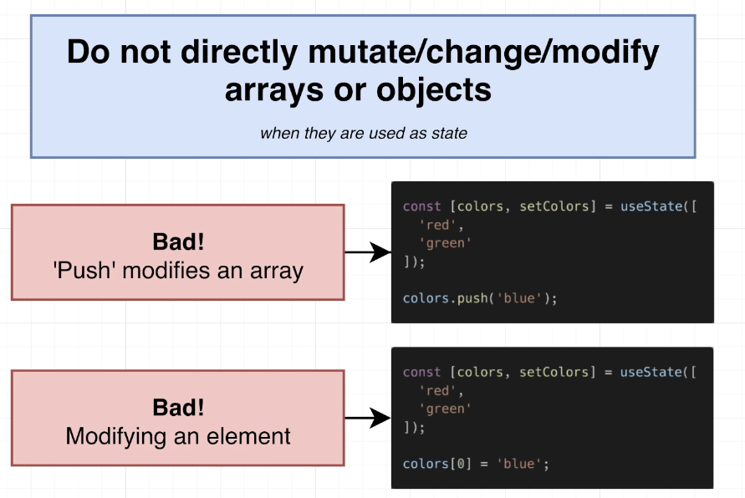

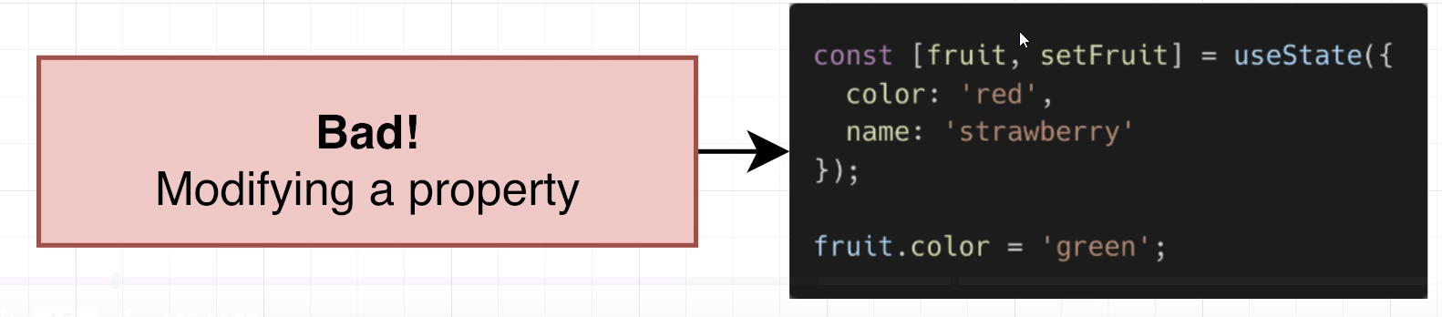

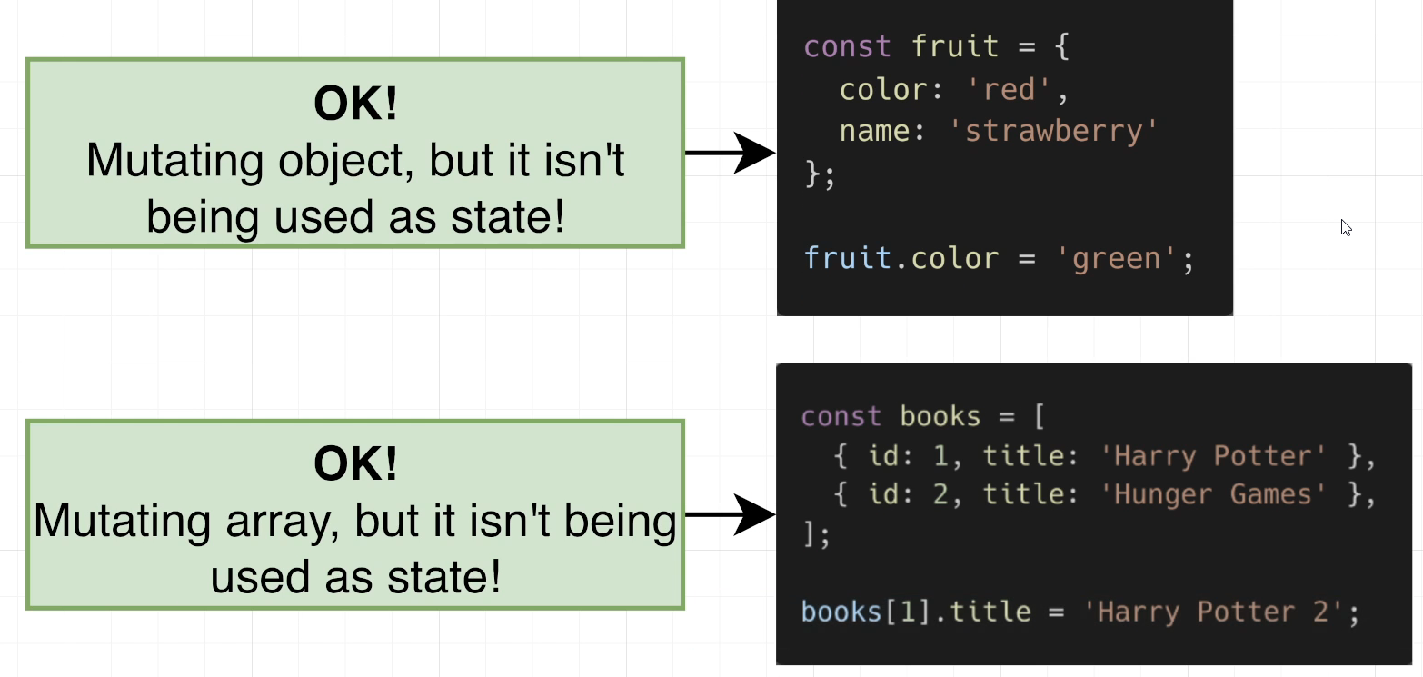

## 93. State Updates - Cheat Sheet

<https://state-updates.vercel.app/>

### State Updates

If your state in a React component is an array of an object, you must be careful in how you update it.

Do not update arrays or objects directly.

const [colors, setColors] = useState(['red', 'green', 'blue']);

const changeColor = () => {

  // Bad!  This directly changes the 'colors' state!

  colors[0] = 'orange';

  setColors(colors);

};

Instead, there are special techniques to update arrays and objects by first creating a new array or object. Even though this does require a tiny, tiny bit of extra processing power, it allows React to do far less work when re-rendering a component.

### Adding Elements to an Array

You can add elements to the **start** of an array by using the spread syntax.

const [colors, setColors] = useState(['red', 'green']);

const addColor = (colorToAdd) => {

  const updatedColors = [colorToAdd, ...colors];

  setColors(updatedColors);

};

Add elements to the **end** of an array by reversing the order of elements in updatedColors.

const [colors, setColors] = useState(['red', 'green']);

const addColor = (colorToAdd) => {

  // Now 'colorToAdd' will be at the end

  const updatedColors = [...colors, colorToAdd];

  setColors(updatedColors);

};

Elements can be added at any index by using the slice method available on all arays.

const [colors, setColors] = useState(['red', 'green']);

const addColorAtIndex = (colorToAdd, index) => {

  const updatedColors = [

    ...colors.slice(0, index),

    colorToAdd,

    ...colors.slice(index),

  ];

  setColors(updatedColors);

};

The slice method can be used to add elements at the start or end of an array as well.

### **Removing Elements From An Array**

Elements can be removed from an array by using the filter method.

The filter method can remove elements by index.

const [colors, setColors] = useState(['red', 'green', 'blue']);

const removeColorAtIndex = (indexToRemove) => {

  const updatedColors = colors.filter((color, index) => {

    return index !== indexToRemove;

  });

  setColors(updatedColors);

};

filter can also remove elements by value.

const [colors, setColors] = useState(['red', 'green', 'blue']);

const removeValue = (colorToRemove) => {

  const updatedColors = colors.filter((color) => {

    return color !== colorToRemove;

  });

  setColors(updatedColors);

};

### **Changing Elements**

Objects in an array can be modified by using the map function.

const [books, setBooks] = useState([

    { id: 1, title: 'Sense and Sensibility' },

    { id: 2, title: 'Oliver Twist' },

  ]);

  const changeTitleById = (id, newTitle) => {

    const updatedBooks = books.map((book) => {

      if (book.id === id) {

        return { ...book, title: newTitle };

      }

      return book;

    });

    setBooks(updatedBooks);

  };

### **Changing Properties In Objects**

Properties in an object can be changed or added by using the spread syntax (the ...).

const [fruit, setFruit] = useState({

    color: 'red',

    name: 'apple',

  });

  const changeColor = (newColor) => {

    const updatedFruit = {

      ...fruit,

      color: newColor,

    };

    setFruit(updatedFruit);

  };

### **Removing Properties In Objects**

Properties in an object can be removed by using destructuring.

const [fruit, setFruit] = useState({

    color: 'red',

    name: 'apple',

  });

  const removeColor = () => {

    // `rest` is an object with all the properties

    // of fruit except for `color`.

    const { color, ...rest } = fruit;

    setFruit(rest);

  };

## 94. [Optional] Adding Elements to the Start or End

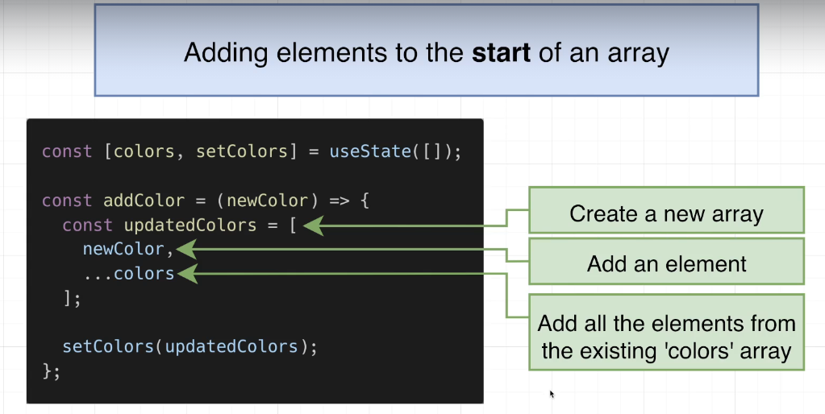

## Coding Exercise 6: Adding Elements

import React from 'react';

import { Input } from './Input';

// Udemy's code editor is a little weird...

// We do *not* need an 'import {useState}' line

function App() {

  const [colors, setColors] = useState([]);

  const addColor = (newColor) => {

    const updatedColors = [

        newColor,

        ...colors

    ];

    setColors(updatedColors);

  };

  const renderedColors = colors.map((color, i) => {

      return <li key={i}>{color}</li>

  });

  return (

    <div>

      <Input onSubmit={addColor} />

      <ul>

        {renderedColors}

      </ul>

    </div>

  );

}

const useState = React.useState;

export default App;

## 95. [Optional] Exercise Solution

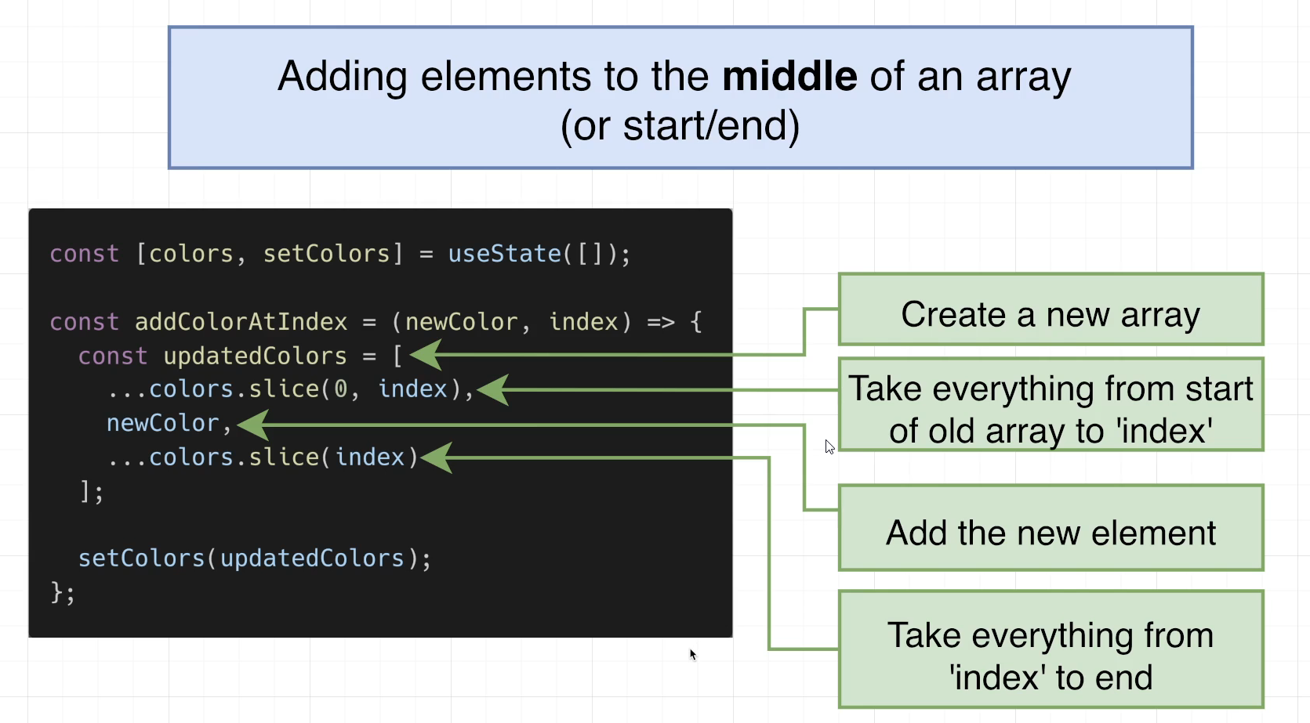

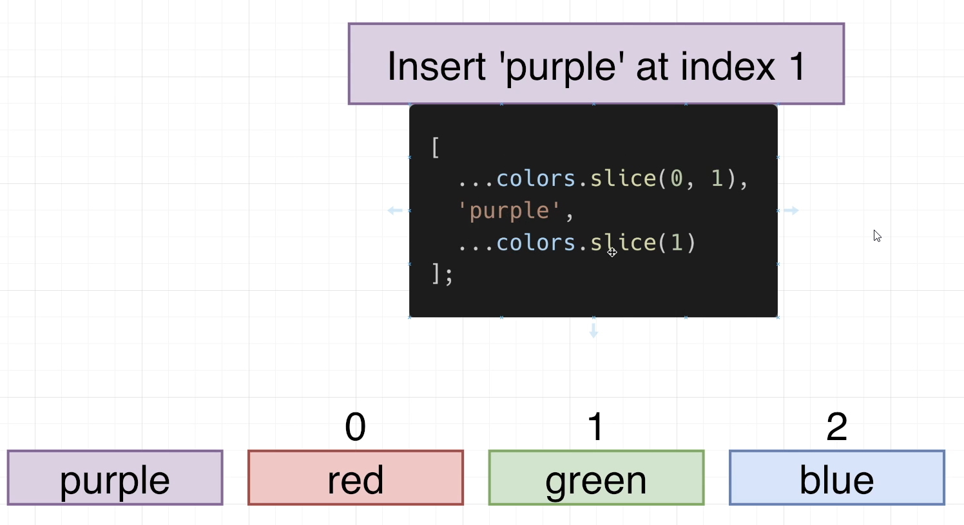

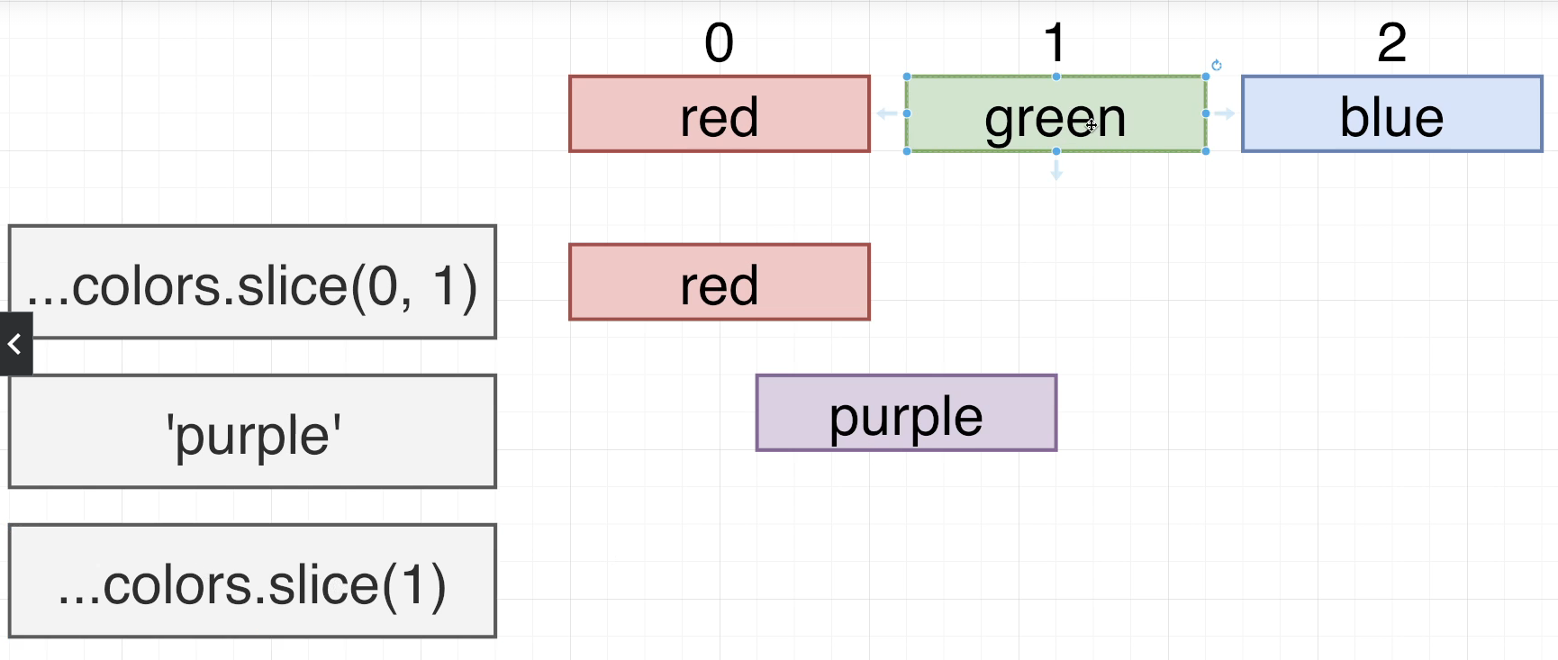

## 96. [Optional] Inserting Elements

## Coding Exercise 7: Inserting Elements

import React from 'react';

import { Input } from './Input';

// Udemy's code editor is a little weird...

// We do *not* need an 'import {useState}' line

function App() {

  const [colors, setColors] = useState([]);

  const addColorAtIndex = (newColor, index) => {

    // Todo: Add 'newColor' to 'colors' at the designated 'index'

    // and update state

    const updatedColors = [

        ...colors.slice(0, index),

        newColor,

        ...colors.slice(index)

    ];

    setColors(updatedColors);

  };

  const renderedColors = colors.map((color, i) => {

      return <li key={i}>{color}</li>

  });

  return (

    <div>

      <Input onSubmit={addColorAtIndex} max={colors.length} />

      <ul>

        {renderedColors}

      </ul>

    </div>

  );

}

const useState = React.useState;

export default App;

## 97. [Optional] Exercise Solution

## 98. [Optional] Removing Elements

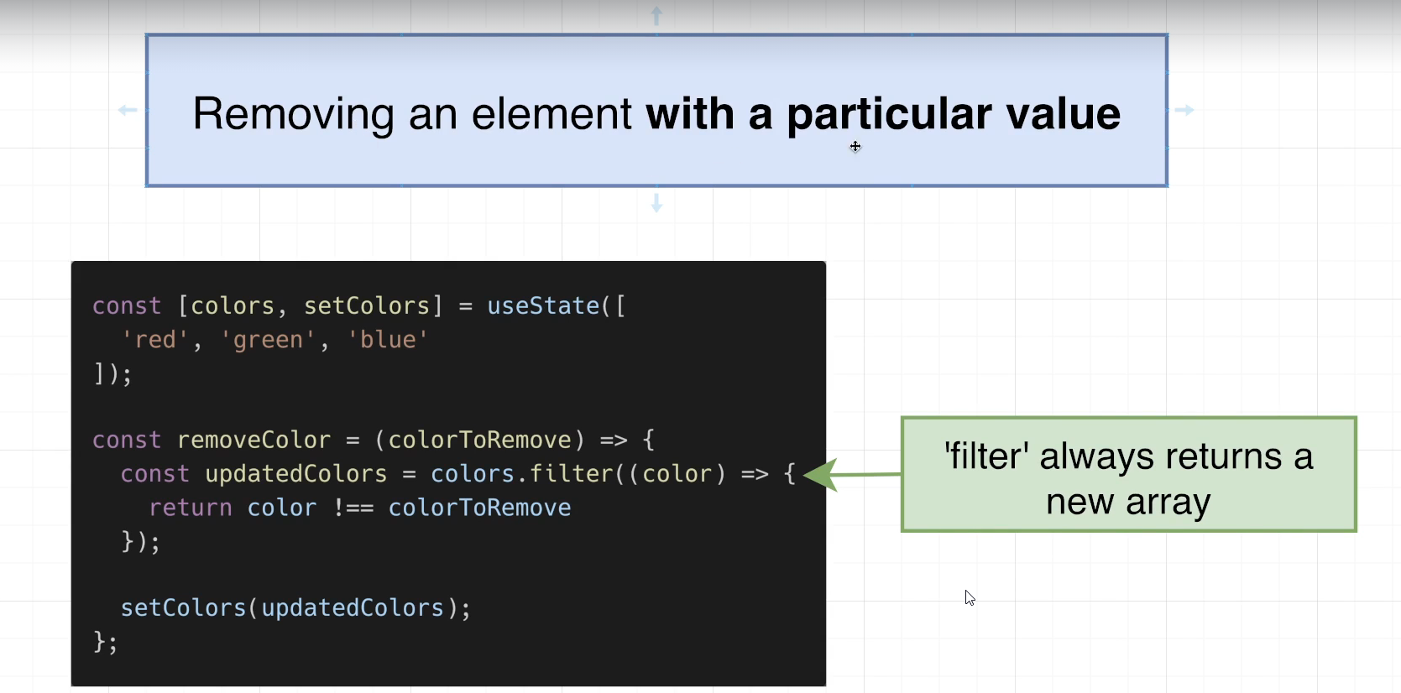

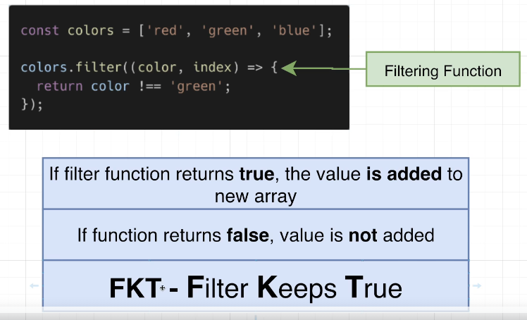

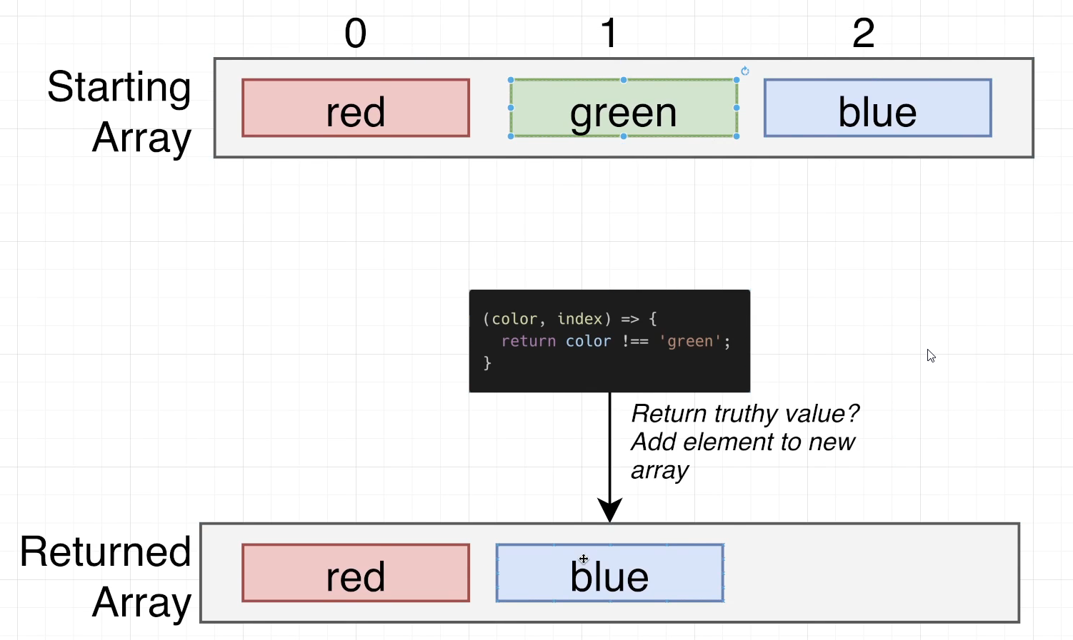

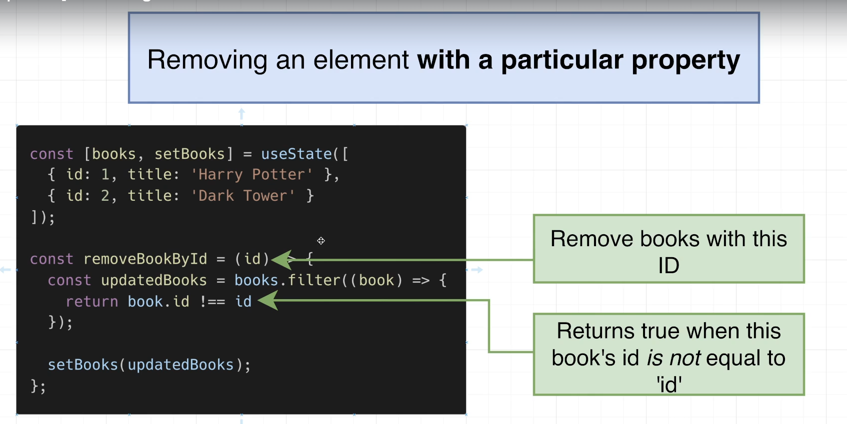

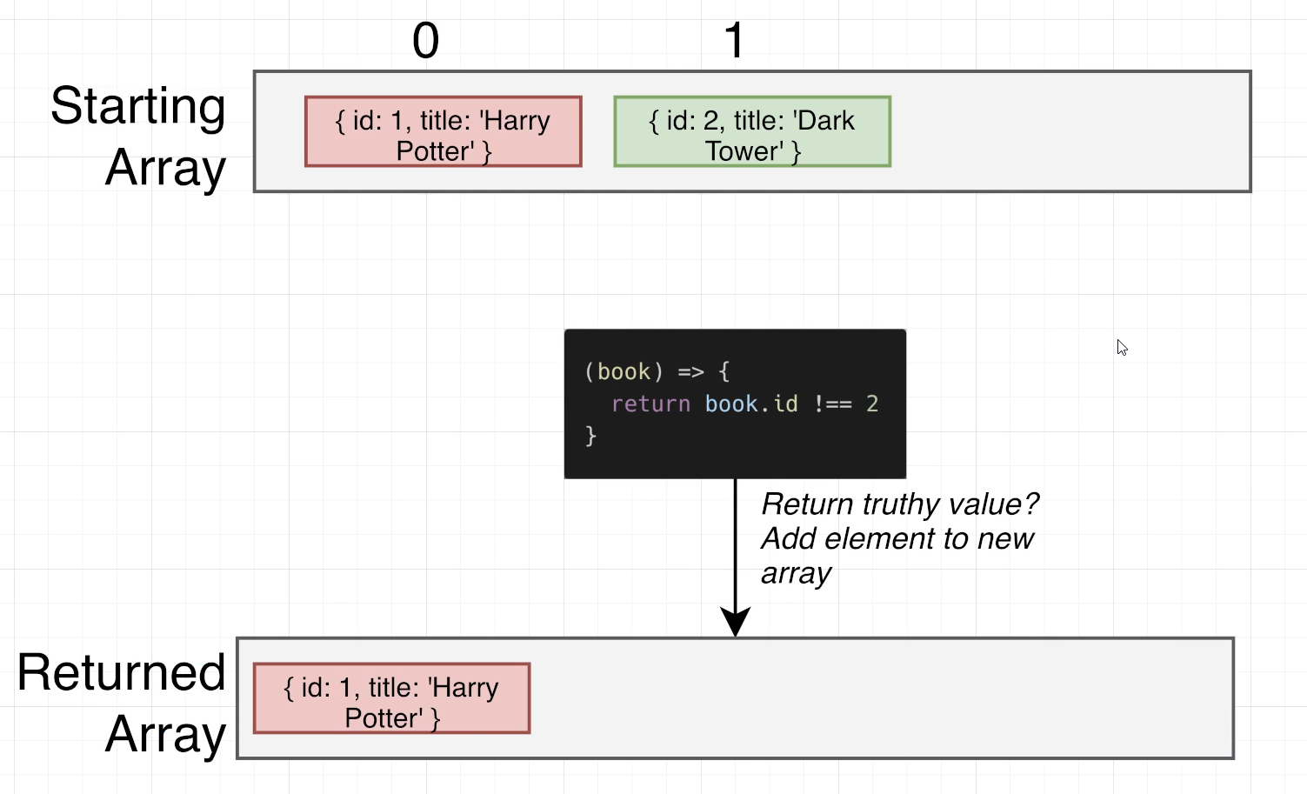

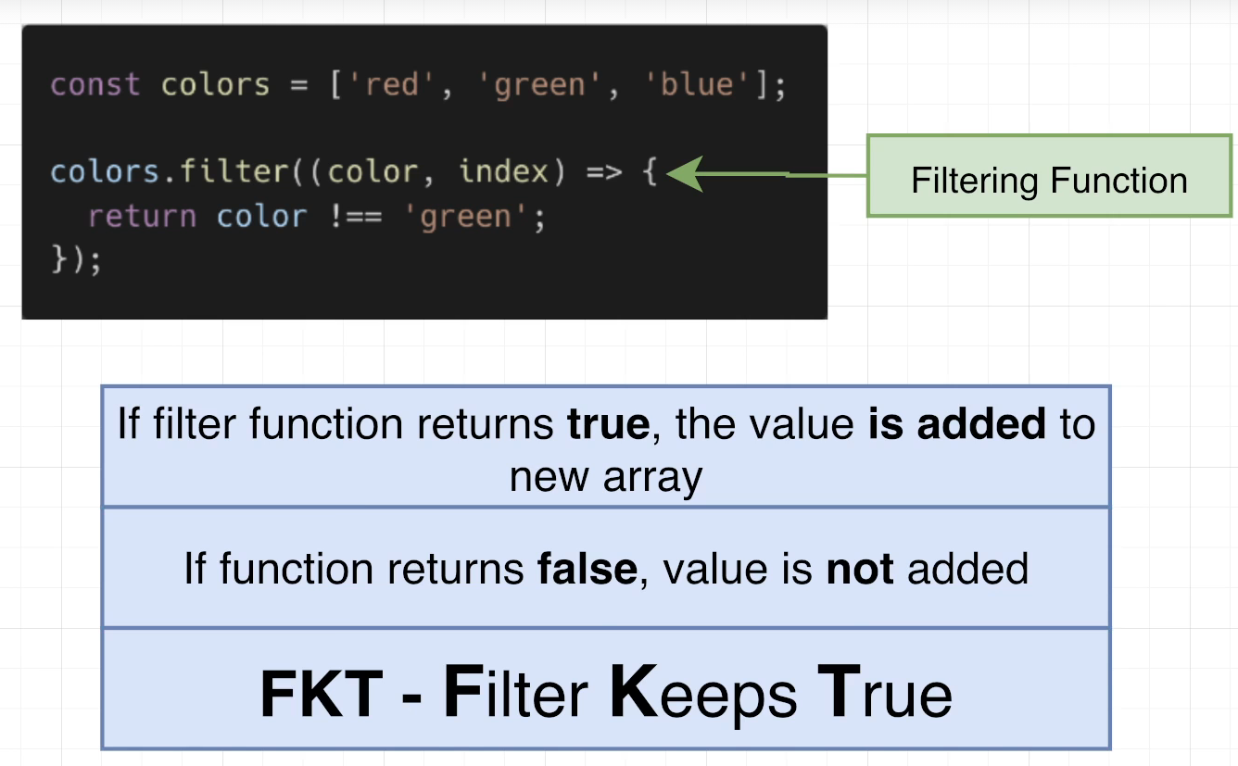

## Coding Exercise 8: Removing Elements

import React from 'react';

import { Input } from './Input';

import { RemoveForm } from './RemoveForm';

// Udemy's code editor is a little weird...

// We do *not* need an 'import {useState}' line

function App() {

  const [colors, setColors] = useState(['red', 'green', 'blue']);

  const removeColorAtIndex = (indexToRemove) => {

    const updatedColors = colors.filter((color, index) => {

        return index !== indexToRemove;

    });

    setColors(updatedColors);

  };

  const addColor = (newColor) => {

    setColors([...colors, newColor])

  };

  const renderedColors = colors.map((color, i) => {

      return <li key={i}>{color}</li>

  });

  return (

    <div>

      <Input onSubmit={addColor} />

      <ul>

        {renderedColors}

      </ul>

      <hr />

      <RemoveForm onSubmit={removeColorAtIndex} max={colors.length}  />

    </div>

  );

}

const useState = React.useState;

export default App;

## 99. [Optional] Exercise Solution

## 100. [Optional] Modifying Elements

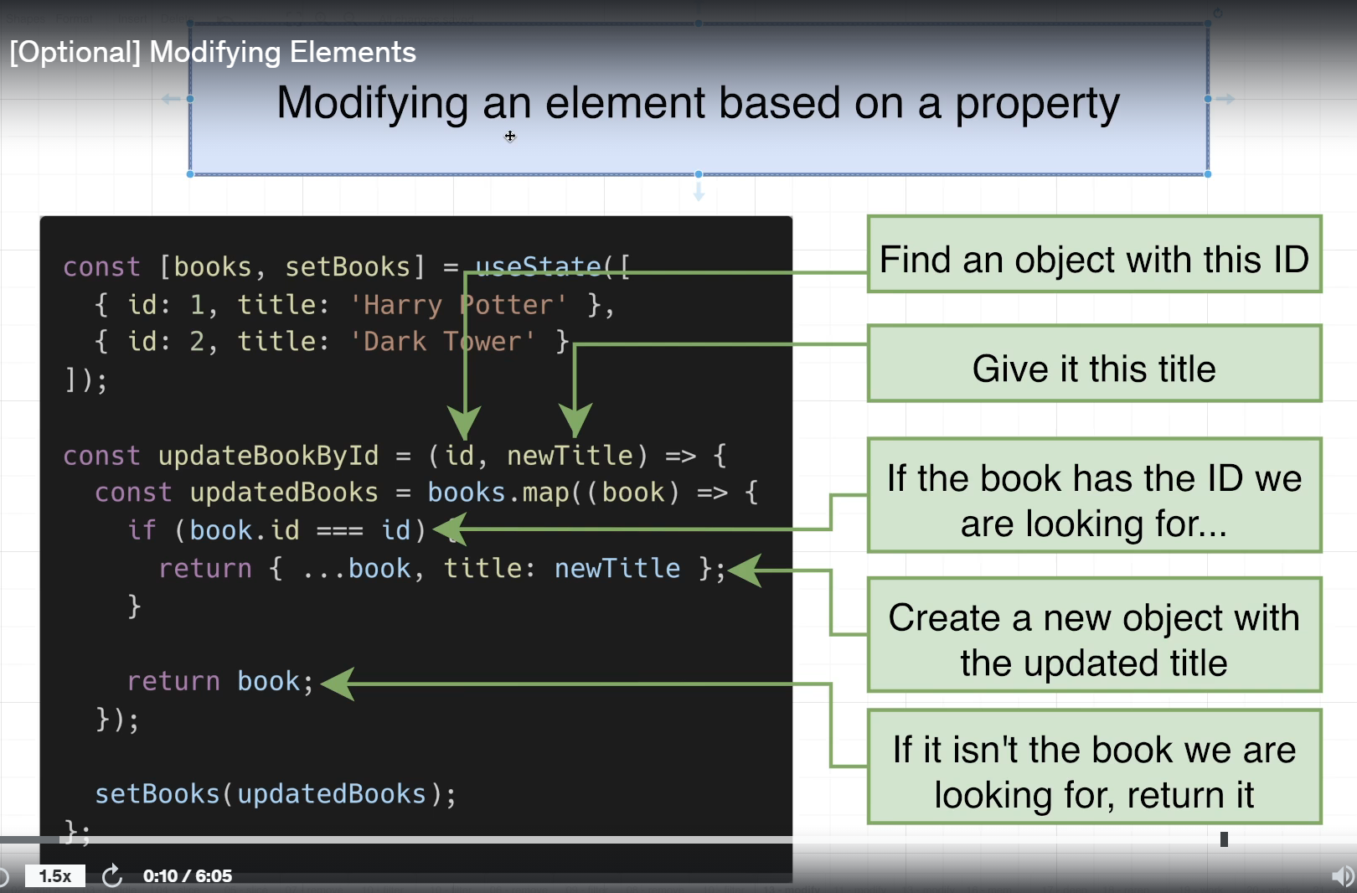

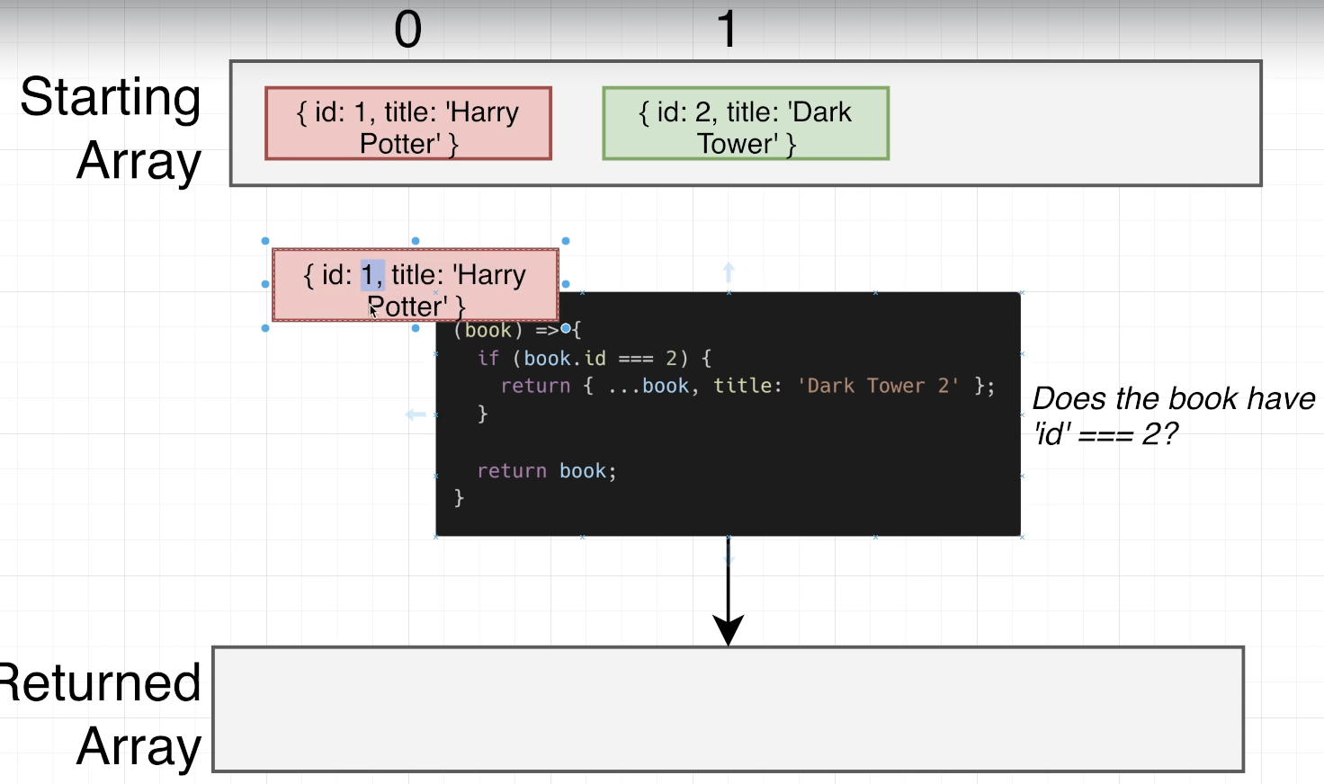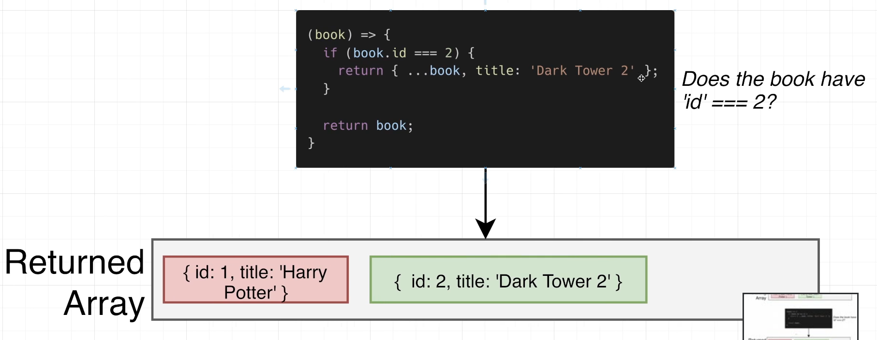

## 101. [Super Optional] Why the Special Syntax?

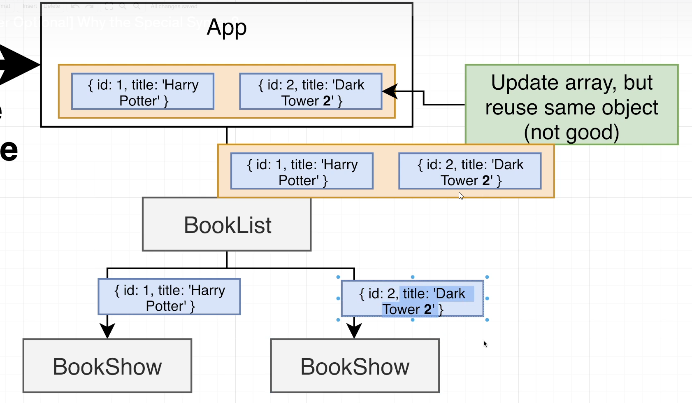

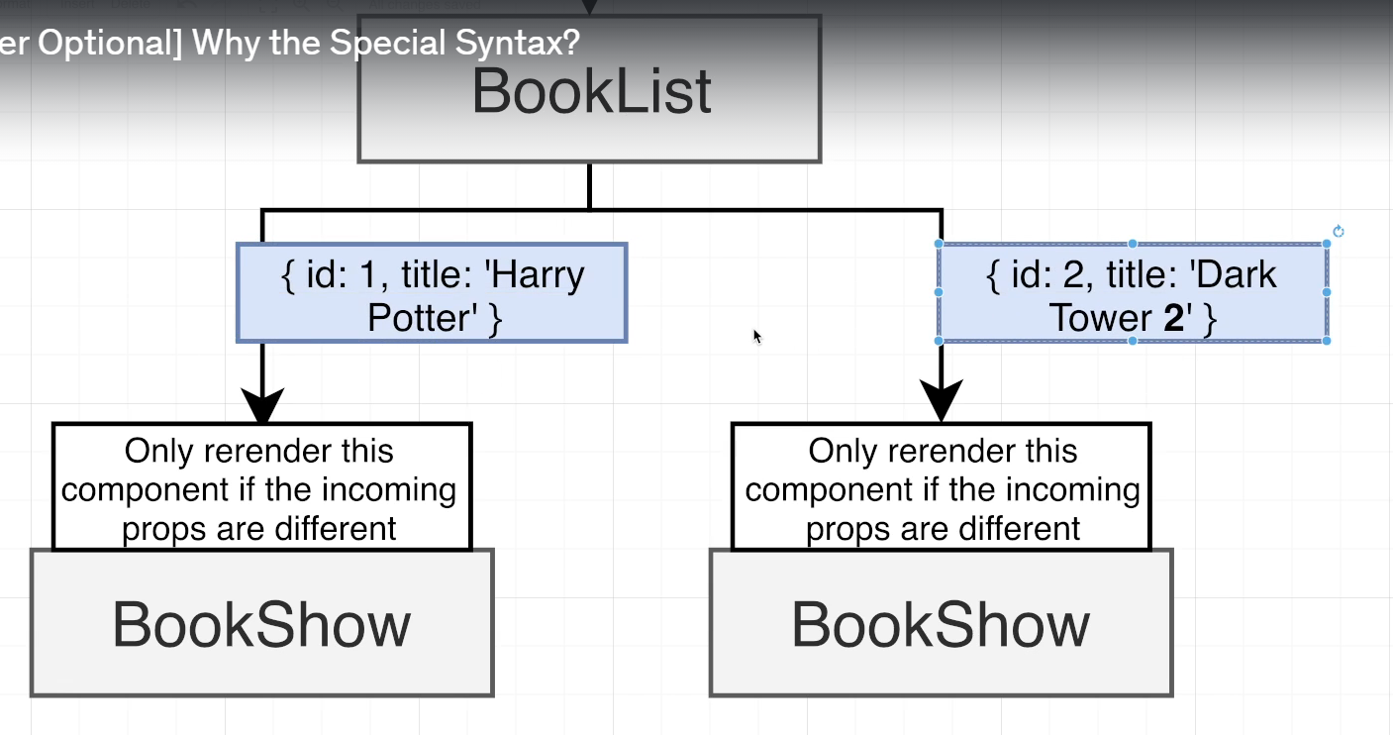

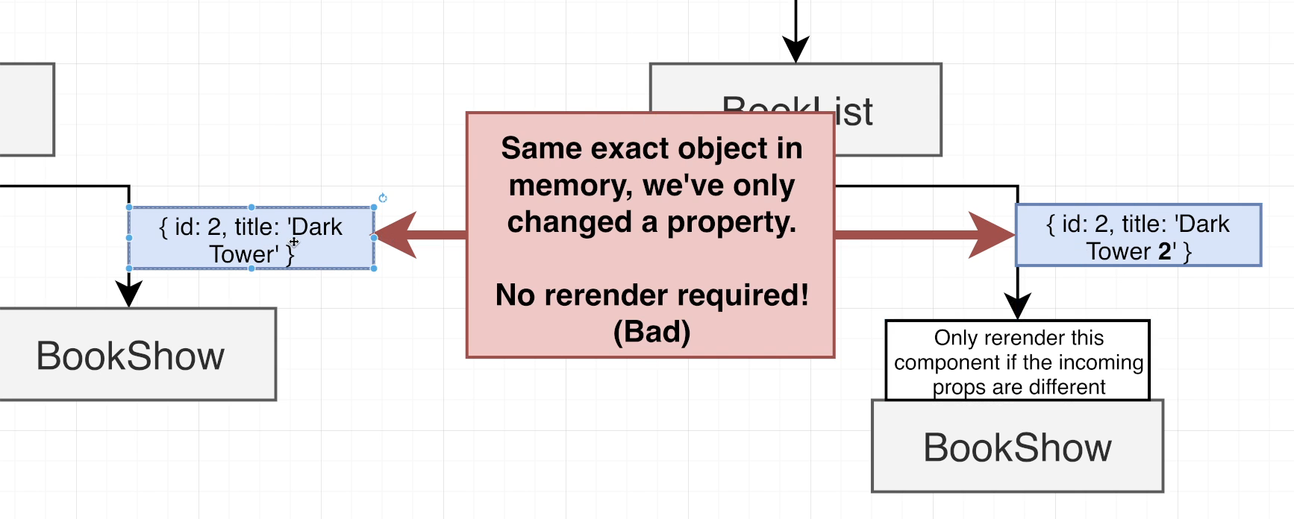

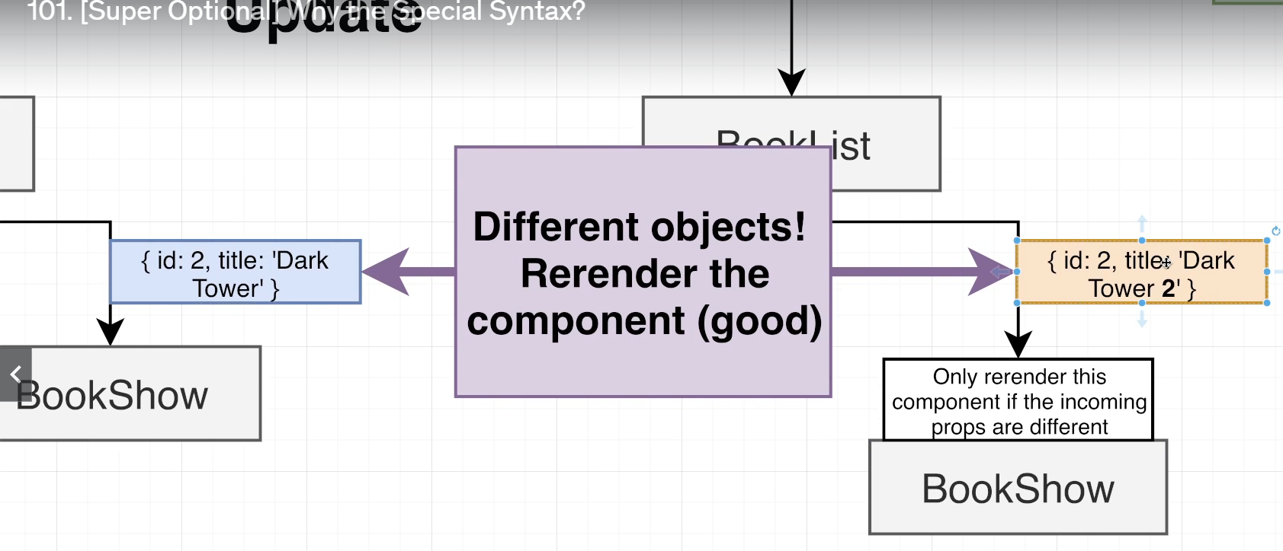

## Coding Exercise 9: Modifying Elements

## 102. [Optional] Exercise Solution

import React, { useState } from 'react'; // Import useState

import { Input } from './Input';

import { EditForm } from './EditForm';

function App() {

  // Correctly imported and initialized useState

  const [books, setBooks] = useState([

    { id: 10, title: 'Harry Potter' },

    { id: 17, title: 'Hunger Games' },

    { id: 54, title: 'Dark Tower' },

  ]);

  const updateBookById = (id, newTitle) => {

    const updatedBooks = books.map((book) => {

      if (book.id === id) {

        return { ...book, title: newTitle };

      }

      return book;

    });

    setBooks(updatedBooks);

  };

  const addBook = (title) => {

    const newBook = { title: title, id: ~~(Math.random() * 1000) }; // Renamed variable to avoid confusion

    setBooks([...books, newBook]);

  };

  const renderedBooks = books.map((book) => {

    return (

      <li key={book.id}>

        Title: {book.title}, Id: {book.id}

      </li>

    );

  });

  return (

    <div>

      <Input onSubmit={addBook} />

      <ol>{renderedBooks}</ol>

      <hr />

      <EditForm books={books} onSubmit={updateBookById} />

    </div>

  );

}

export default App;

## 103. [Optional] Adding Changing or Removing Object Properties

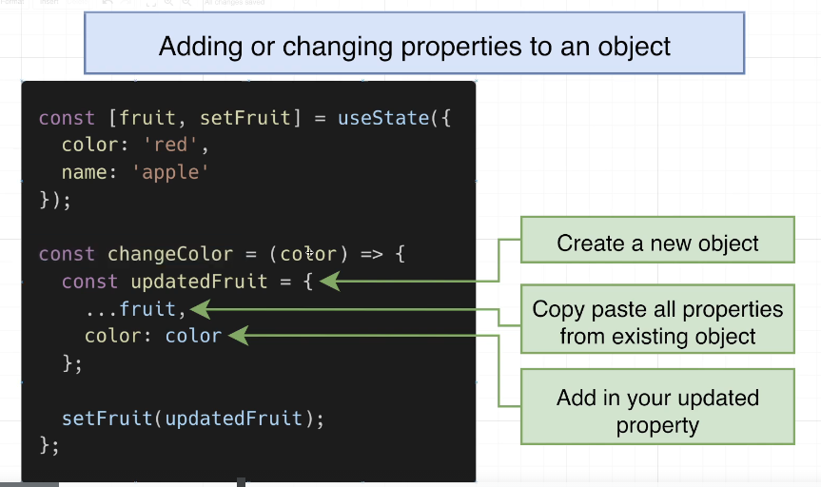

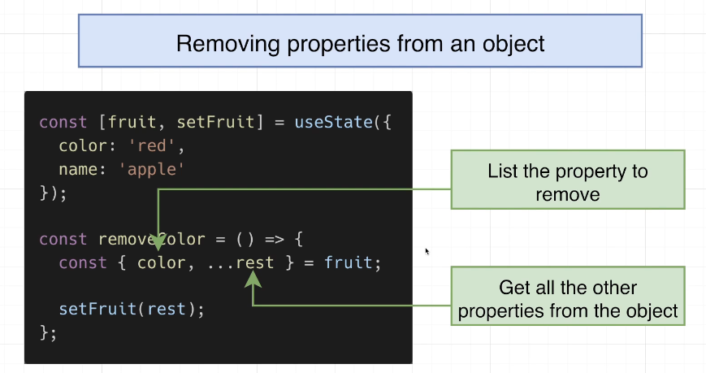

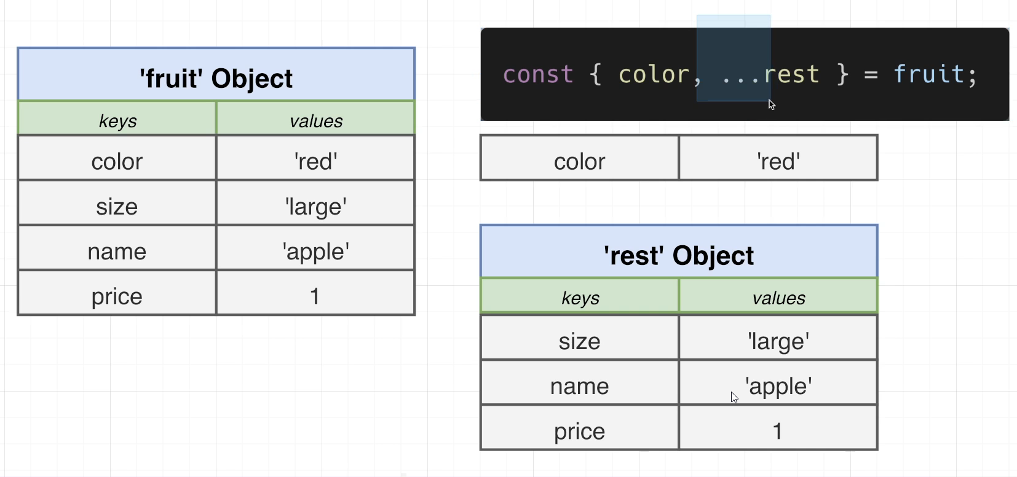

## 104. Cheatsheet for State Changes

## 105. Adding a Book For Real!

## 106. Generating Random ID's

const createBook = (title) => {

    console.log("Need to add book with:", title);

    const updatedBooks = [...books,

      {

          id: Math.round(Math.random() * 9999),

          title,

      },

    ];

    setBooks(updatedBooks);

  };

## 107. Displaying the List

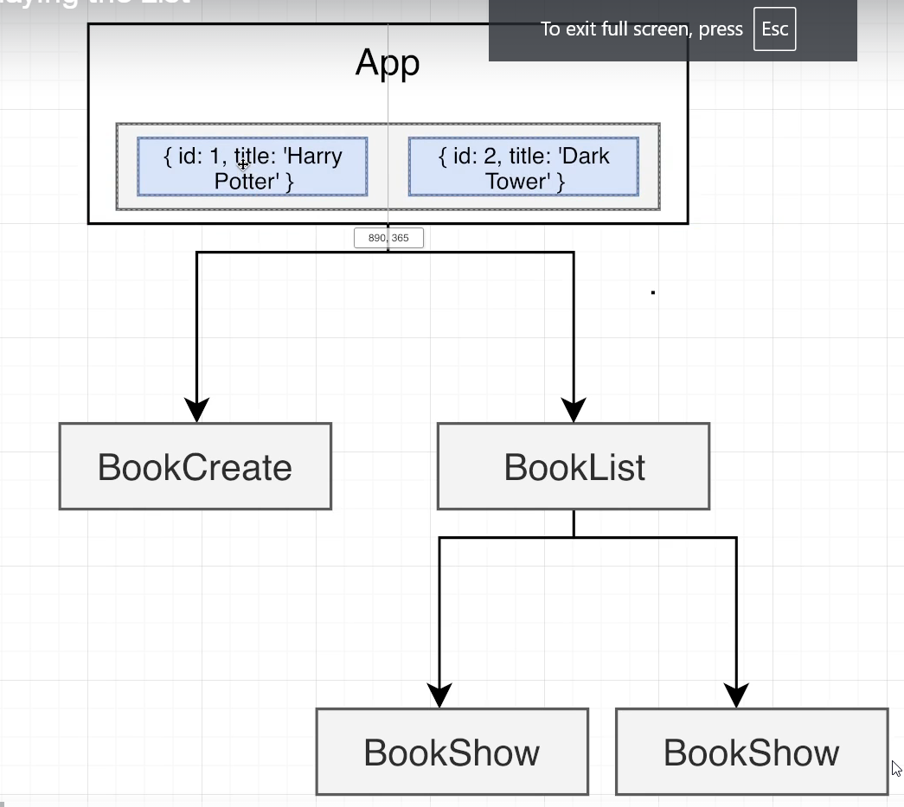

BookList.js

import BookShow from './BookShow';

function BookList({books}) {

    const renderedBooks = books.map((book) => {

        return <BookShow key={book.id} book={book} />;

    });

    return <div className="book-list">{renderedBooks}</div>;

}

export default BookList;

BookShow.js

function BookShow({book}) {

    return <div className="book-show">{book.title}</div>;

}

export default BookShow;

## 108. Deleting Records

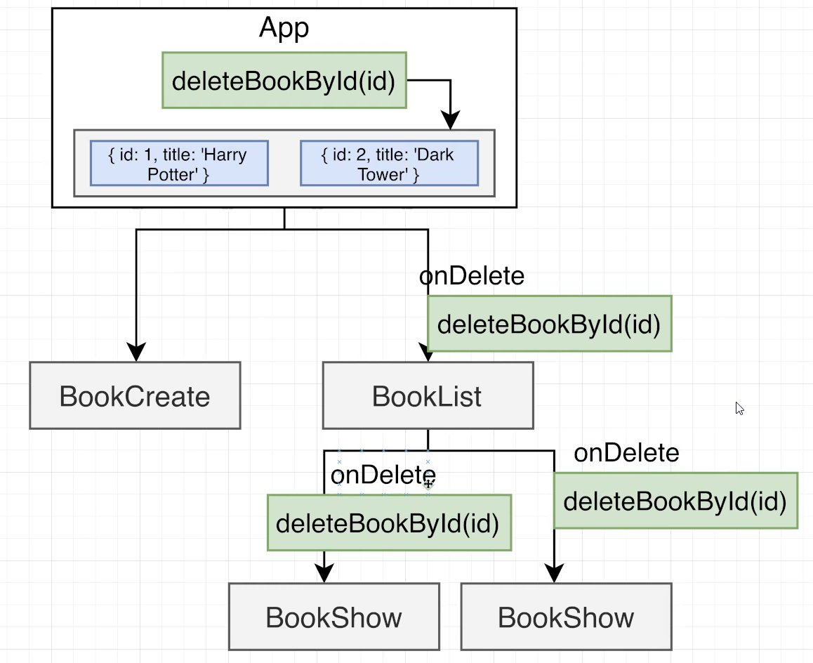

const deletedBookById = (id) => {

    console.log("Need to delete book with id:");

    const updatedBooks = books.filter((book) => {

       return book.id !== id

    });

    setBooks(updatedBooks);

  };

## 109. Toggling Form Display

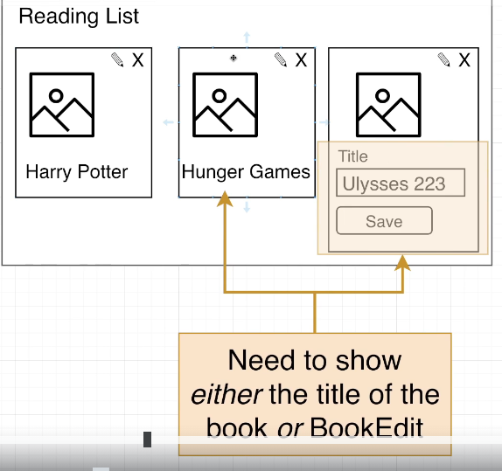

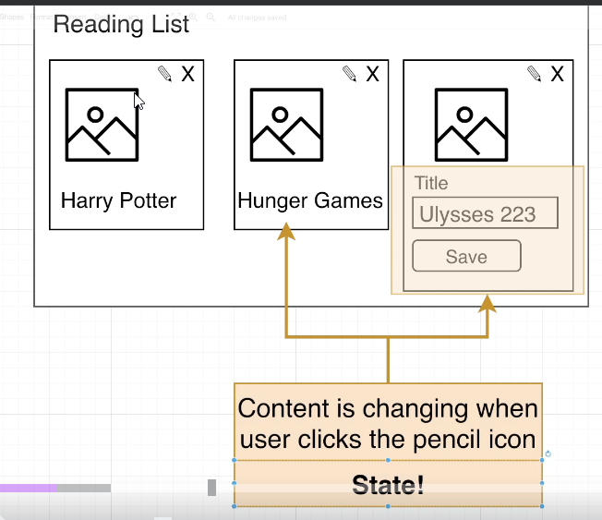

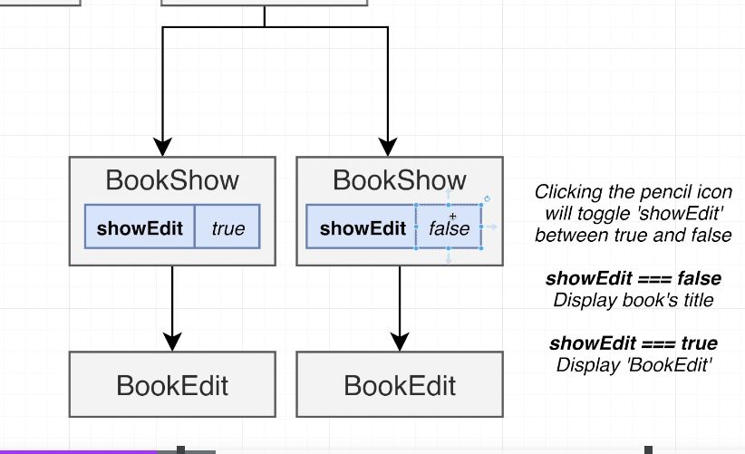

## 110. Default Form Values

## 111. Updating the Title

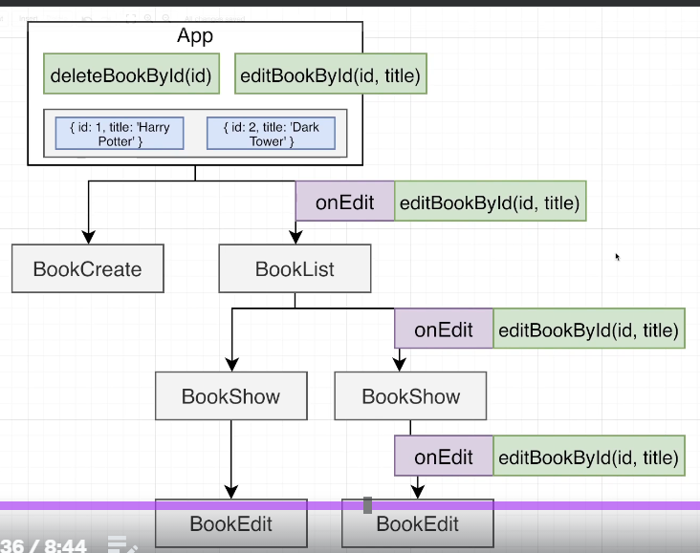

## 112. Closing the Form on Submit

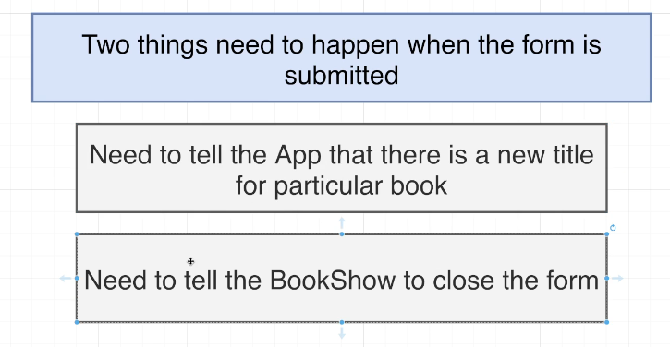

## 113. A Better Solution!

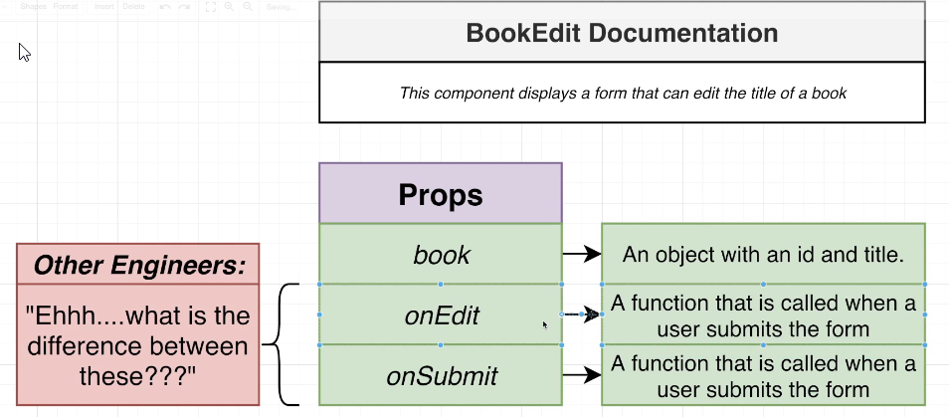

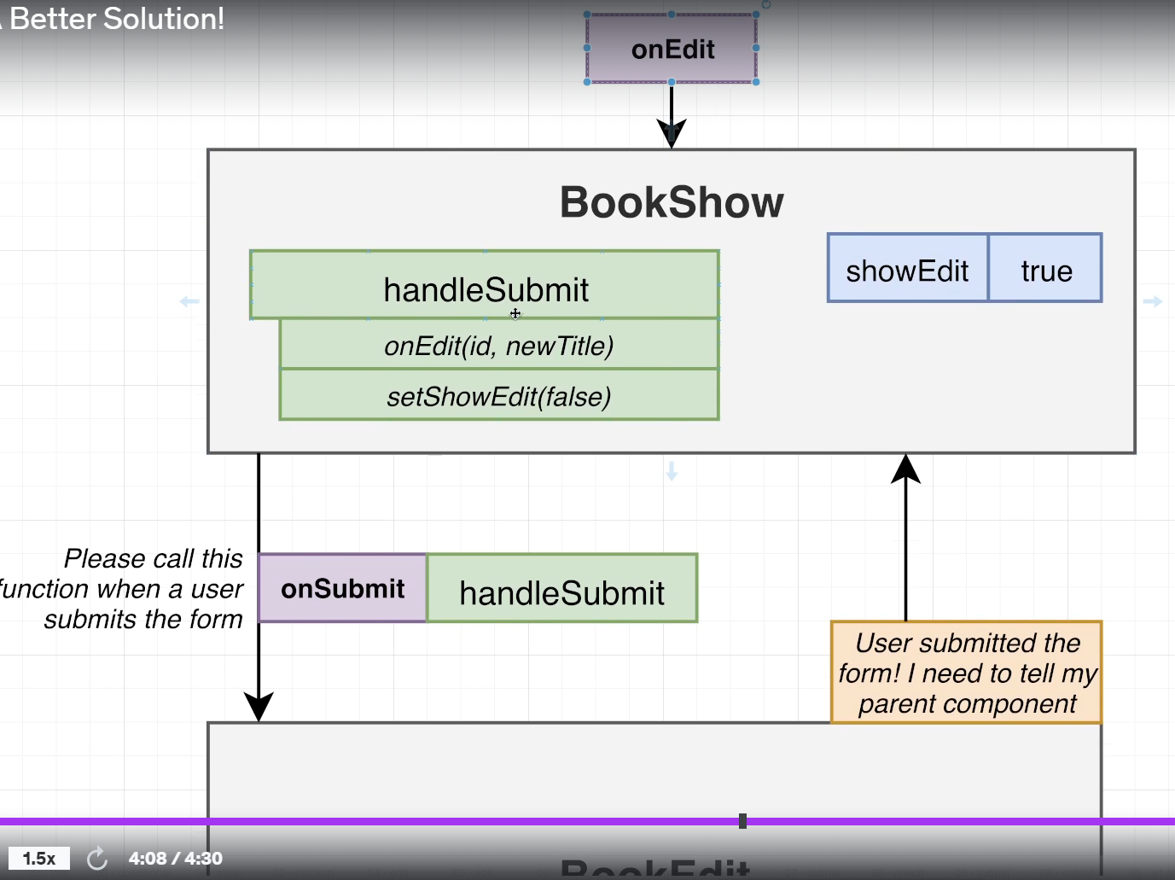

## 114. Collapsing Two Handlers into One

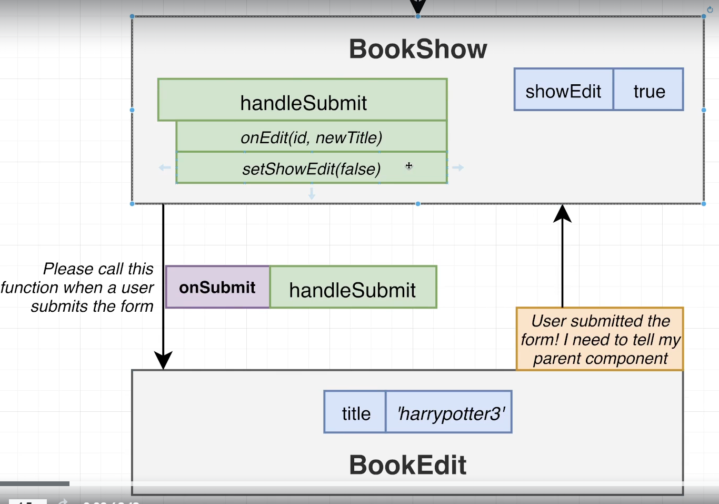

## 115. Adding Images

<https://picsum.photos/>

# Section 7: Data Persistence with API Requests

## 116. Adding Data Persistence

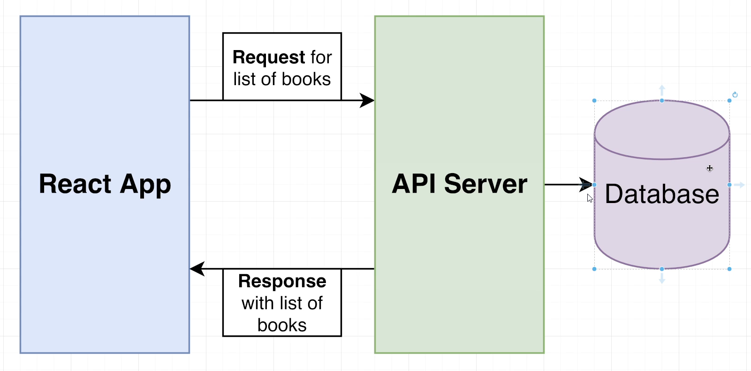

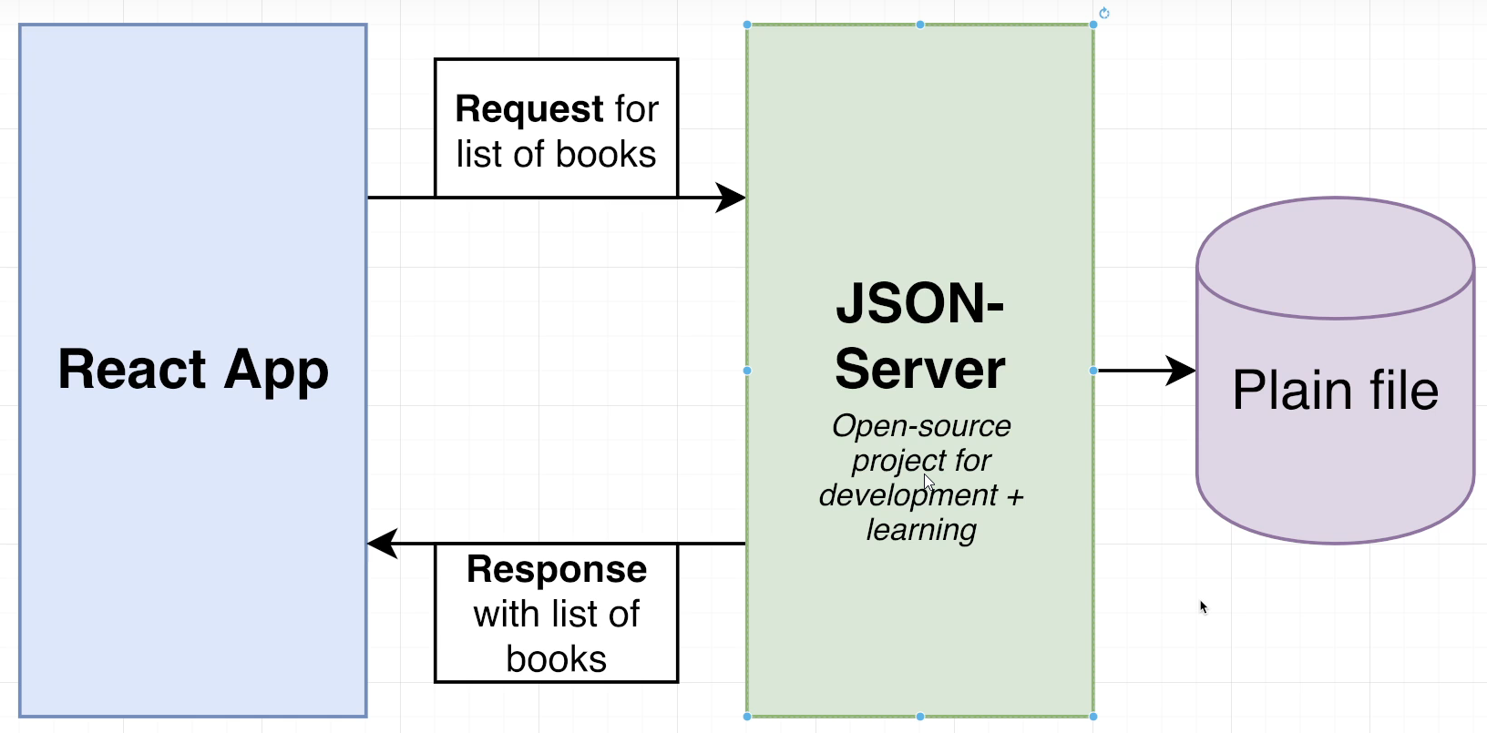

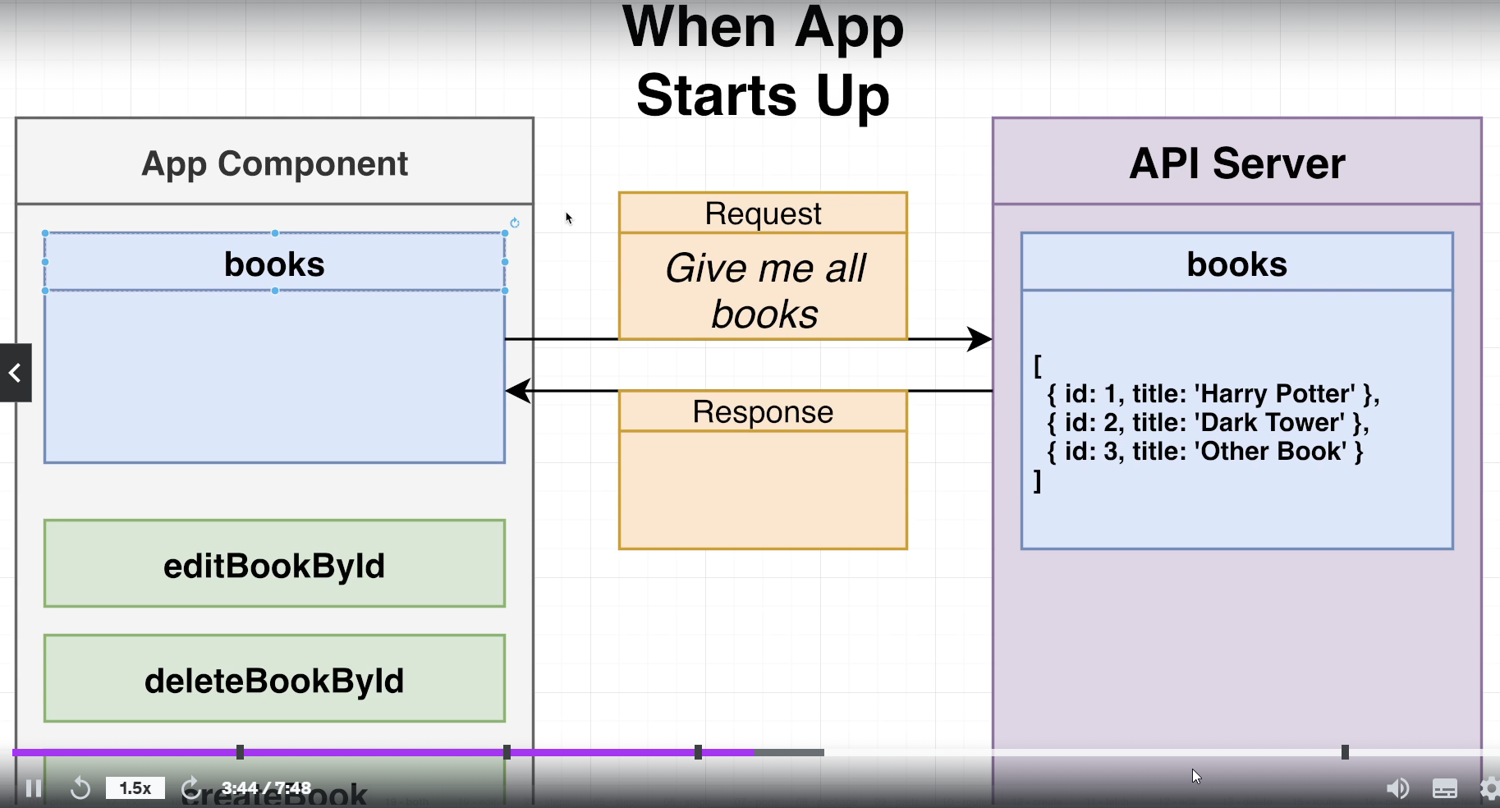

## 117. JSON Server Issues and Required Version

npm install json-server

## 118. Server Setup

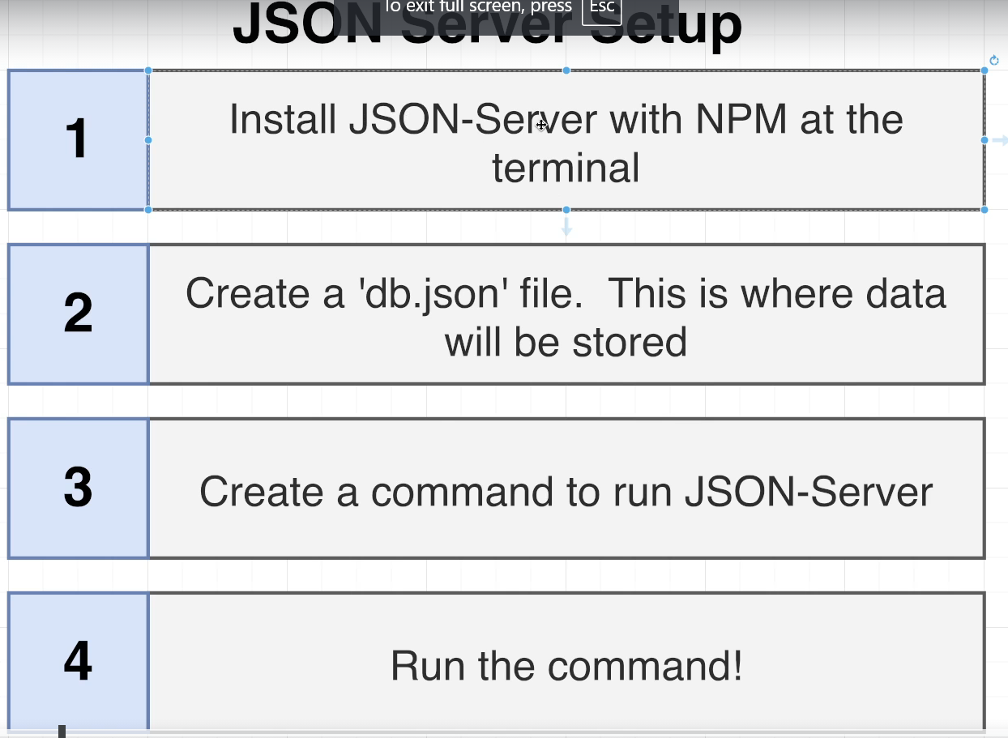

db.json

{

    "books": []

}

package.json

"scripts": {

    "start": "react-scripts start",

    "server": "json-server -port 3001 --watch db.json ",

    "build": "react-scripts build",

    "test": "react-scripts test",

    "eject": "react-scripts eject"

  },

**npm run server** for running the db.json file

<http://localhost:3001/>

## 119. What Just Happened?

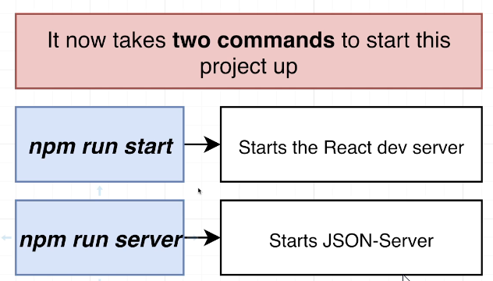

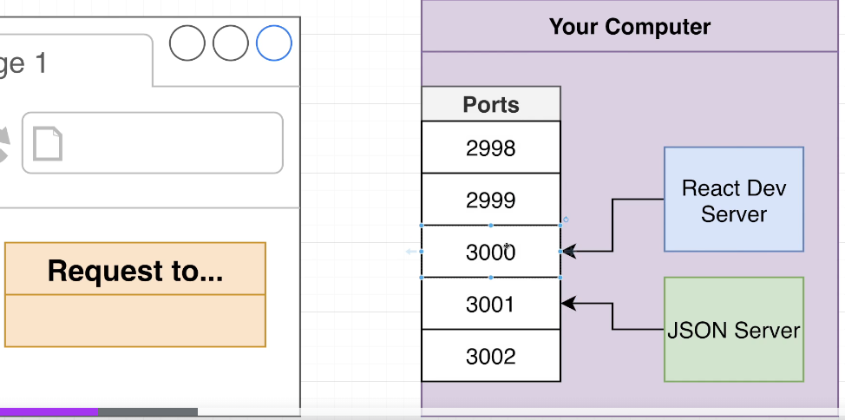

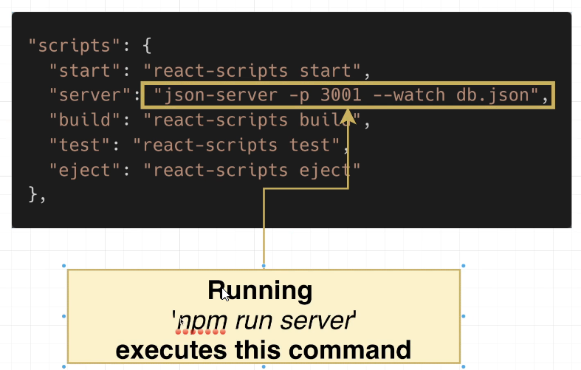

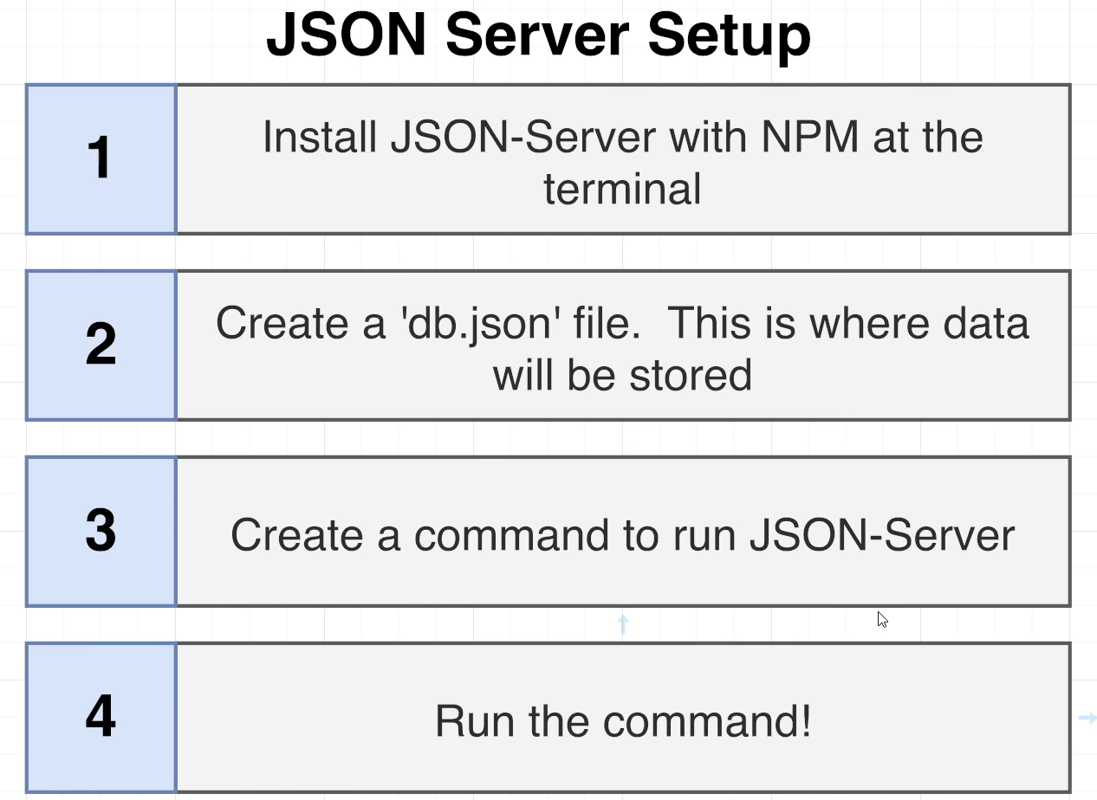

## 120. How the API Works

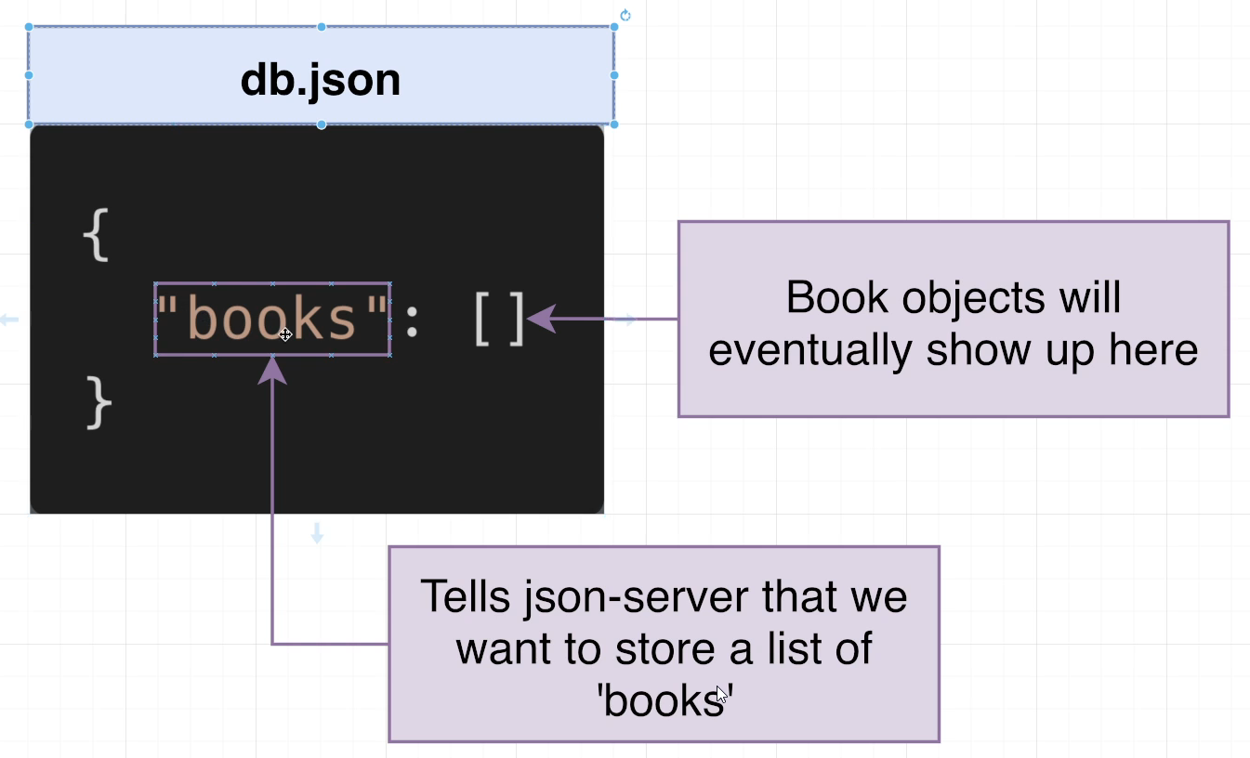

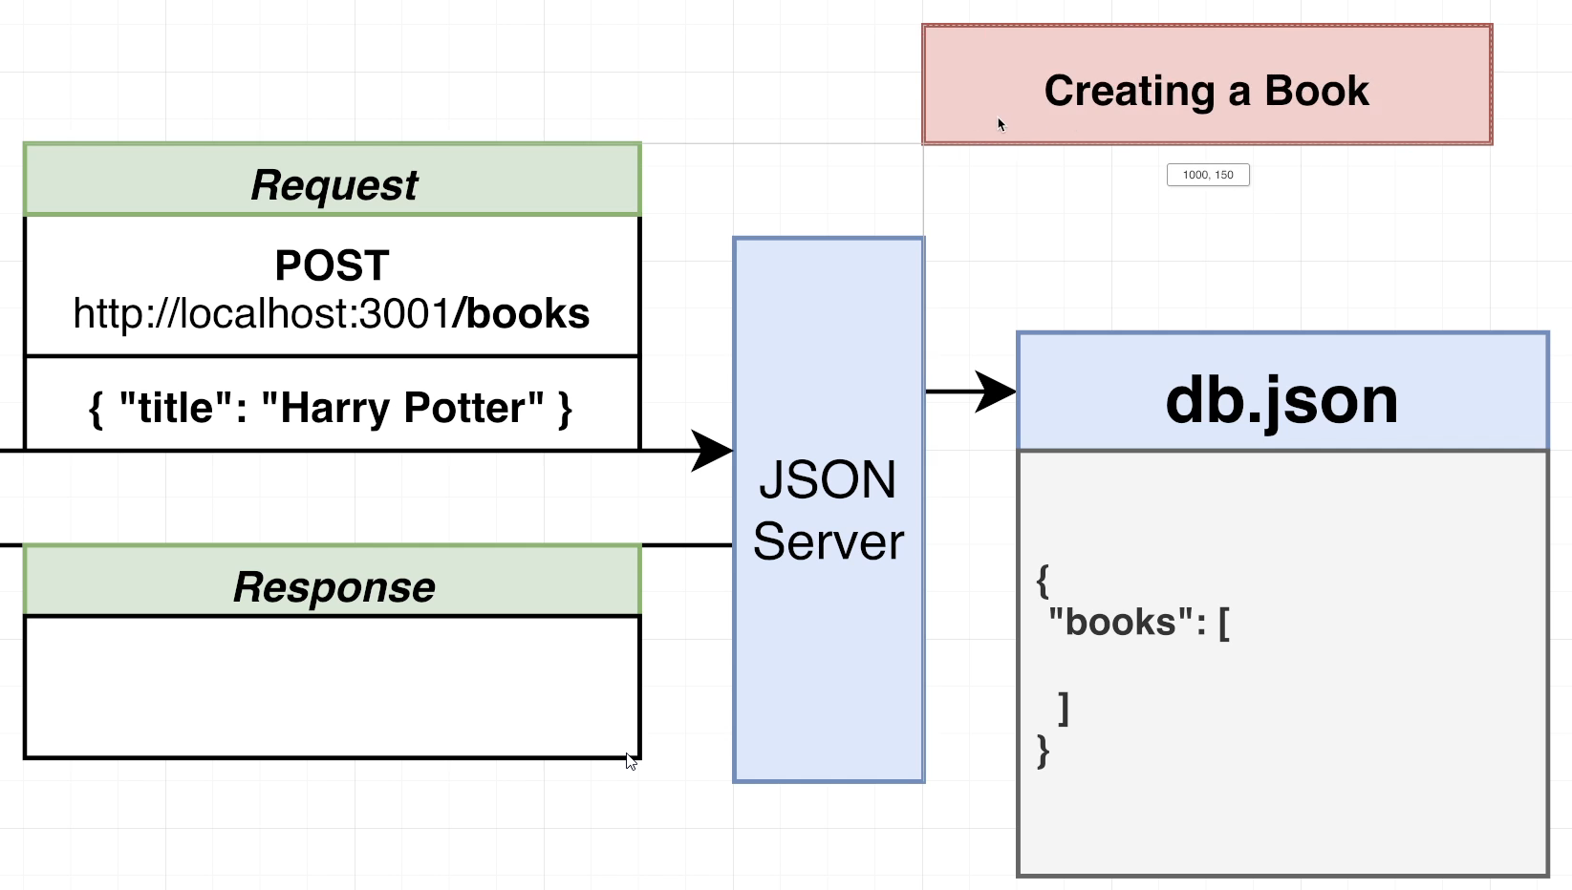

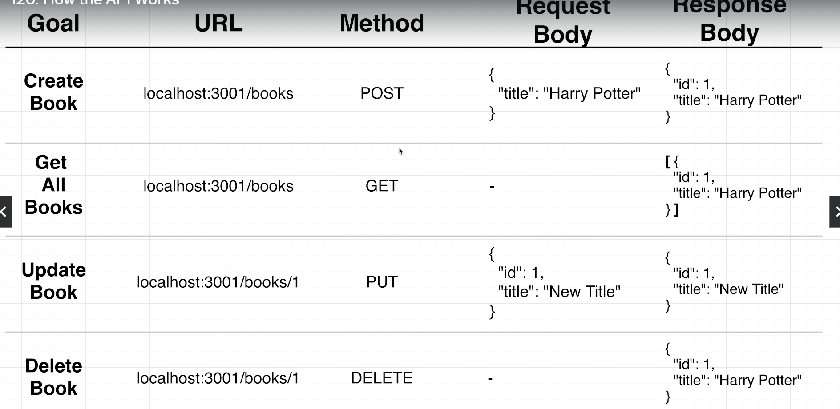

## 121. Introducing the REST Client

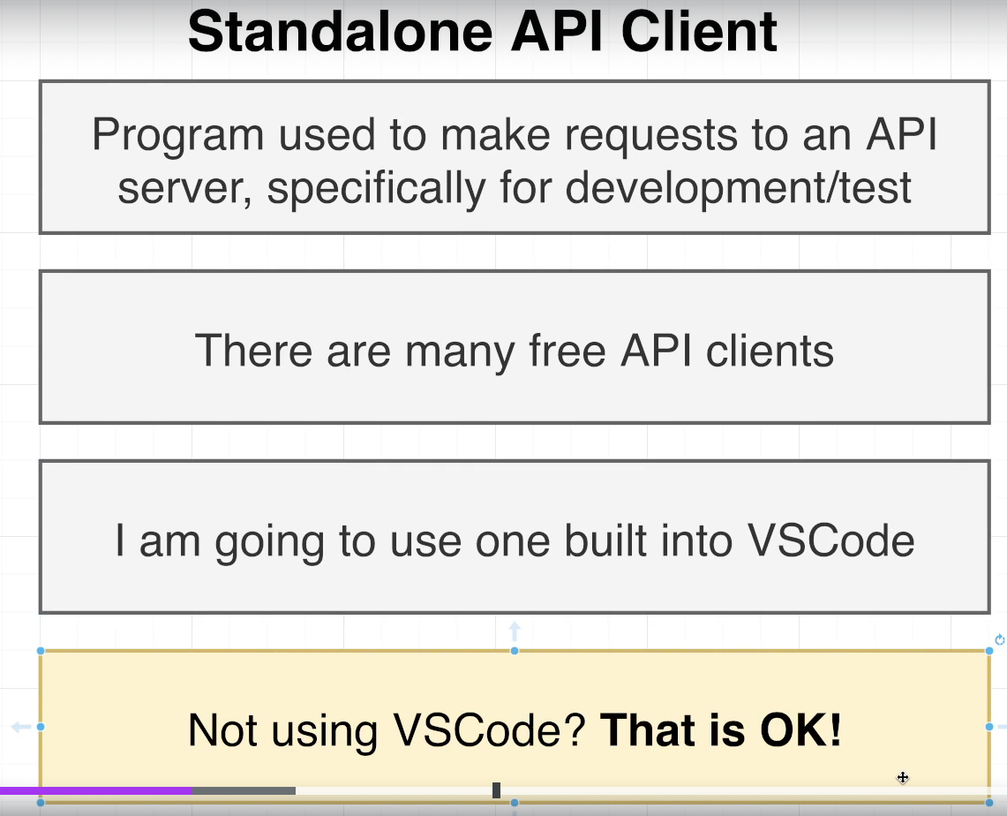

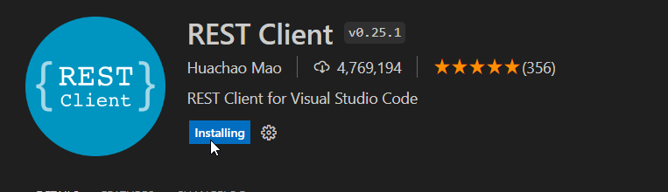

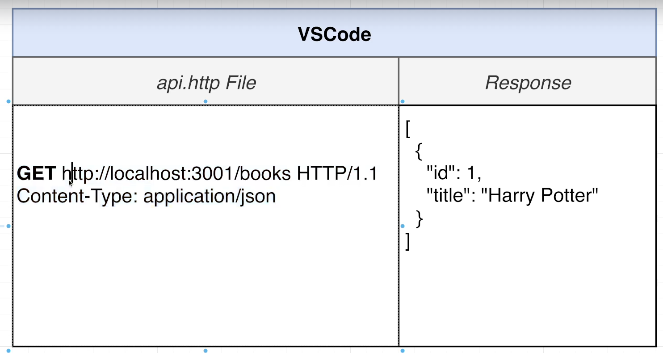

## 122. ECONNREFUSED 127.0.0.1:3001 Errors in VSCode

"server" : "json-server --port 3001 --watch db.json --host 127.0.0.1"

## 123. Using the REST Client

api.http is as follows for making request example:

# Get all books

GET http://localhost:3001/books HTTP/1.1

Content-Type: application/json

###

# Get a book

GET http://localhost:3001/books/1 HTTP/1.1

Content-Type: application/json

###

# Create a book

POST http://localhost:3001/books HTTP/1.1

Content-Type: application/json

{

    "title":"Harry Potter"

}

###

# Update the book

PUT http://localhost:3001/books/1 HTTP/1.1

Content-Type: application/json

{

    "title":"Dark Tower"

}

###

# Delete the book

DELETE http://localhost:3001/books/1 HTTP/1.1

Content-Type: application/json

## 124. Creating a New Record

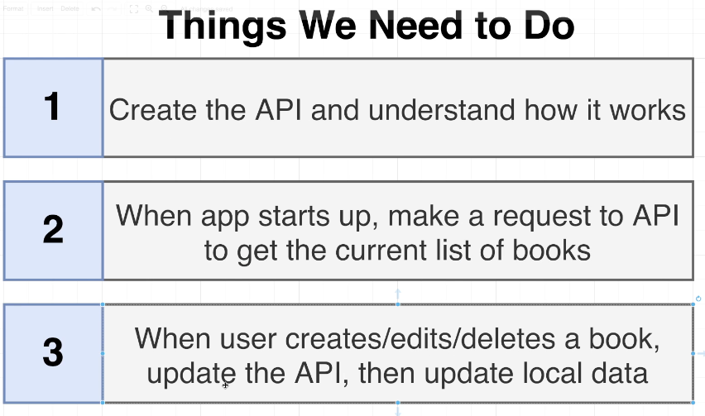

npm install axios

npm run start

 const createBook = async (title) => {

    console.log("Need to add book with:", title);

    const response = await axios.post('http://localhost:3001/books', { title });

    const updatedBooks = [ ...books, response.data];

    setBooks(updatedBooks);

  };

## 125. Fetching a List of Records

 const fetchBooks = async () => {

    const response = await axios.get("http://localhost:3001/books");

    setBooks(response.data);

  };

## 126. Introducing useEffect

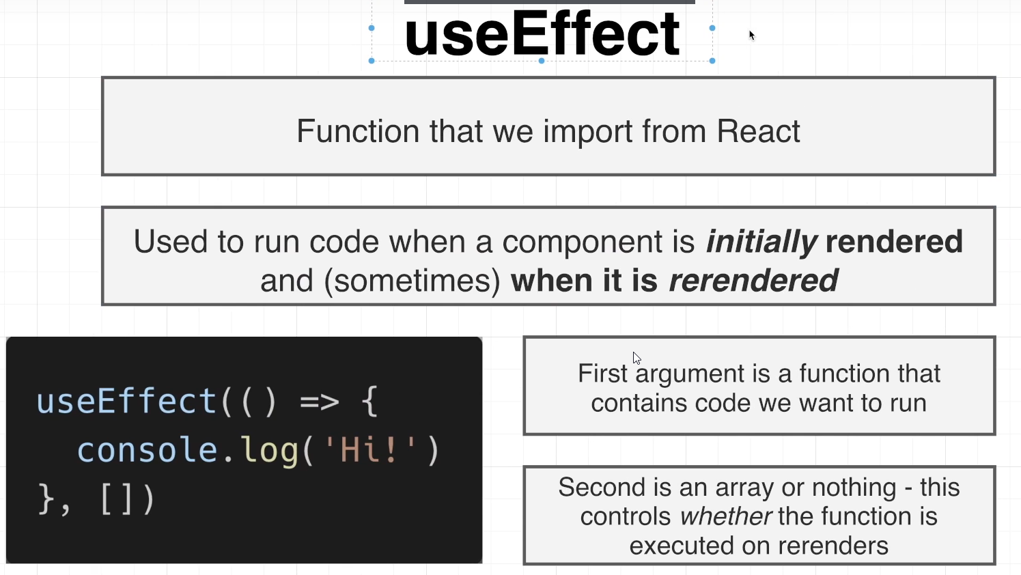

function App() {

  const [books, setBooks] = useState([]);

  useEffect(() => {

    fetchBooks();

  }, []);

  const fetchBooks = async () => {

    const response = await axios.get("http://localhost:3001/books");

    setBooks(response.data);

  };

## 127. useEffect in Action

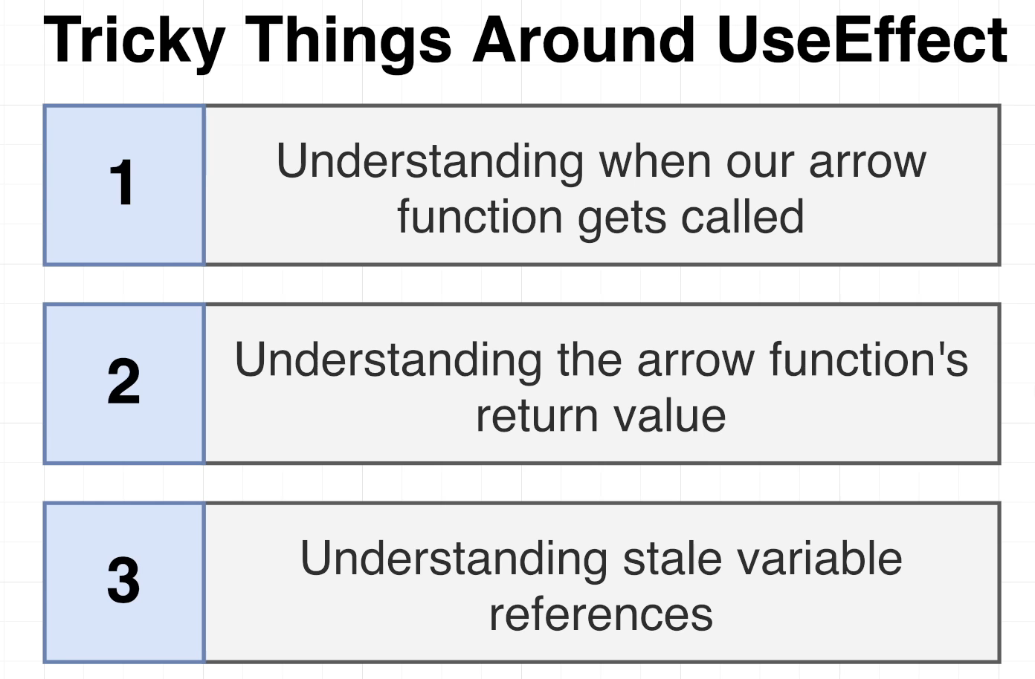

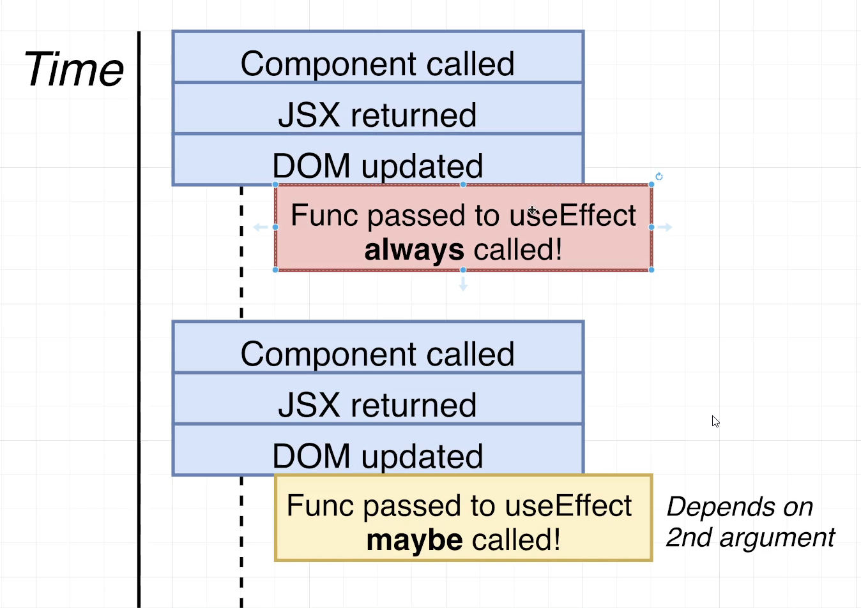

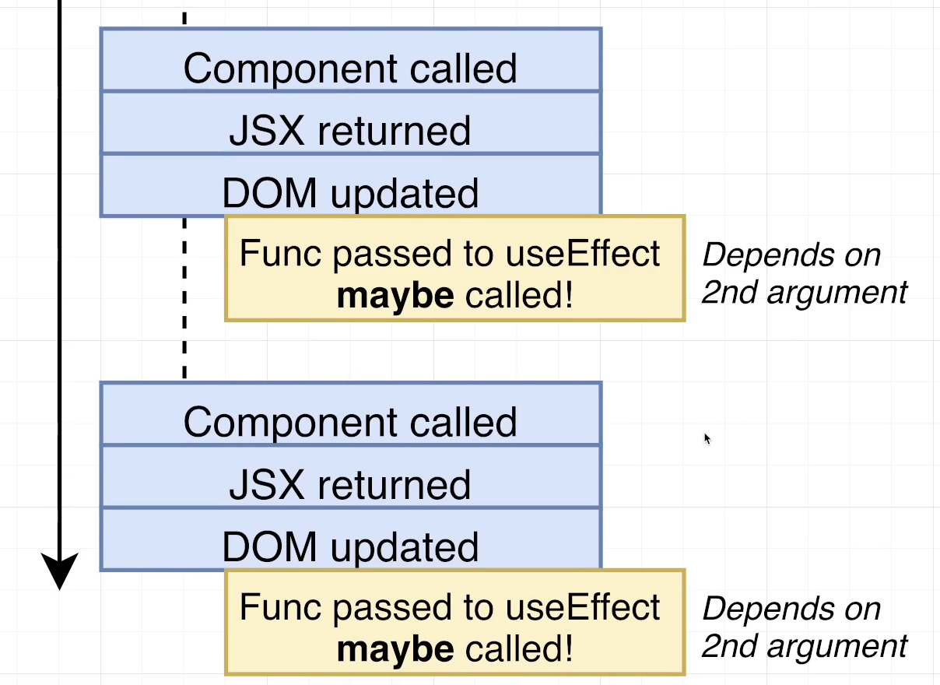

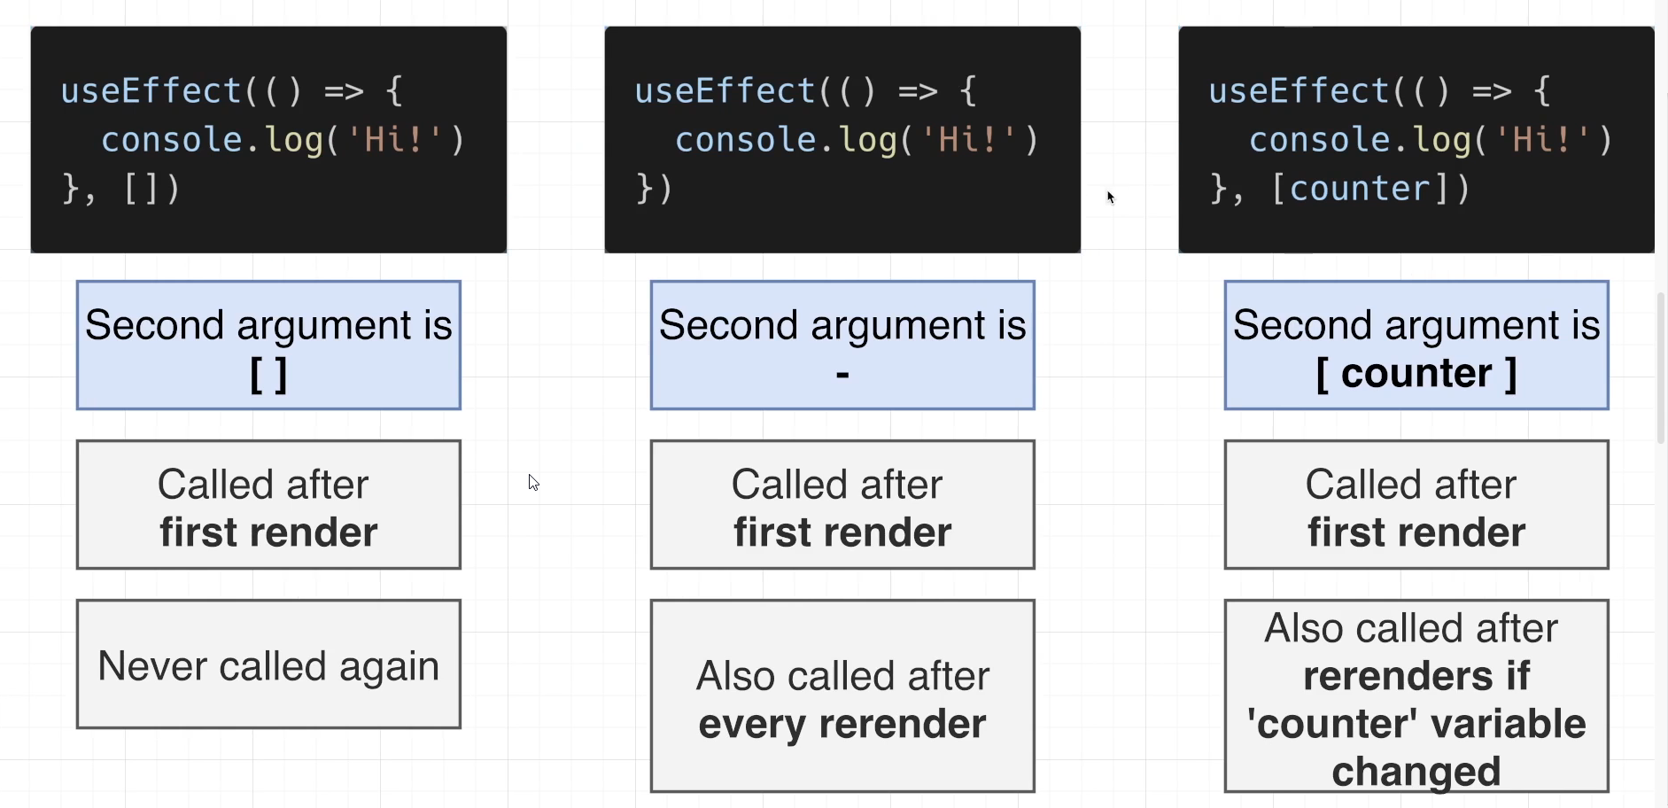

## 128. More on useEffect

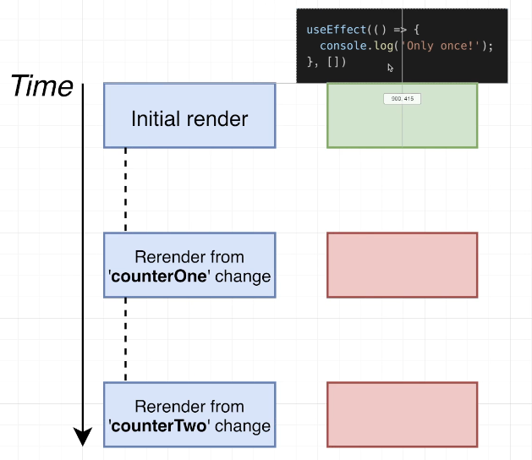

function App() {

  console.clear();

  const [counterOne, setCounterOne] = useState(0);

  const [counterTwo, setCounterTwo] = useState(0);

  useEffect(() => {

    console.log('Only once!');

  }, []);

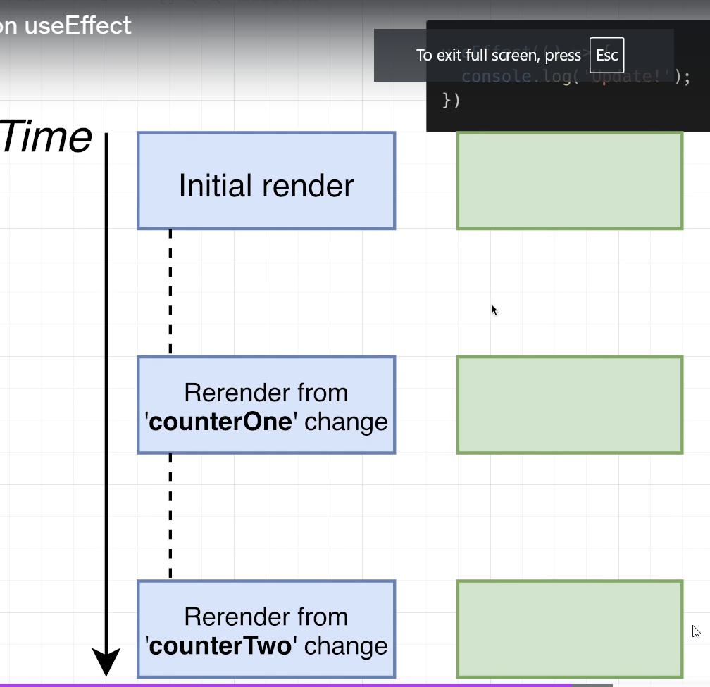

const { useState, useEffect } = React;

function App() {

  console.clear();

  const [counterOne, setCounterOne] = useState(0);

  const [counterTwo, setCounterTwo] = useState(0);

  useEffect(() => {

    console.log('called every time!');

  });

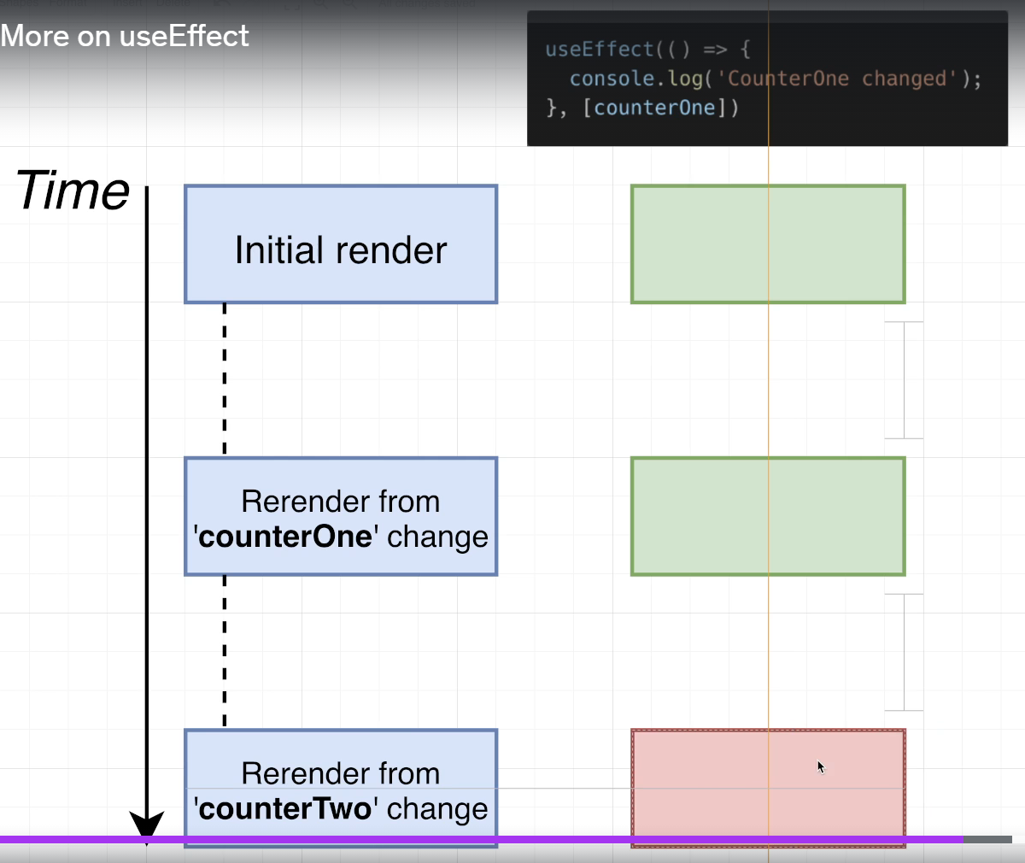

const { useState, useEffect } = React;

function App() {

  console.clear();

  const [counterOne, setCounterOne] = useState(0);

  const [counterTwo, setCounterTwo] = useState(0);

  useEffect(() => {

    console.log('CounterOne changed!');

  }, [counterOne]);

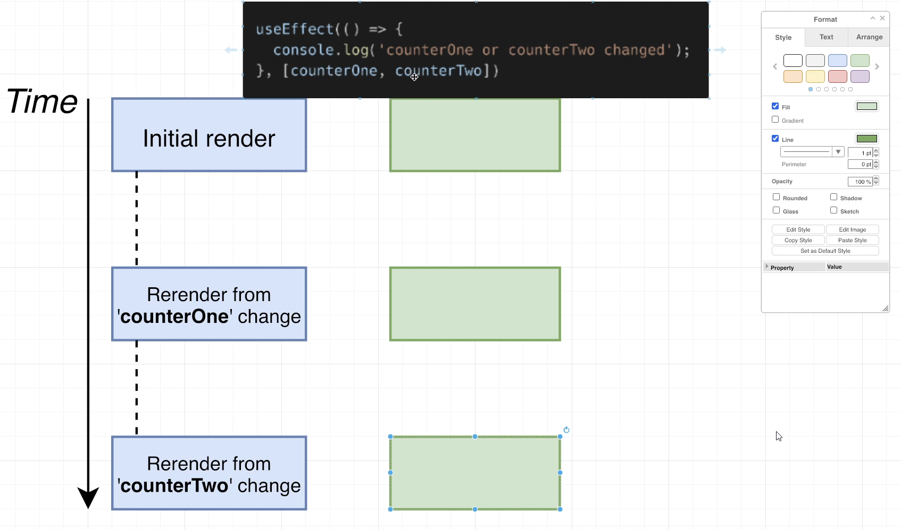

const { useState, useEffect } = React;

function App() {

  console.clear();

  const [counterOne, setCounterOne] = useState(0);

  const [counterTwo, setCounterTwo] = useState(0);

  useEffect(() => {

    console.log('CounterOne or counterTwo changed!');

  }, [counterOne, counterTwo]);

## Quiz 9: When Does it Run?

## 129. Updating a Record

## 130. Thinking About Updates

  const editBookById = async (id, newTitle) => {

    console.log("Need to edit book with id:", id);

    const response = await axios.put(`http://localhost:3001/books/${id}`, { title: newTitle });

    console.log(response);

    const updatedBooks = books.map((book) => {

      if (book.id === id) {

        return { ...book, ...response.data };

      }

      return book;

    });

    setBooks(updatedBooks);

  };

## 131. Deleting a Record

  const deleteBookById = async (id) => {

    console.log("Need to delete book with id:", id);

    await axios.delete(`http://localhost:3001/books/${id}`);

    const updatedBooks = books.filter((book) => {

      return book.id !== id;

    });

    setBooks(updatedBooks);

  };

# Section 8: Communication Using the Context System

## 132. Introducing Context

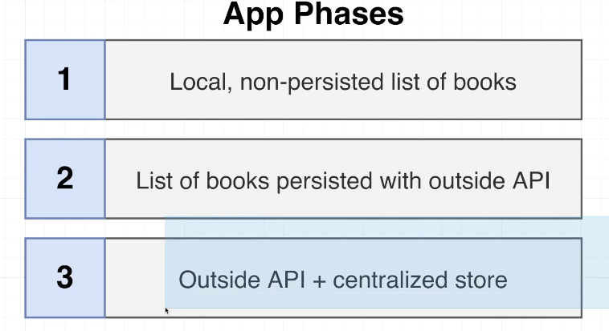

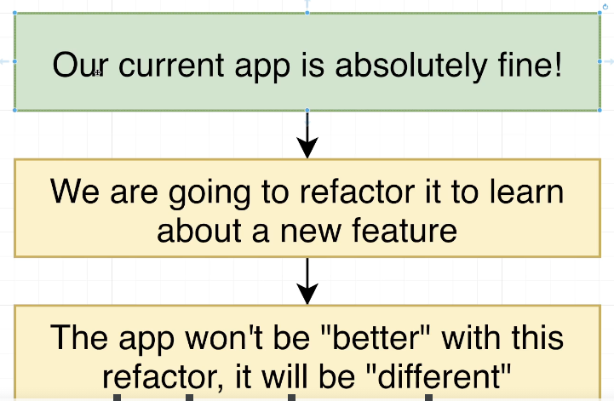

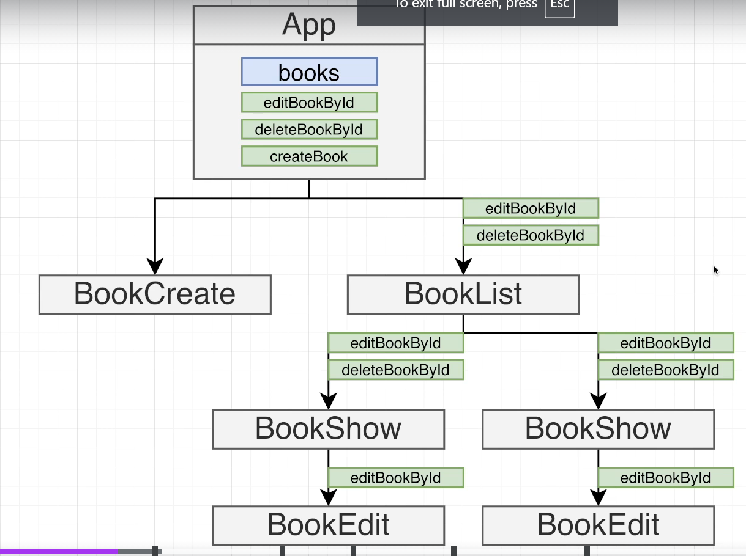

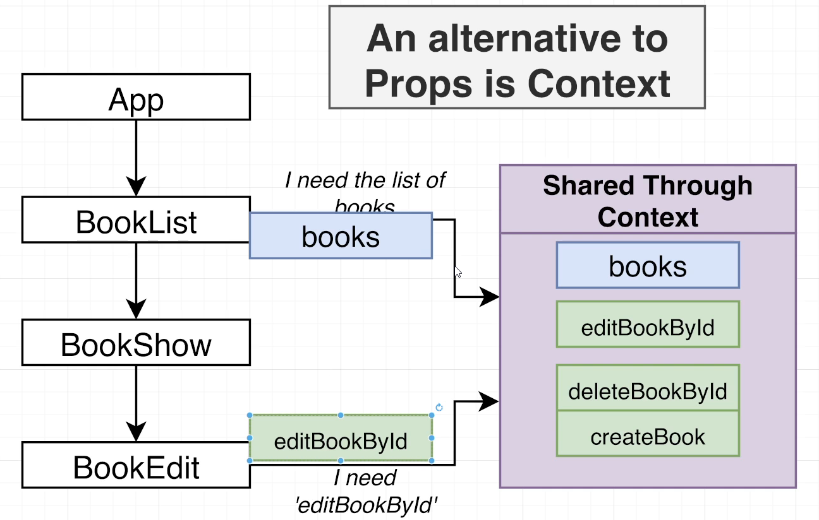

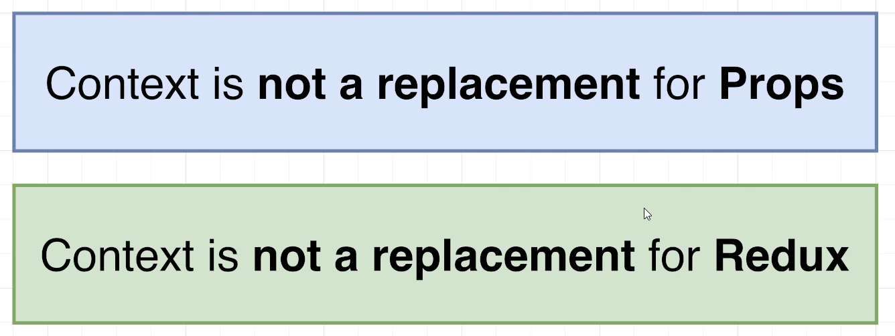

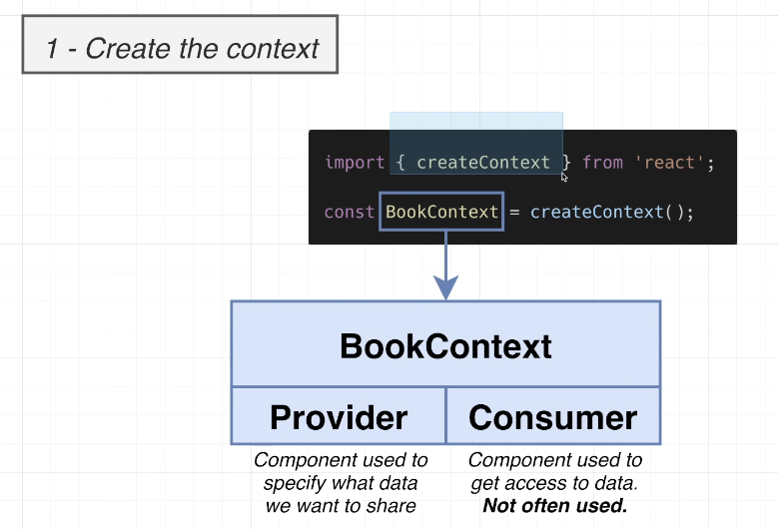

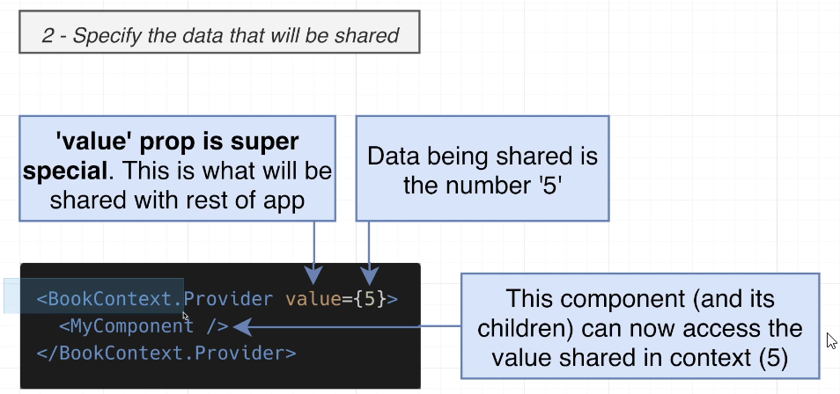

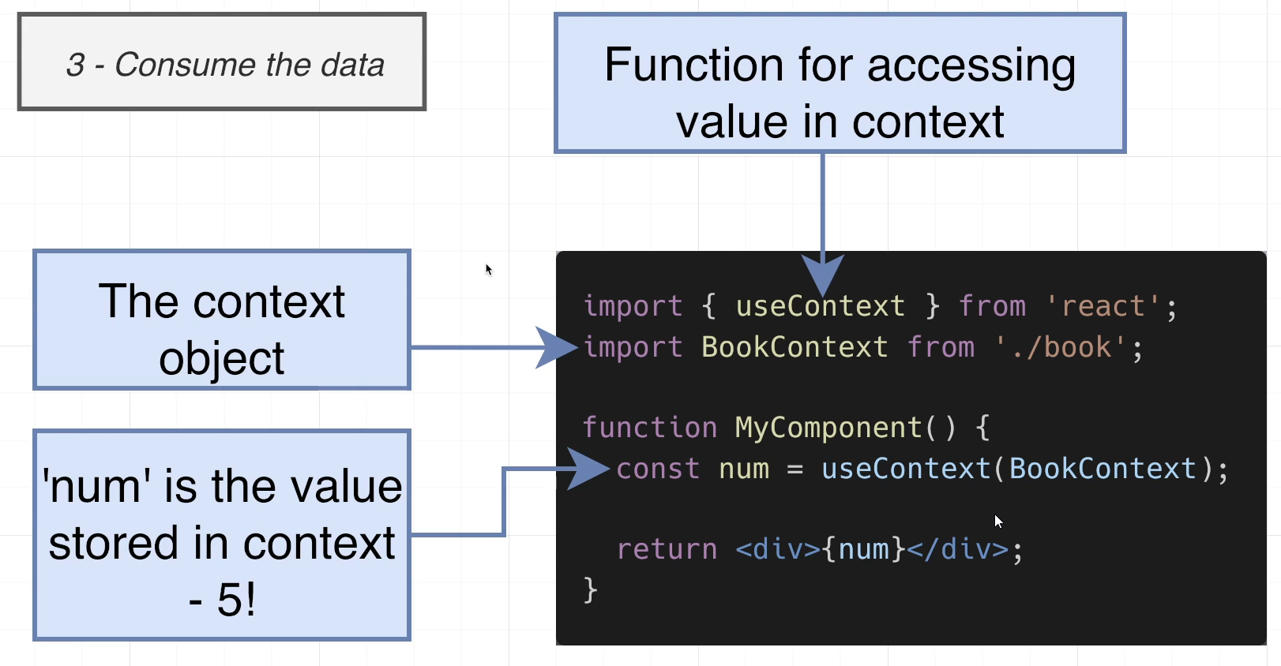

## 133. Context in Action

context -> books.js

import { createContext } from "react";

const BooksContext = createContext();

export default BooksContext;

index.js

import "./index.css";

import React from "react";

import ReactDOM from "react-dom/client";

import App from "./App";

import BooksContext from "./context/books";

const el = document.getElementById("root");

const root = ReactDOM.createRoot(el);

root.render(

  <BooksContext.Provider value={12}>

    <App />

  </BooksContext.Provider>

);

BookList.js

import { useContext } from "react";

import BooksContext from "../context/books";

import BookShow from "./BookShow";

function BookList({ books, onEdit, onDelete }) {

  const value = useContext(BooksContext);

  const renderedBooks = books.map((book) => {

    return (

      <BookShow onEdit={onEdit} onDelete={onDelete} key={book.id} book={book} />

    );

  });

  return (

    <div className="book-list">

      <div>

        {value}

        {renderedBooks}

      </div>

    </div>

  );

}

export default BookList;

## 134. Changing Context Values

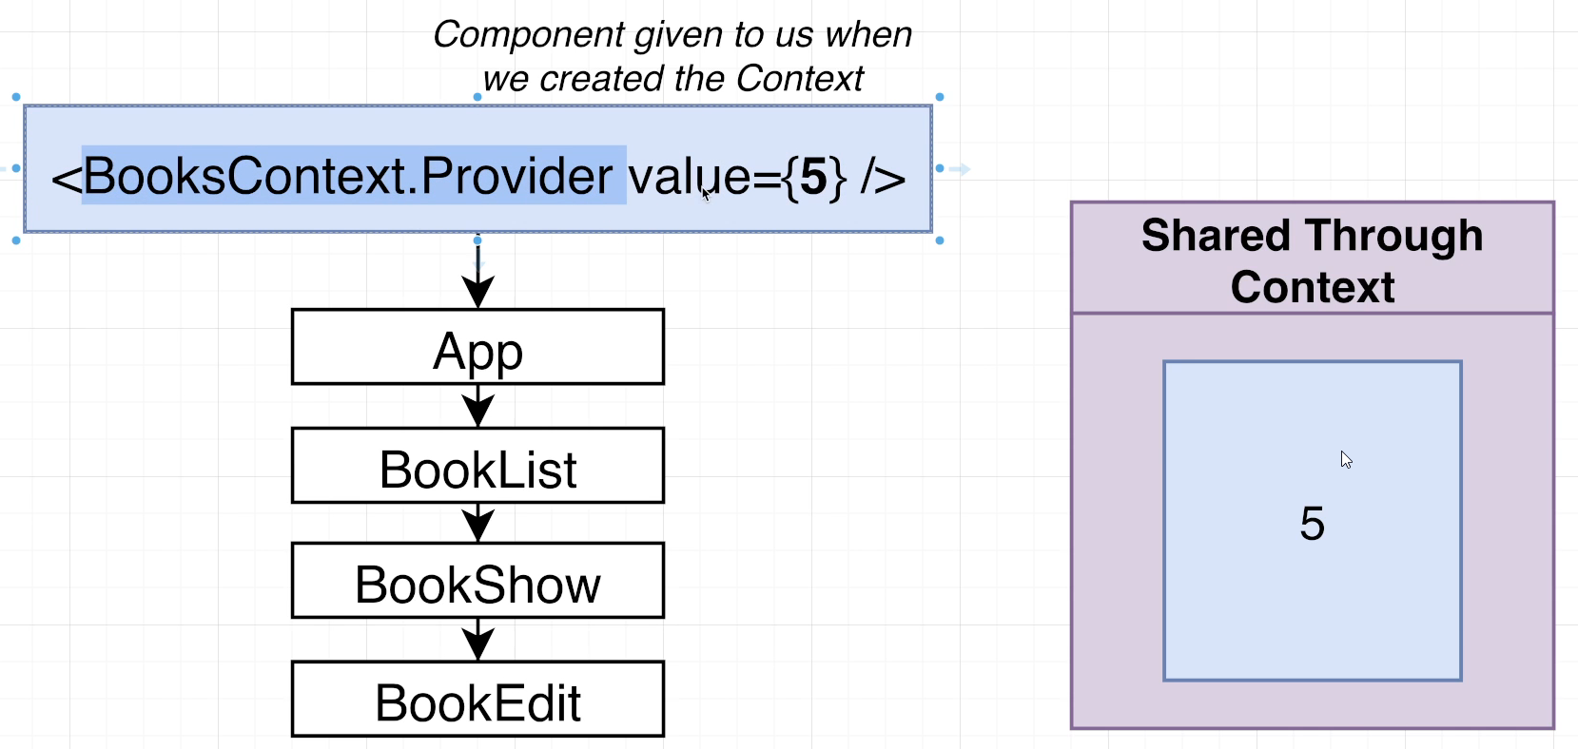

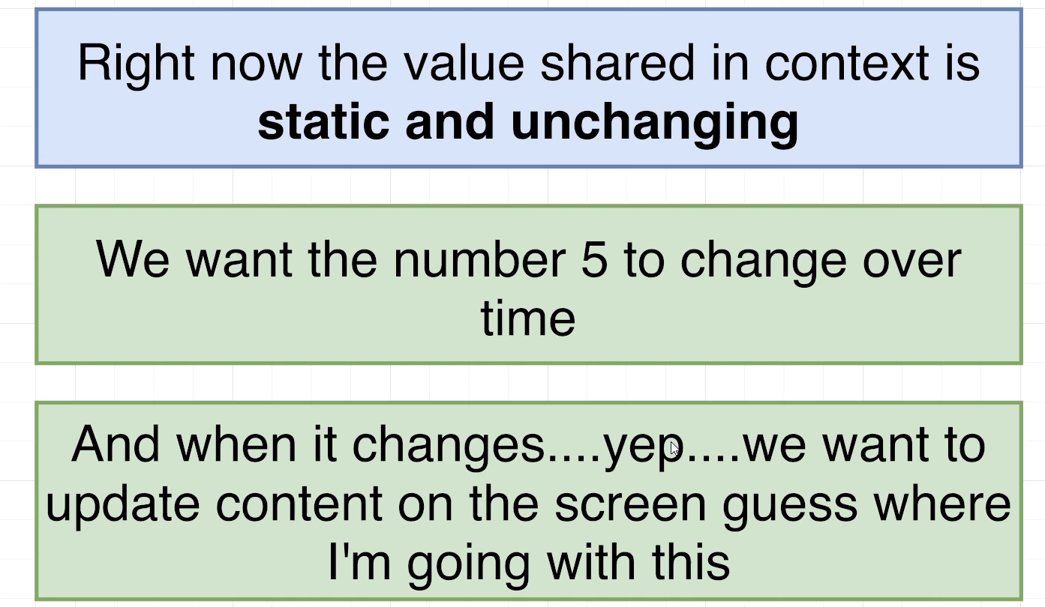

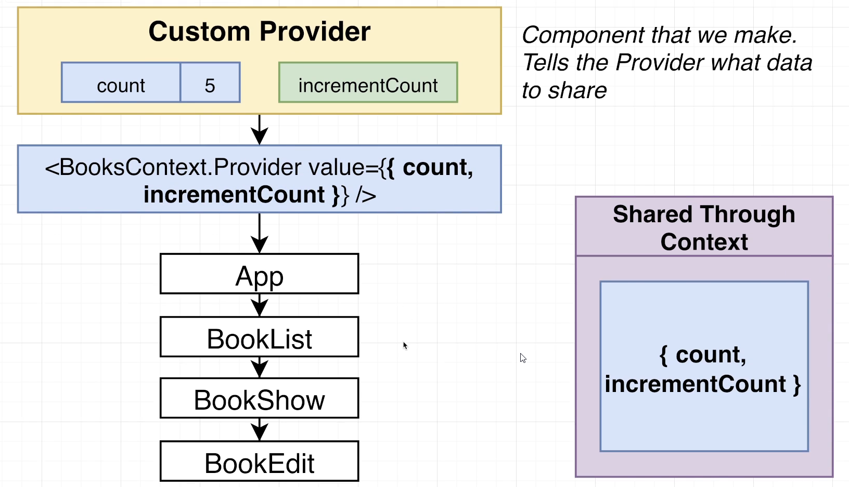

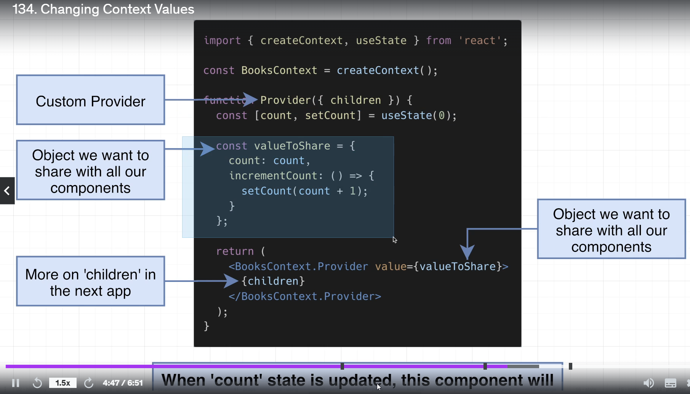

## 135. More on Changing Context

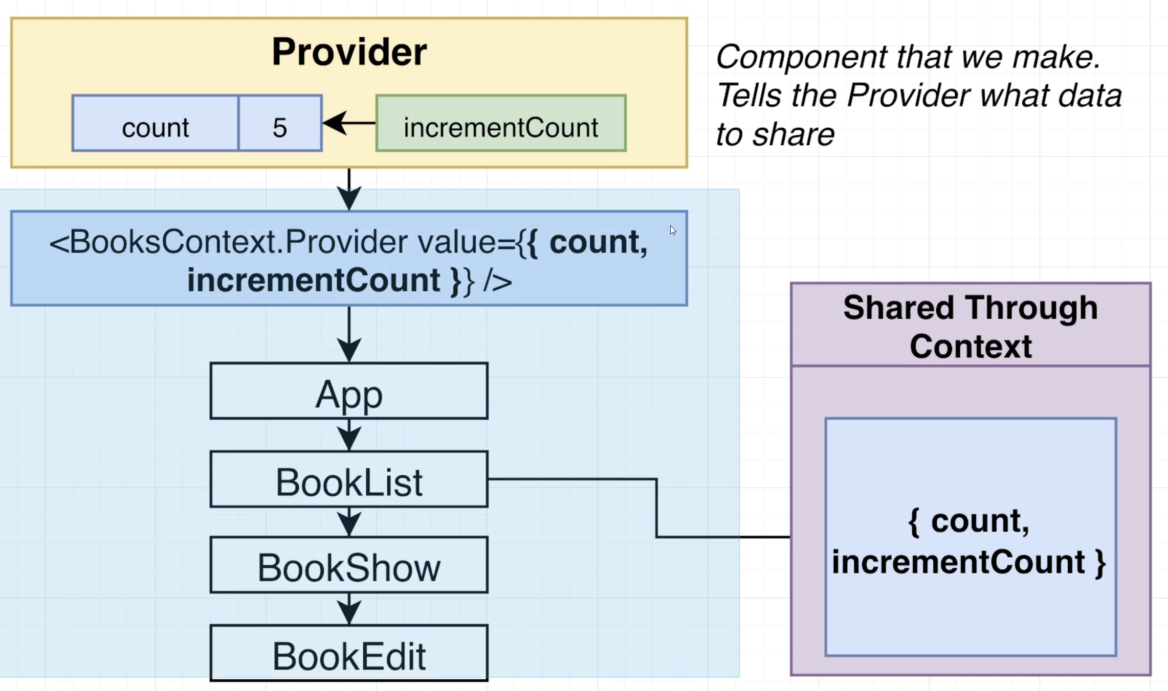

## 136. Application vs Component State

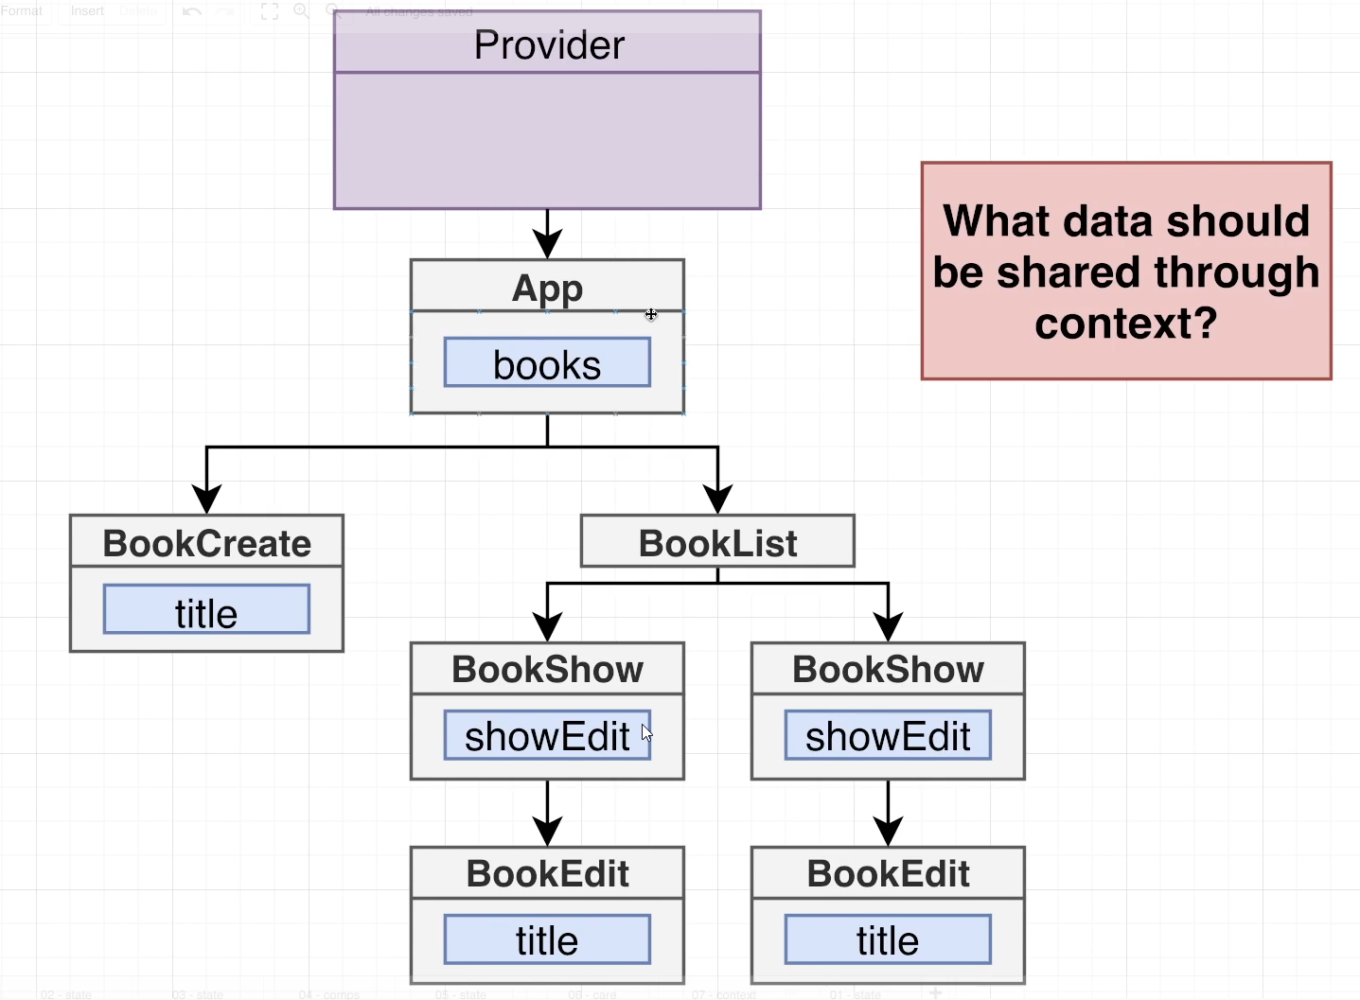

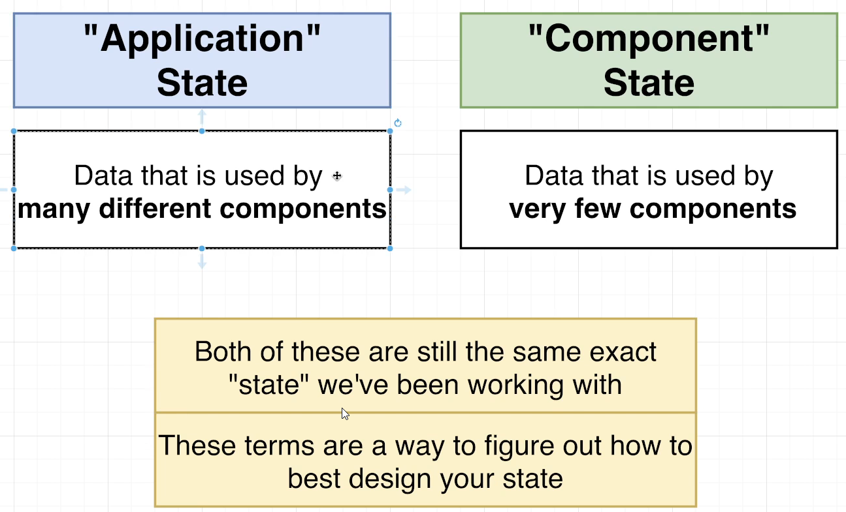

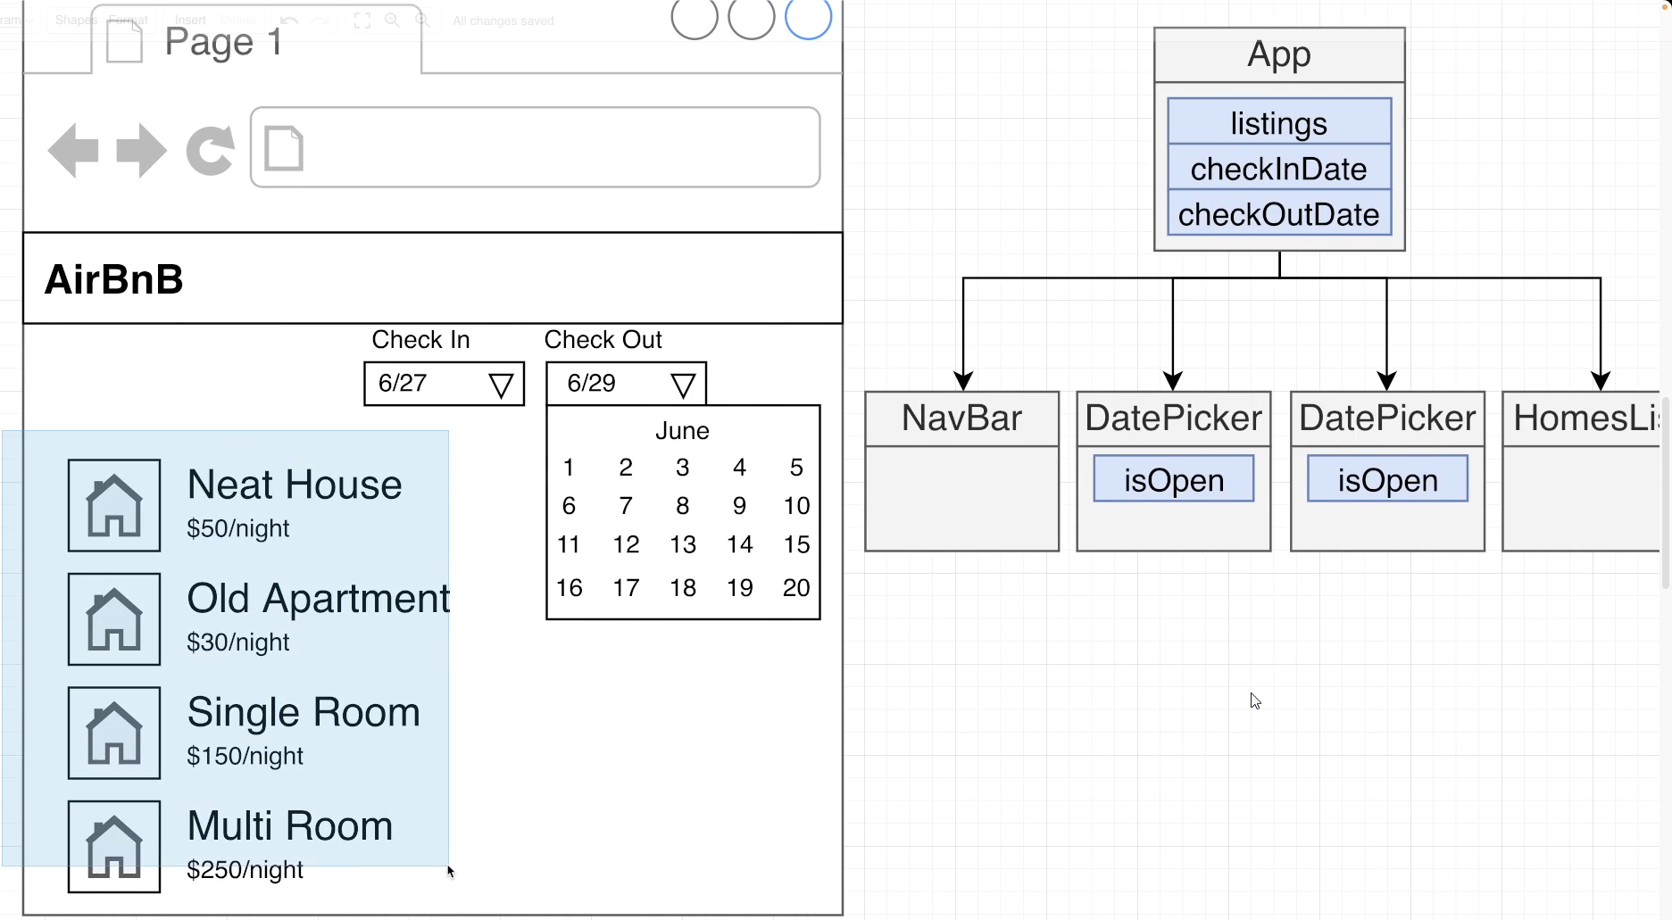

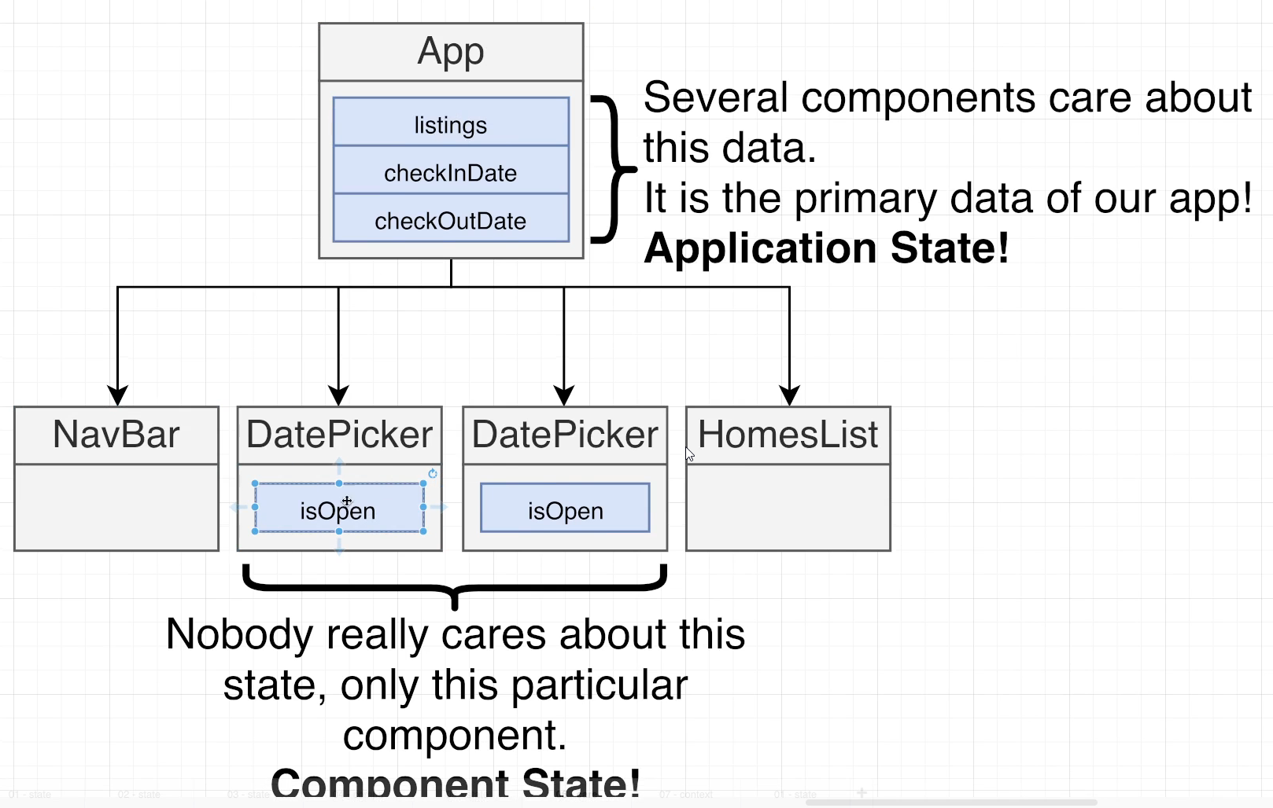

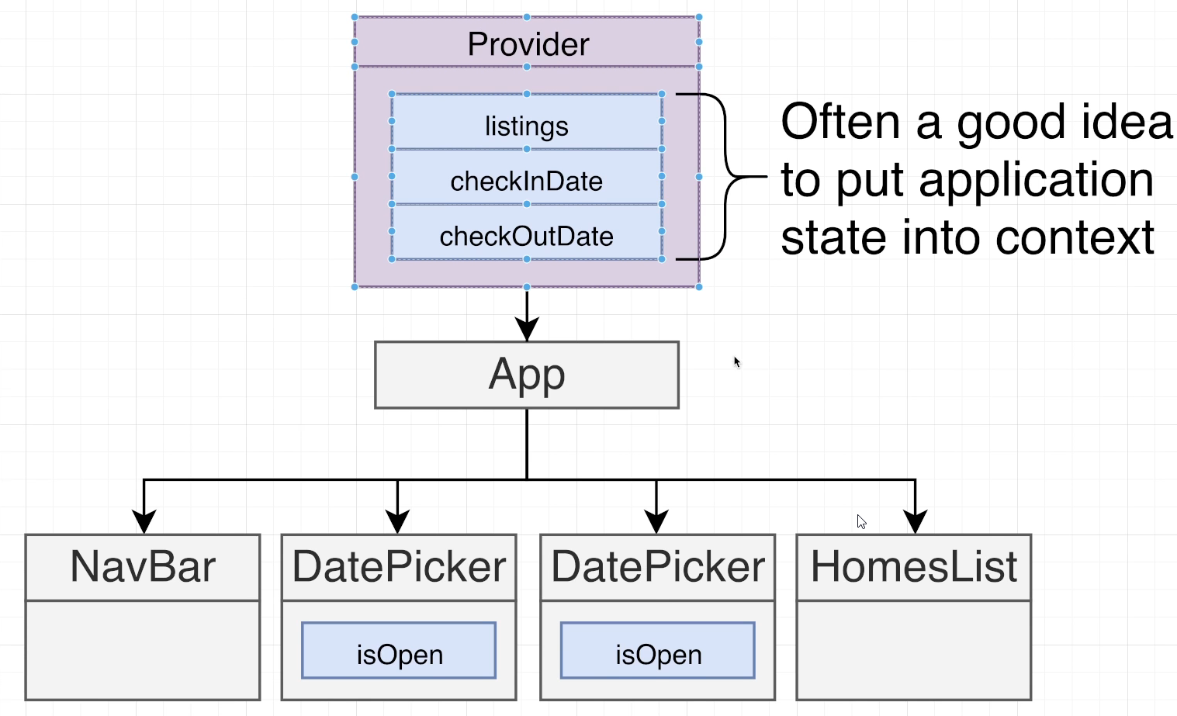

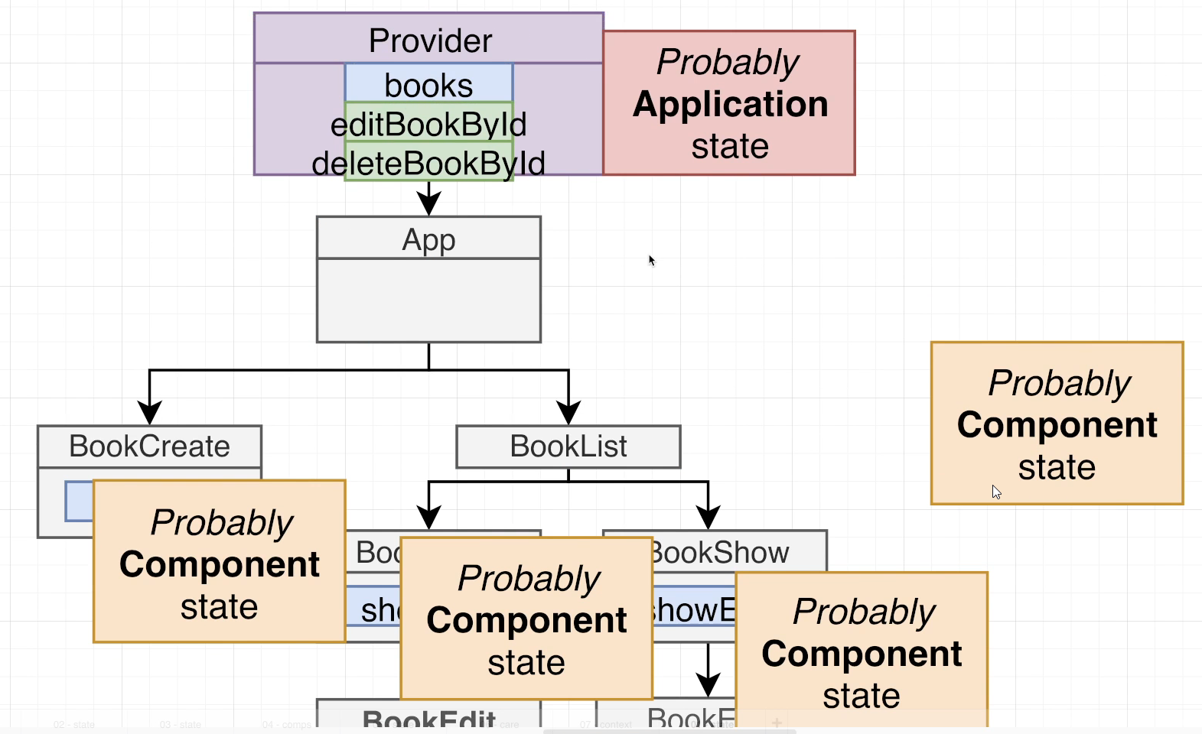

## 137. Refactoring to Use Context

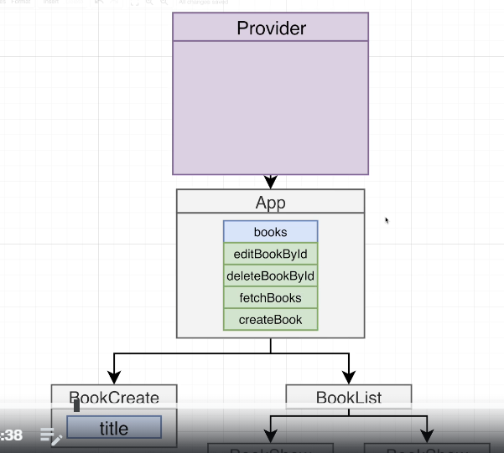

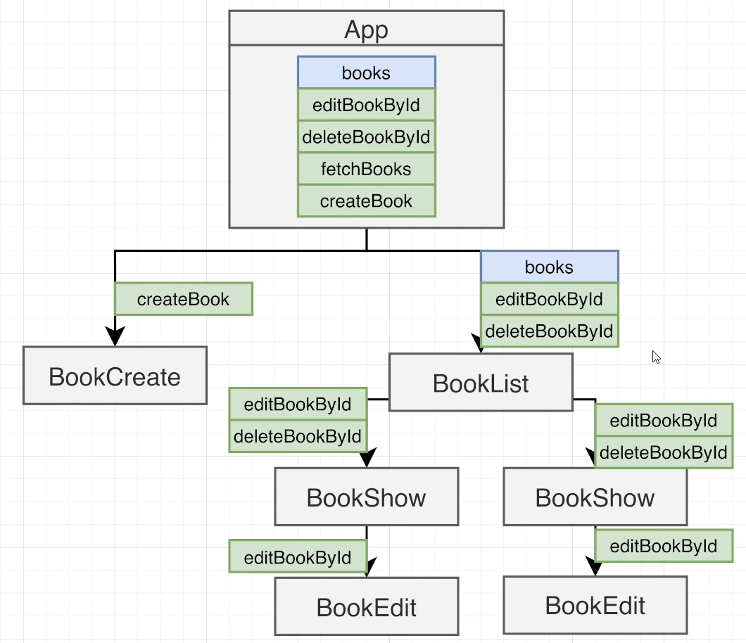

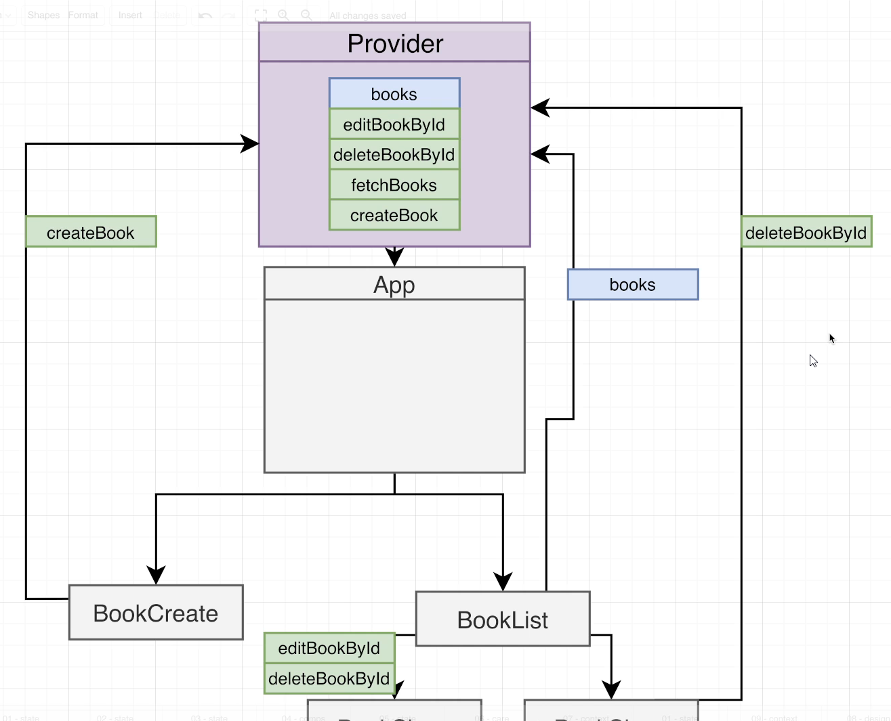

## 138. Refactoring the App

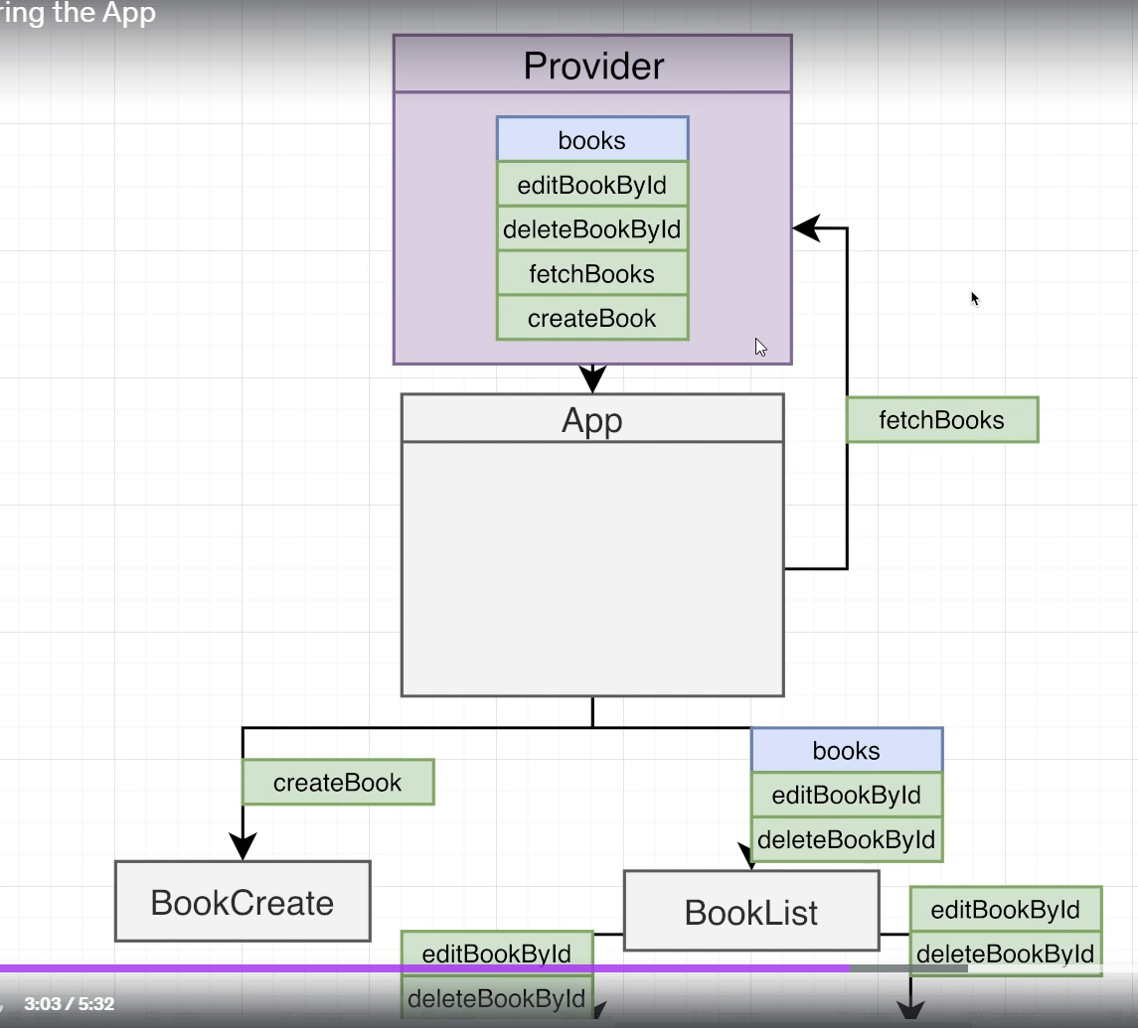

## 139. Quick Note

## 140. Reminder on Sharing with Context

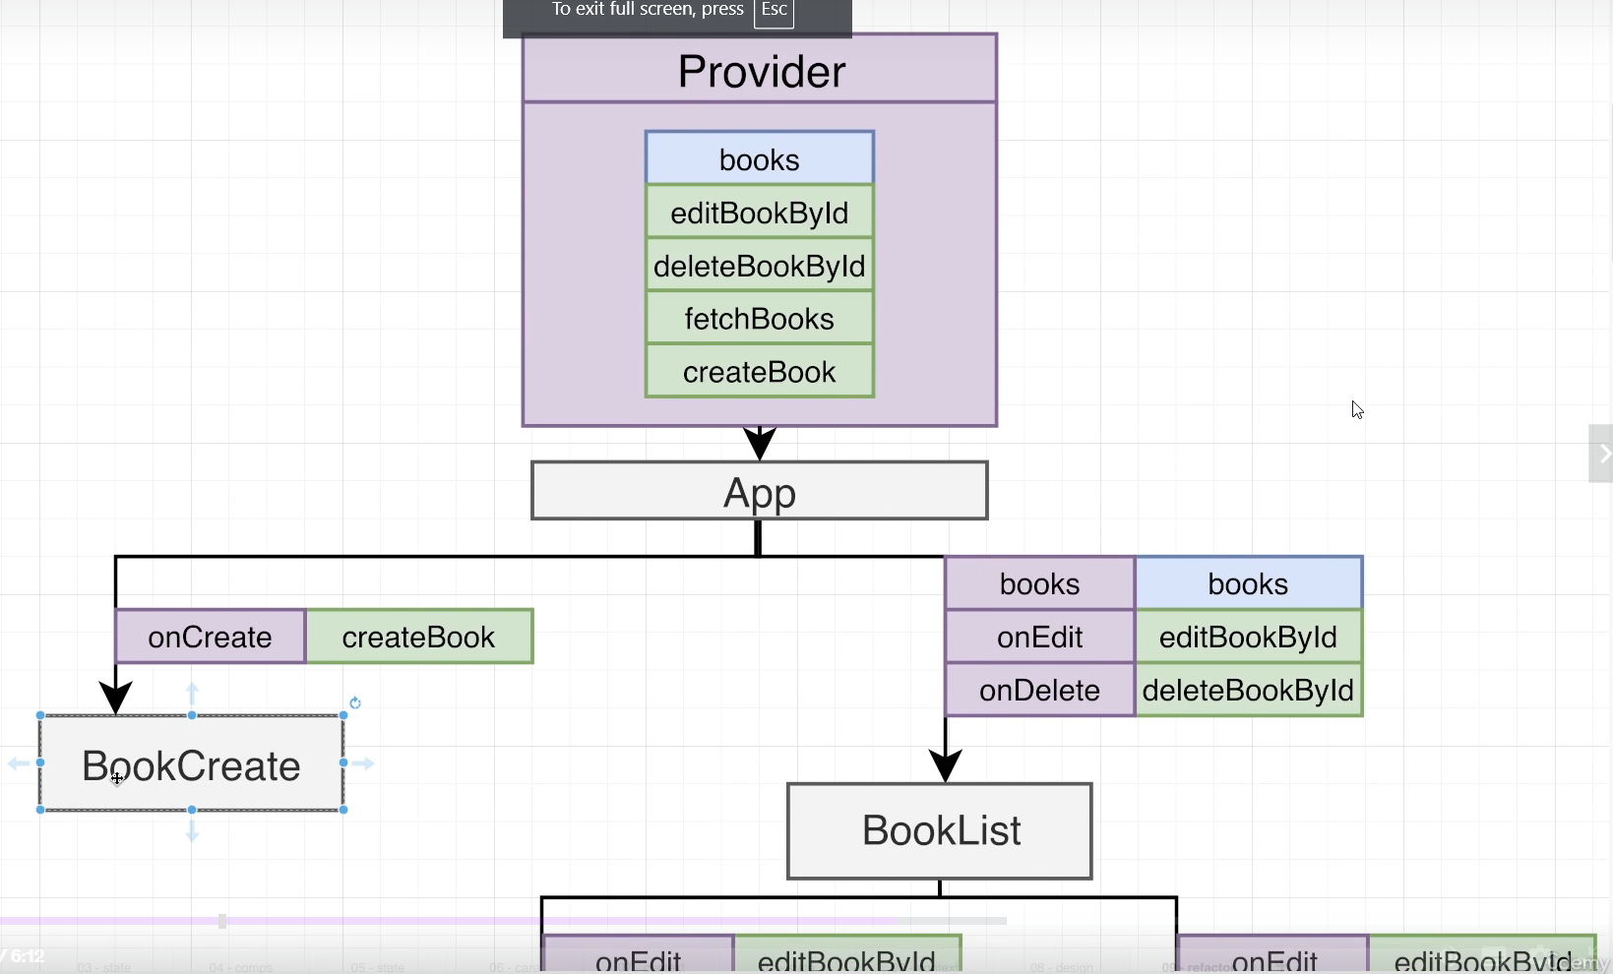

## 141. Props and Context Together

## 142. Last Bit of Refactoring

## 143. A Small Taste of Reusable Hooks

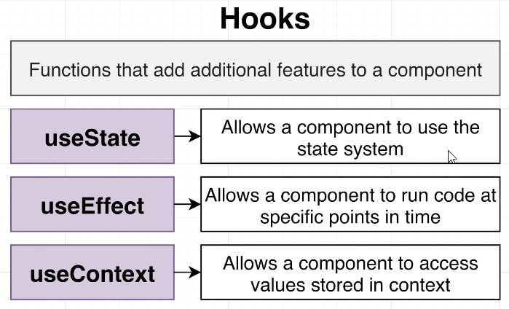

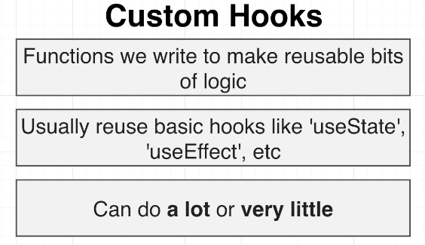

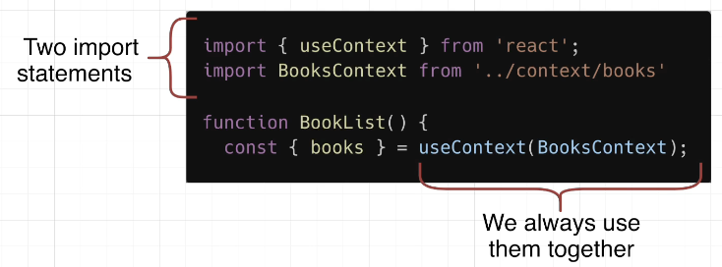

index.js

import "./index.css";

import React from "react";

import ReactDOM from "react-dom/client";

import App from "./App";

import { Provider } from "./context/books";

const el = document.getElementById("root");

const root = ReactDOM.createRoot(el);

root.render(

  <Provider>

    <App />

  </Provider>

);

App.js

import { useEffect, useContext } from "react";

import BookCreate from "./components/BookCreate";

import BookList from "./components/BookList";

import BooksContext from "./context/books";

function App() {

  const { fetchBooks } = useContext(BooksContext);

  useEffect(() => {

    fetchBooks();

  }, []);

  return (

    <div className="app">

      <h1>Reading List</h1>

      <BookList />

      <BookCreate />

    </div>

  );

}

export default App;

hooks->use-books-context.js

import { useContext } from "react";

import BooksContext from "../context/books";

function useBooksContext() {

    return useContext(BooksContext);

}

export default useBooksContext;

context->books.js

import { createContext, useState } from "react";

import axios from "axios";

const BooksContext = createContext();

function Provider({ children }) {

  const [books, setBooks] = useState([]);

  const fetchBooks = async () => {

    const response = await axios.get("http://localhost:3001/books");

    setBooks(response.data);

  };

  const editBookById = async (id, newTitle) => {

    console.log("Need to edit book with id:", id);

    const response = await axios.put(`http://localhost:3001/books/${id}`, {

      title: newTitle,

    });

    const updatedBooks = books.map((book) => {

      if (book.id === id) {

        return { ...book, ...response.data };

      }

      return book;

    });

    setBooks(updatedBooks);

  };

  const deleteBookById = async (id) => {

    console.log("Need to delete book with id:", id);

    await axios.delete(`http://localhost:3001/books/${id}`);

    const updatedBooks = books.filter((book) => {

      return book.id !== id;

    });

    setBooks(updatedBooks);

  };

  const createBook = async (title) => {

    console.log("Need to add book with:", title);

    const response = await axios.post("http://localhost:3001/books", {

      title,

    });

    const updatedBooks = [...books, response.data];

    setBooks(updatedBooks);

  };

  const valueToShare = {

    books,

    deleteBookById,

    editBookById,

    createBook,

    fetchBooks,

  };

  return (

    <BooksContext.Provider value={valueToShare}>

      {children}

    </BooksContext.Provider>

  );

}

export { Provider };

export default BooksContext;

components -> BookCreate.js

import { useState } from "react";

import useBooksContext from "../hooks/use-books-context";

function BookCreate() {

  const [title, setTitle] = useState("");

  const { createBook } = useBooksContext();

  const handleChange = (event) => {

    setTitle(event.target.value);

  };

  const handleSubmit = (event) => {

    event.preventDefault();

    createBook(title);

    setTitle("");

  };

  return (

    <div className="book-create">

      <h3>Add a Book</h3>

      <form onSubmit={handleSubmit}>

        <label>Title</label>

        <input className="input" value={title} onChange={handleChange} />

        <button className="button">Create!</button>

      </form>

    </div>

  );

}

export default BookCreate;

components -> BookEdit.js

import { useState } from "react";

import useBooksContext from "../hooks/use-books-context";

function BookEdit({ book, onSubmit }) {

  const [title, setTitle] = useState(book.title);

  const { editBookById } = useBooksContext();

  const handleChange = (event) => {

    setTitle(event.target.value);

  };

  const handleSubmit = (event) => {

    event.preventDefault();

    console.log("BookEdit->new title is:", title);

    onSubmit();

    editBookById(book.id, title);

  };

  return (

    <form onSubmit={handleSubmit} className="book-edit">

      <label>Title</label>

      <input className="input" value={title} onChange={handleChange} />

      <button className="button is-primary">Save</button>

    </form>

  );

}

export default BookEdit;

components -> BookList.js

import BookShow from "./BookShow";

import useBooksContext from "../hooks/use-books-context";

function BookList() {

  const { books } = useBooksContext();

  const renderedBooks = books.map((book) => {

    return <BookShow key={book.id} book={book} />;

  });

  return <div className="book-list">{renderedBooks}</div>;

}

export default BookList;

components -> BookShow.js

import { useState } from "react";

import BookEdit from "./BookEdit";

import useBooksContext from "../hooks/use-books-context";

function BookShow({ book }) {

  const [showEdit, setShowEdit] = useState(false);

  const { deleteBookById } = useBooksContext();

  const handleDeleteClick = () => {

    deleteBookById(book.id);

  };

  const handleEditClick = () => {

    setShowEdit(!showEdit);

  };

  const handleSubmit = () => {

    setShowEdit(false);

  };

  let content = <h3>{book.title}</h3>;

  if (showEdit) {

    content = <BookEdit onSubmit={handleSubmit} book={book} />;

  }

  return (

    <div className="book-show">

      <img alt="books" src={`https://picsum.photos/seed/${book.id}/300/200`} />

      <div>{content}</div>

      <div className="actions">

        <button className="edit" onClick={handleEditClick}>

          Edit

        </button>

        <button className="delete" onClick={handleDeleteClick}>

          Delete

        </button>

      </div>

    </div>

  );

}

export default BookShow;

# Section 9: Deeper Dive into Hooks!

## 144. Return to useEffect

## 145. Quick Note

## 146. Understanding the Issue

## 147. Applying the Fix

## 148. ESLint is Good, but be Careful!

## 149. Stable References with useCallback

## 150. Fixing Bugs with useCallback

## Quiz 10: Fixing UseEffect Bugs

## 151. useEffect Cleanup Functions

## 152. The Purpose of Cleanup Functions

# Section 10: Custom Navigation and Routing Systems:

## 153. Important Info About the Following Sections and Lectures

## 154. Project Overview

## 155. Project Setup

## 156. Some Button Theory

## 157. Underlying Elements

## 158. The Children Prop

## 159. Props Design

## 160. Validating Props with PropTypes

## 161. PropTypes in Action

## 162. Introducing TailwindCSS

## 163. Updated Guidance for Installing and Configuring Tailwind

## 164. Installing Tailwind

## 165. How to use Tailwind

## 166. Review on Styling

## 167. The ClassNames Library

## 168. Building Some Variations

## 169. text-white Overriding Other Colors

## 170. Finalizing the Variations

## 171. Using Icons in React Projects

## 172. Issues with Event Handlers

## 173. Passing Props Through

## 174. Handling the Special ClassName Case

## 175. Exclusive Props with TypeScript instead of PropTypes

# Section 11: Mastering the State Design Process:

## 176. Project Organization

## 177. Refactoring with Organization

## 178. Component Overview

## 179. Component Setup

## 180. Reminder on Building Lists

## 181. Quick Note

## 182. State Design Process Overview

## 183. Finding the Expanded Item

## 184. Conditional Rendering

## 185. Inline Event Handlers

## 186. Variation on Event Handlers

## 187. Conditional Icon Rendering

## 188. Displaying Icons

## 189. Adding Styling

## 190. Toggling Panel Collapse

## 191. Quick Note

## 192. [Optional] Delayed State Updates

## 193. [Optional] Functional State Updates

## Quiz 11: Conditional Rendering

## Coding Exercise 10: Event Handlers with Lists

## 194. Exercise Solution

# Section 12: Practicing Props and State Design:

## 195. Component Overview

## 196. Designing the Props

## 197. Component Creation

## 198. [Optional] More State Design

## 199. Finally... Implementation!

## 200. Reminder on Event Handlers in Maps

## 201. Dropdown as a Controlled Component

## 202. Controlled Component Implementation

## 203. Existence Check Helper

## 204. Community Convention with Props Names

## Coding Exercise 11: Form Controls - Prop Naming Convention

## 205. Exercise Solution

## 206. Adding Styling

## 207. The Panel Component

## 208. Creating the Reusable Panel

## 209. A Challenging Extra Feature

## 210. Document-Wide Click Handlers

## 211. Event Capture and Bubbling

## 212. Putting it All Together

## 213. Why a Capture Phase Handler?

## 214. Reminder on the useEffect Function

## 215. Reminder on useEffect Cleanup

## 216. Issues with Element References

## 217. useRef in Action

## 218. Checking Click Location

# Section 13: Making Navigation Reusable:

## 219. Traditional Browser Navigation

## 220. Theory of Navigation in React

## 221. Extracting the DropdownPage

## 222. Answering Critical Questions

## 223. The PushState Function

## 224. Handling Link Clicks

## 225. Handling Back:Forward Buttons

## 226. Navigation Context

## 227. Listening to Forward and Back Clicks

## 228. Programmatic Navigation

## 229. A Link Component

## 230. A Route Component

## 231. Handling Control and Command Keys

## 232. Link Styling

## 233. Custom Navigation Hook

## 234. Adding a Sidebar Component

## 235. Highlighting the Active Link

## 236. Navigation Wrapup

# Section 14: Creating Portals with ReactDOM:

## 237. Modal Component Overview

## 238. Toggling Visibility

## 239. At First Glance, Easy!

## 240. We're Lucky it Works At All!

## 241. Fixing the Modal with Portals

## 242. Closing the Modal

## 243. Customizing the Modal

## 244. Additional Styling

## 245. One Small Bug

## 246. Modal Wrapup

# Section 15: Make a Feature-Full Data Table!:

## 247. Creating a Reusable table

## 248. Communicating Data to the Table

## 249. Reminder on Table HTML Structure

## 250. Building the Rows

## 251. Better Styling

## 252. Done! But It's Not Reusable

## 253. Here's the Idea

## 254. Dynamic Table Headers

## 255. Rendering Individual Cells

## 256. Fixed Cell Values

## 257. Nested Maps

## 258. Fixing the Color

## 259. Adding a Key Function

# Section 16: Getting Clever with Data Sorting:

## 260. Adding Sorting to the Table

## 261. Reminder on Sorting in JavaScript

## 262. Sorting Strings

## 263. Sorting Objects

## 264. Object Sort Implementation

## 265. Reversing Sort Order

## 266. Optional Sorting

## 267. A Small Extra Feature

## 268. Customizing Header Cells

## 269. React Fragments

## 270. The Big Reveal

## 271. Adding SortableTable

## 272. Watching for Header Cell Clicks

## 273. Quick State Design

## 274. Adding Sort State

## 275. Yessssss, It Worked!

## 276. Determining Icon Set

## 277. Styling Header Cells

## 278. Resetting Sort Order

## 279. Table Wrapup

# Section 17: Custom Hooks In Depth:

## 280. Exploring Code Reuse

## 281. Revisiting Custom Hooks

## 282. Creating the Demo Component

## 283. Custom Hook Creation

## 284. Quick Note

## 285. Hook Creation Process in Depth

## 286. Making a Reusable Sorting Hook

# Section 18: Into the World of Reducers:

## 287. App Overview

## 288. Adding the Form

## 289. More on the Form

## 290. useReducer in Action

## 291. Rules of Reducer Functions

## 292. Understanding Action Objects

## 293. Constant Action Types

## 294. Refactoring to a Switch

## 295. Adding New State Updates

## 296. A Few Design Considerations Around Reducers

## Quiz 12: A Few Questions on Reducers

## 297. Introducing Immer

## 298. Immer in Action

# Section 19: Dive Into Redux Toolkit:

## 299. Into the World of Redux

## 300. Redux vs Redux Toolkit

## 301. App Overview

## 302. The Path Forward

## 303. Implementation Time!

## 304. Understanding the Store

## 305. The Store's Initial State

## 306. Understanding Slices

## 307. Understanding Action Creators

## 308. Connecting React to Redux

## 309. Updating State from a Component

## 310. Accessing State in a Component

## 311. Removing Content

## 312. Practice Updating State!

## 313. Practice Accessing State!

## 314. Even More State Updating!

## 315. Resetting State

## 316. Multiple State Updates

## 317. Understanding Action Flow

## 318. Watching For Other Actions

## 319. Getting an Action Creator's Type

## 320. Manual Action Creation

## 321. File and Folder Structure

## 322. Refactoring the Project Structure

## 323. Link to Completed Project

# Section 20: Managing Multiple Slices with Redux Toolkit:

## 324. Project Overview

## 325. Adding Component Boilerplate

## 326. Thinking About Derived State

## 327. Thinking About Redux Design

## 328. Adding the Form Slice

## 329. Maintaining a Collection with a Slice

## 330. Creating the Store

## 331. Form Values to Update State

## 332. Receiving the Cost

## 333. Dispatching During the Form Submission

## 334. Awkward Double Keys

## 335. Listing the Records

## 336. Deleting Records

## 337. CSS File for Download

## 338. Adding Styling

## 339. Form Reset on Submission

## 340. Reminder on ExtraReducers

## 341. Adding a Searching Input

## 342. Derived State in useSelector

## 343. Total Car Cost

## 344. Highlighting Existing Cars

# Section 21: Interfacing with API's Using Async Thunks:

## 345. App Overview

## 346. Adding a Few Dependencies

## 347. Initial App Boilerplate

## 348. API Server Setup

## 349. Component Files

## 350. Adding a Few Components

## 351. Creating the Redux Store

## 352. Thinking About Data Structuring

## 353. Reminder on Request Conventions

## 354. Data Fetching Techniques

## 355. Optional Async Thunks Section

## 356. Adding State for Data Loading

## 357. Understanding Async Thunks

## 358. Steps for Adding a Thunk

## 359. More on Adding Thunks

## 360. Wrapping up the Thunk

## 361. Using Loading State

## 362. Adding a Pause for Testing

## 363. Adding a Skeleton Loader

## 364. Animations with TailwindCSS

## 365. Rendering the List of Users

## 366. Creating New Users

## 367. Unexpected Loading State

## 368. Strategies for Fine-Grained Loading State

## 369. Local Fine-Grained Loading State

## 370. More on Loading State

## 371. Handling Errors with User Creation

## 372. Creating a Reusable Thunk Hook

## 373. Creating a Fetch-Aware Button Component

## 374. Better Skeleton Display

## 375. A Thunk to Delete a User

## 376. Updating the Slice

## 377. Refactoring the Component

## 378. Deleting the User

## 379. Fixing a Delete Error

## 380. Album Feature Overview

## 381. Additional Components

## 382. Adding the ExpandablePanel

## 383. Wrapping Up the ExpandablePanel

## 384. Adding the Albums Listing

# Section 22: Modern Async with Redux Toolkit Query:

## 385. Skipping to this Section?

## 386. [Optional] Getting Caught Up

## 387. Introducing Redux Toolkit Query

## 388. Creating a RTK Query API

## 389. Creating an Endpoint

## 390. Using the Generated Hook

## 391. A Few Immediate Notes

## 392. Rendering the List

## 393. Changing Data with Mutations

## 394. Differences Between Queries and Mutations

## 395. Options for Refetching Data

## 396. Request De-Duplication

## 397. Some Internals of Redux Toolkit Query

## 398. Refetching with Tags

## 399. Fine-Grained Tag Validation

## 400. Styling Fixups

## 401. Adding a Pause for Testing

## 402. Refactoring the List

## 403. Remove Implementation

## 404. Easy Tag Invalidation

## 405. Getting Clever with Cache Tags

## 406. More Clever Tag Implementation

## 407. Photos Feature Overview

## 408. Lots of Photos Setup!

## 409. Adding the Endpoints

## 410. Creating the Photo

## 411. Showing the List of Photos

## 412. Adding Mouse-Over Deletes

## 413. Adding Automatic Data Refetching

# Section 23: Diving Into TypeScript:

## 414. Why Use Typescript?

## 415. Basic Types and Type Annotations

## 416. Function Type Annotations

## 417. Type Inference

## Quiz 13: Quiz - Type Annotations and Type Inference

## 418. Describing Objects with Interfaces

## 419. Using Interfaces to Annotate Props

## Quiz 14: Quiz - Props with Interfaces

## 420. Downsides to Type Inference

## 421. Function Types

## 422. Function Types in Props Interfaces

## Quiz 15: Quiz - Function Types

## 423. Extending an Interface

## 424. Type Unions

## 425. Type Narrowing with Type Guards

## 426. Tricky Cases with Type Guards

## Quiz 16: Quiz - Type Narrowing and Guards

## 427. Type Predicates

## 428. Optional Properties

## Quiz 17: Quiz - Optional Properties

## 429. The "Any" and "Unknown" Types

## 430. Type Aliases

## 431. Life Without Generics

## 432. Introduction to Function Generics

## 433. More on Function Generics

## 434. Multiple Generic Types

## 435. More Generic Examples!

## 436. Generics with Fetch

## 437. Generic Type Inference

## 438. More on Generic Type Inference

## 439. Issues with Generic Type Inference

## 440. Generic Type Constraints

## 441. More on Generic Type Constraints

## 442. TypeScript Wrapup

# Section 24: Build a Google Maps Clone with Typescript:

## 443. Project Overview

## 444. Project Setup

## 445. Component Creation

## 446. App Architecture

## 447. Defining an Interface

## 448. Typing of Props

## 449. Type Inference Around useState

## 450. Typing a Callback

## 451. Form Submissions with TypeScript

## 452. Searching with the OSM API

## 453. Why Use Interfaces?

## 454. Rendering the Locations

## 455. Showing and Panning a Map

## 456. App Review

# Section 25: Navigation and Data Fetching with React Router:

## 457. App Overview

## 458. Project Setup

## 459. Introducing React Router

## 460. React Router Setup

## 461. Navigating with a Link

## 462. Programmatic Navigation

## 463. Form Submission Navigation Shortcut

## 464. A Touch of Styling

## 465. The Registry API

## 466. Fetching Data with React Router

## 467. More on Fetching with a Loader

## 468. Designing New Types

## 469. An Improved Project Structure

## 470. Mapping the Response

## 471. Extracting the Loader

## 472. Connecting the Page and Loader

## 473. Rendering the List of Results

## 474. Focusing on the Details Page

## 475. Details Interface

## 476. Fetching Details

## 477. Creating the Details Loader

## 478. Accessing Route Params

## 479. Typing the Page and Loader Together

## 480. Rendering Package Details

## 481. Error Around the Name Property

## 482. Fetching Packages in Parallel

## 483. Creating the Home Loader

## 484. Accessing the Data from a Loader

## 485. Assembling the Home Page

## 486. React Router Review

# Section 26: Legacy Version of Modern React with Redux Course:

## 487. Note About This Legacy Course

## 488. What is JSX? / Converting HTML

## 489. Inline Styling / Converting Styling

## 490. Class vs. ClassName / Referencing JS Variables

## 491. Important Note About Viewing Errors

## 492. Three Tenants of Components / App Overview

## 493. IMPORTANT Info About Faker Installation

## 494. Getting Some Free Styling / Naive Component Approach

## 495. Specifying Images / Duplicating a Single Component

## 496. Extracting JSX / Component Nesting

## 497. React Props System / Passing and Receiving Props

## 498. Component Reuse / Implementing an Approval Card

## 499. Showing Custom Children / Component Reuse

## 500. Class Based Components

## 501. Application Overview / Scaffolding the App

## 502. Getting a User's Physical Location / Resetting Geolocation Preferences

## 503. Handling Async Operations / Refactoring to Class Components

## 504. Rules of State / Initializing State Through Constructors

## 505. Updating State Properties / App Lifecycle Walkthrough

## 506. Handling Errors Gracefully / Conditionally Rendering Content

## 507. Introducing Lifecycle Methods / Why Lifecycle Methods

## 508. Refactoring Data Loading / Alternate State initialization

## 509. Passing State as Props

## 510. Determining Season

## 511. Ternary Expressions in JSX / Showing Icons

## 512. Extracting Options to Config Objects / Adding Some Styling

## 513. Showing a Loading Spinner / Specifying Default Props

## 514. Avoiding Conditionals in Render / Breather and Review

## 515. App Overview / Component Design

## 516. Adding Some Project Structure / Showing Forms

## 517. Adding a Touch of Styling / Creating Event Handlers

## 518. Alternate Event Handlers / Uncontrolled vs Controlled Elements

## 519. More on Controlled Elements / Handling Form Submittal

## 520. Understanding "this" in JS / Solving Context Issues

## 521. Communicating Child to Parent / Invoking Callbacks in Children

## 522. Fetching Data / Axios vs. Fetch

## 523. Viewing Request Results / Handling Requests with Async Await

## 524. Setting State After Async Requests / Binding Callbacks

## 525. Creating Custom Clients

## 526. Rendering Lists / Review of Map Statements

## 527. Rendering Lists of Components / Purpose of Keys

## 528. Implementing Keys in Lists

## 529. Grid CSS / Issues with Grid CSS

## 530. Creating an ImageCard Component / Accessing the DOM with Refs

## 531. Accessing Image Height / Callbacks on Image Load

## 532. Dynamic Spans / App Review

## 533. App Overview / Component Design

## 534. Scaffolding the App / Reminder on Event Handlers

## 535. Handling Form Submittal / Accessing the YouTube API

## 536. Searching for Videos / Putting it All Together

## 537. Updating State with Fetched Data / Passing State as Props

## 538. Rendering a List of Videos / Rendering Video Thumbnails

## 539. Styling a List / Communicating from Children to Parent

## 540. Deeply Nested Callbacks / Conditional Rendering

## 541. Styling the VideoDetail / Displaying a Video Player

## 542. Fixing a few Warnings / Defaulting Video Selection

## 543. React Hooks / App Architecture

## 544. Communicating the Items Prop / Building and Styling the Accordion

## 545. Helper Functions / Introducing useState

## 546. Understanding useState / Setter Functions

## 547. Expanding the Accordion / Creating Additional Widgets

## 548. Search Widget Architecture / Scaffolding the Widget

## 549. Text Inputs with Hooks / When do We Search

## 550. useEffect Hook / Testing Execution

## 551. Async Code in useEffect / Executing the Request from useEffect

## 552. Default Search Terms / List Building

## 553. XSS Server Code

## 554. XSS Attacks in React / Linking to a Wikipedia Page

## 555. Only Search with a Term / Throttling API Requests

## 556. Reminder on setTimeout / useEffect's Cleanup Function

## 557. Implementing a Delayed Request / Searching on Initial Render

## 558. Edge Case When Clearing Out Input Form

## 559. Fixing a Warning / Dropdown Architecture

## 560. Scaffolding the Dropdown / A Lot of JSX

## 561. Selection State / Filtering the Option List

## 562. Hiding and Showing the Option List / Why is this Hard?

## 563. React v17 Update - capture: true

## 564. Reminder on Event Bubbling / Applying What We've Learned

## 565. Binding an Event Handler / Why Stay Open

## 566. Important Update for Event Listeners

## 567. Which Element was Clicked / Making use of useRef

## 568. Body Event Listener Cleanup / Translate Widget

## 569. Scaffolding the Translate Component / Adding the Language Input

## 570. Google Translate API Key

## 571. Understanding the Convert Component / Building the Convert Component

## 572. Using the Google Translate API / Displaying Translated Text

## 573. Debouncing Translation Updates / Navigation in React

## 574. Basic Component Routing / Building Reusable Route Component

## 575. Implementing Header for Navigation / Handling Navigation

## 576. Building a Link / Changing the URL

## 577. Detecting Navigation / Updating the Route

## 578. Handling Command Clicks

## 579. Project Overview / Refactoring the SearchBar

## 580. Refactoring the App / Removing a Callback

## 581. Overview of Custom Hooks / Process for Building Custom Hooks

## 582. Extracting Video Logic / Using the Custom Hook

## 583. Deployment Overview / Deployment with Vercel

## 584. Deployment with Netlify

## 585. Introduction to Redux / Redux by Analogy

## 586. A Bit More Analogy / Finishing the Analogy

## 587. Mapping the Analogy to Redux / Modeling with Redux

## 588. Creating Reducers / Rules of Reducers

## 589. Testing Our Example / Important Redux Notes

## 590. Integrating React with Redux / React, Redux and React-Redux

## 591. Design of the Redux App / How React-Redux Works

## 592. Redux Project Structure / Named vs Default Exports

## 593. Building Reducers / Wiring up the Provider

## 594. Connect Function / Configuring Connect with mapStateToProps

## 595. Building a List with Redux Data / Calling Action Creators

## 596. Redux is Not Magic / Functional Components with Connect

## 597. Conditional Rendering

## 598. App Overview / Initial App Setup

## 599. Tricking Redux with Dummy Reducers / A Touch More Setup

## 600. How to Fetch Data in a Redux App / Wiring Up Action Creators

## 601. Making a Request from an Action Creator / Understanding Async Action Creators

## 602. Behind the Scenes of Redux Thunk / Shortened Syntax with Redux Thunk

## 603. Rules of Reducers / Return Values from Reducers

## 604. Argument Values in Reducers / Pure Reducers

## 605. Mutations in JavaScript / Equality of Arrays and Objects

## 606. A Misleading Rule / Safe State Updates in Reducers

## 607. Switch Statements in Reducers / Dispatching Correct Values

## 608. List Building / Displaying Users

## 609. Fetching Singular Records / Displaying the User Header

## 610. Finding Relevant Users / Extracting Logic with mapStateToProps

## 611. That's the Issue / Memoizing Functions

## 612. Memoizing Issues / One Time Memoization

## 613. Alternate Overfetching Solution / Action Creators in Action Creators

## 614. Finding Unique User IDs / Quick Refactor with Chain

## 615. App Wrapup

## 616. App Outline / Mockups in Detail

## 617. App Challenges / Initial Setup

## 618. IMPORTANT - React Router Installation Update

## 619. Introducing React Router / How React Router Works

## 620. How Paths Get Matched / How Now to Navigate with React Router

## 621. Navigating with React Router / Different Router Types

## 622. Component Scaffolding / Wiring Up Routes

## 623. Always Visible Components / Wiring Up the Header

## 624. Links Inside Routers

## 625. OAuth Based Authentication / OAuth for Servers vs Browser Apps

## 626. Creating OAuth Credentials / Wiring Up the Google API Library

## 627. Required plugin_name Parameter - Do Not Skip

## 628. Sending a User into the OAuth Flow / Rendering Auth Status

## 629. Updating Auth State / Displaying Sign In and Sign Out Buttons

## 630. On Demand Sign In and Sign Out / Redux Architecture

## 631. Redux Setup / Connecting Auth Action Creators

## 632. Building the Auth Reducers / Handling Auth Status Through Redux

## 633. Fixed Action Types / Recording the User's ID

## 634. Redux Dev Tools / Debug Sessions with Redux Dev Tools

## 635. Important Note about Redux Form Installation

## 636. Forms with Redux Form / Useful Redux Form Examples

## 637. Connecting Redux Form / Creating Forms with Redux Form

## 638. Automatically Handling Events / Customizing Form Fields

## 639. Handling Form Submission / Validation of Form Inputs

## 640. Displaying Validation Messages / Showing Errors on Touch

## 641. Highlighted Errored Fields

## 642. Creating Streams / RESTful Conventions

## 643. Setting Up an API Server / Creating Streams Through Action Creators

## 644. Creating a Stream with REST Conventions / Dispatching Actions

## 645. Bulk Action Creators / Object Based Reducers

## 646. Key Interpolation Syntax / Handling Fetching, Creating and Updating

## 647. Deleting Properties with Omit / Merging Lists of Records

## 648. Fetching a List of Streams / Rendering All Streams

## 649. Associating Streams with Users / Conditionally Showing Edit and Delete

## 650. Linking to Stream Creation / When to Navigate Users

## 651. History Object Deprecation

## 652. History References / Creating a Browser History Object

## 653. Implementing Programmatic Navigation / Manually Changing API Records

## 654. URL Based Selection / Wildcard Navigation

## 655. More on Route Params / Pulling Streams Out of State

## 656. Selecting Records from State / Component Isolation with React Router

## 657. Fetching a Stream for Edit Stream / Real Code Reuse

## 658. Refactoring Stream Creation / Setting Initial Values

## 659. Avoiding Changes to Properties / Edit Form Submission

## 660. PUT vs PATCH Requests

## 661. Why Use Portals / More on Using Portals

## 662. Creating a Portal / Hiding a Modal

## 663. Making the Modal Reusable / React Fragments

## 664. onDismiss From the Parent / Reminder on Path Params

## 665. Fetching the Deletion Stream / Conditionally Showing Stream Details

## 666. Deleting a Stream

## 667. Viewing a Stream / Switches with React Router

## 668. RTMP NodeMediaServer is not a constructor error fix

## 669. Showing a Stream / RTMP Server Setup

## 670. OBS Installation

## 671. OBS Scene Setup

## 672. Video Player Setup / Implementing FLV.js

## 673. Creating a FLV Player / Optional Player Building

## 674. It works! / Cleaning up Resources with componentWillUnmount

## 675. Context System / An App with Context

## 676. App Generation / Selecting a Language

## 677. A Touch More Setup / Getting Data Into and Out of Context

## 678. Creating Context Objects / Consuming the Context Value

## 679. Context Provider / Gotchas Around Providers

## 680. Accessing Data With Consumers / Pulling From Multiple Contexts

## 681. Replacing Redux with Context / Creating a Store Component

## 682. Implementing a Language Store / Rendering the Language Store

## 683. Connecting the Selector to the Store / Connecting the Field and Button

## 684. Context vs Redux

# Section 27: Bonus!:

## 685. Bonus!